NEW PERSPECTIVES TO IMPROVE ACCURACY OF THE MOLAR GAS CONSTANT USING PNEUMATIC PHOTONIC STRUCTURES

¹Glushko, E. Ya., ²Stepanyuk, A. N.

¹ Semiconductor Photonic Structures Dept., Institute of Semiconductor Physics of NAS of Ukraine Nauki Prsp., 45, Kyiv -03028, scientist.com_eugene.glushko@mail.com
² Krivyi Rih State Pedagogical University, 54 Gagarin Prsp., 50086, Krivyi Rih, Ukraine.

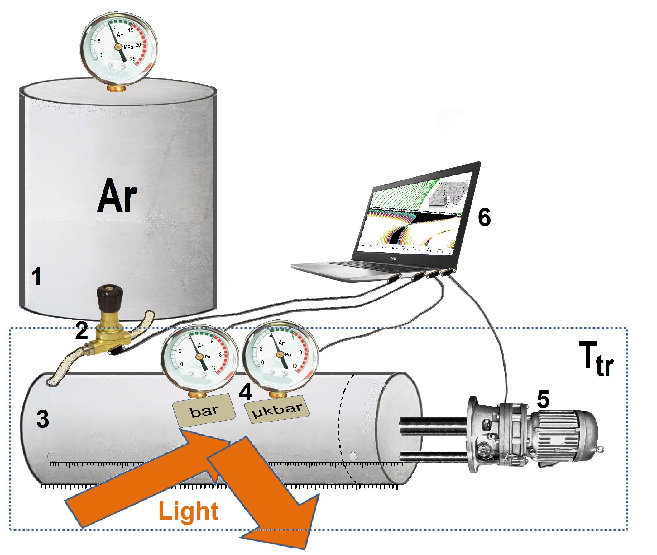
Fig 1. Schematically precise pressure indication in the echeloning approach. 1, Inert gas reservoir; 2, controlled lower pressure pump, 3, two-scale volume measurement cylinder: upper scale calibrated from 0.00005 cm³ to 4.9999 cm³ and lower scale calibrated from 4.9999 cm³ to 499,999,999.999 cm³ (1m·0.5 m² ; 4, two-scale manometer: detector A calibrated in area from 0.099 mbar to 9.9999 bar and device B calibrated in area from 0.99 nanobar to 99.999 µkbar; 5, plunger position controlling system; 6, main control station. Dotted line, area of stable temperature, triple point of water.
In this work, a method is proposed to determine the molar constant R with the relative standard uncertainty near 10⁻¹⁰ that is based on an extra accurate volume controlling and high sensitive pressure measurements in the framework of scale echeloning procedure. An essential moment of the method is uniting of results for two measurement scales with increased relative standard uncertainty (10⁻⁵) to obtain the higher precise level. A calibrated stable area of fixed temperature is used in vicinity of the triple point of water.
The gas-filled 1D elastic pneumatic photonic crystal is proposed as an optical indicator of pressure which can unite several pressure scales of magnitude. The indicator includes layered elastic platform, optical fibers and switching valves, all enclosed into a chamber. We have investigated theoretically the pneumatic photonic crystal bandgap structure and light reflection changes under external pressure. At the chosen parameters the device may cover the pressure interval (0, 10) bar with extremely high accuracy (1 nbar) for actual pressures. The size of the indicator is close to 1 mm and may be decreased. The miniaturized optical devices considered here may offer an opportunity to organize precise monitoring of pressure in different parts of the measurement cylinder.
As it was described in the framework of scale echeloning procedure [1], the junior scale is calibrated by B detector (Fig. 1) in a process of fine increasing the pressure in the every interval of 10 Pa beginning with zero pressure. For our goal this interval can be chosen in vicinity of several reference pressures. In Fig. 2, a scheme is shown of accuracy improving for all measurement system at reference pressures and volumes (P₁, V₁), (P₂, V₂), (P₃, V₃) and (P₄, V₄). A problem to be solved is that in general at initial stage the junior scale is unmatched with the needed accuracy of parameters a, b, ν participating the gas state equation shown in Fig. 2. Therefore the µkbar pressure scale 4 in Fig. 1 has a character of the entrance scale which should be defined more exactly during the iteration procedure including cyclic measurement of pressure at chosen volumes step by step in 6th – 10th
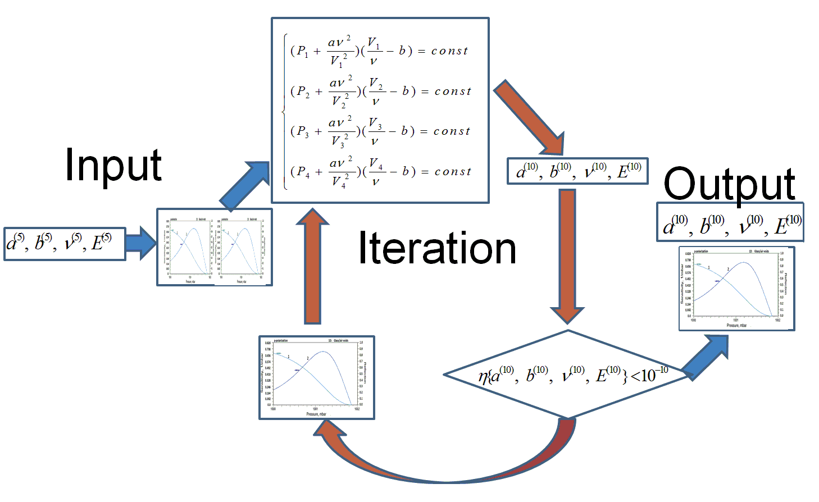
Fig. 2.Iteration procedure of the final increasing of accuracy for the junior level scale.
significant digits of the Van der Waals gas parameters and corresponded correction of the calibration curve. The entrance into the procedure is performed with 5-digit set of parameters a⁽⁵⁾, b⁽⁵⁾, ν⁽⁵⁾, E⁽⁵⁾ (Fig. 2, left part). The eldest calibration curve (detector A, Fig. 1) is perfect and will not change in the following operations. The junior level calibration curve (detector B, Fig. 1) is based on the 5-digit set of parameters that should be defined more exactly using existing 10-digit pairs P-V. The solution of system of four equations allows to find parameters a, b, ν in their preliminary 10-digits view that in turn adds five significant digits to Young modulus of membrane material in the pneumatic photonic crystal what in turn leads to a modification of the junior level calibration curve. The latter calls a pressure shift in 6th – 10th significant digits than demands a next correction in parameters a, b, ν, E and so on (Fig. 2, circular arrows). The iteration procedure stops when deviation in the set of parameters became less than 10 ⁻¹⁰ (Fig. 2, right side). At the outlet of the procedure we have corrected parameters a⁽¹⁰⁾, b⁽¹⁰⁾, ν⁽¹⁰⁾, E⁽¹⁰⁾ and corrected calibration curve of detector B It worth to note that iteration method is applicable if the procedure converges to (1) a constant value in the limits of needed significant digits and (2) this value is right one. An important argument in favor of the efficiency of iteration procedure in our case is extremely narrow area of pressure and volume dispersion: values P_{i} and V_{i} in the central part of Fig. 2 differ one from another only beginning with 6th significant digit.
The four equations of state figuring in Fig. 6 also yield magnitude of a constant in the right-hand side at every step of iteration procedure. At the final stage of the procedure this constant gets ten significant digit accuracy and the sought molar gas constant can be found from correlation in a view containing ten significant digits. A statistically large number of measurements should be performed under the given conditions of experiment. Besides, the variation of the experiment conditions in repeating procedures at the junior level scale to reach a statistically large enough number of measurements.

[1] Pneumatic photonic crystals/ Glushko E.Ya. // Opt. Express 2010, v.18(3), p. 3071-3078.

