Nanooptics and photonics
Luminescence properties and energy transfer processes in Tb³⁺and Eu³⁺ doped nanoscale phosphonates
Zaręba J.K., Samoć M., Nyk M.
Advanced Materials Engineering and Modelling Group, Faculty of Chemistry, Wrocław University of Science and Technology, Wybrzeże Wyspiańskiego 27, 50-370 Wrocław, Poland. E-mail: jan.zareba(at)pwr.edu.pl
Metal phosphonates (MPs) are a subclass of coordination polymers possessing metal ions as nodes and phosphonate-based (-PO₃H₂) organic linkers. In a previous conference contribution we have described our preliminary results on the morphology of nanoparticles of metal phosphonates comprising Ce, La, Nd, Eu, Gd, Tb ions and 1,4-diphosphonobenzene, their AC dielectric response as well as basic luminescence properties.[1]
In this presentation we will explore in more detail the luminescence properties of an isomorphous series of mixed-metal Tb, Eu MP nanomaterials. Luminescence spectra (λ_{exc.}=337 nm) show that substitution of Tb³⁺ with Eu³⁺ even at small concentrations (0.25%) imparts distinct Eu³⁺ emission bands, while further increase of Eu³⁺ content causes a significant quenching of Tb-related luminescence (Fig. 1a), suggesting an energy transfer process. Energy transfer from Tb matrix to Eu³⁺ ions is reflected in the time-resolved measurements of ⁵D₀ → ⁷F₂ electronic transition. Specifically, as seen in Fig. 1b for lower Eu³⁺ concentrations the decay component becomes clearly longer (e.g. 0.25% - 3.74 ms, 1% - 3.04 ms); an even stronger tendency is observed for the rise of luminescence (0.25% - 0.86 ms, 1% - 0.36 ms). Temperature dependence of the steady-state and time-resolved luminescence properties will be also discussed.
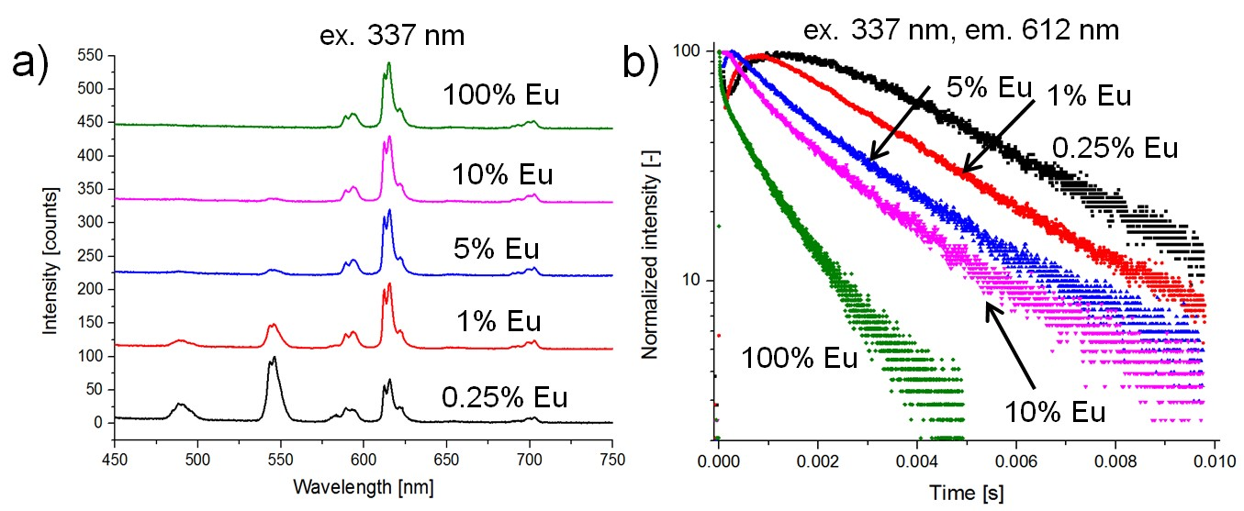
Fig. 1 a) Emission spectra of Tb phosphonates doped with various amounts of Eu³⁺. b) Luminescence decay traces of Tb phosphonates doped with various amounts of Eu³⁺, monitored at ⁵D₀ → ⁷F₂ transition (λ_{em}=612 nm).
- Zaręba J. K., Ciżman A., Samoć M., Nyk M. Study on morphology, luminescence, and dielectric properties of nanoscale lanthanide phosphonates // Nanotechnology and nanomaterials (NANO 2017) Abstract Book, p. 776.

