Nanoscale physics

Quasiparticle Study of Cyclopentadithiophene–Benzothiadiazole -Based Polymers
Yu.V. Klysko, S.V. Syrotyuk
Semiconductor Electronics Department, Lviv Polytechnic National University,
S. Bandera str. 12, Lviv 79013, Ukraine
E-mail: yuraklisko@gmail.com

In this work we have performed the ab initio study of three polymers: poly[2,6-(4,4-bis-(2-ethylhexyl)-4H-cyclopenta[2,1-b;3,4-b′]-dithiophene)-alt-4,7-(2,1,3-benzothiadiazole)] (PCPDT-BT) [1, 2], poly[2,6-(4,4-bis-(2-ethylhexyl)-4H-cyclopenta[2,1-b;3,4-b′]-dithiophene) -alt-4,7-(2, 1, 3-difluorobenzo-thiadiazole) (PCPDT-DFBT) [2, 3], poly[2,7-(5,5-bis-(3,7-dimethyl octyl)-5H-dithieno[3,2-b:2′,3′-d]pyran)-alt-4,7-(5,6-difluoro-2,1,3-benzothiadiazole)] (PDTP-DFBT) [2-6].
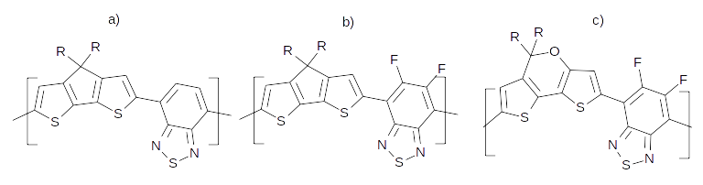
Fig. 1. Chemical structures of three different polymers: a) PCPDT-BT; b) PCPDT-DFBT; c) PDTP-DFBT
The quasiparticle energies have been evaluated within the Green’s function approach, e.g. GW approximation. All calculations were performed using the ABINIT code [7].
We have obtained the GW energy gaps, namely: PCPDT-BT — 2.00 eV; PCPDT-DFBT — 2.45 eV; PDTP-DFBT — 1.90 eV.
The evaluated Bethe-Salpeter exciton binding energies are as follows: PCPDT-BT — 0.15 eV; PCPDT-DFBT — 0.25 eV; PDTP-DFBT — 0.2 eV.

- J. You, L. Dou, K. Yoshimura, T. Kato, K. Ohya, T. Moriarty, T. Emery, C.C. Chen, J. Gao, G. Li, Y. Yang. A polymer tandem solar cell with 10.6% power conversion efficiency // Nature Communications.-2013.-4.3.-P. 1446.
- Gonze X., Jollet F., Abreu Araujo F., Adams D., Amadon B.et al. Recent developments in the ABINIT software package // Computer Phys. Comm.-2016.-205.-P. 106-131.

