Nanocomposites and nanomaterials
Nanosized CeO2-SnO2-Sb2O5 composites: synthesis, morphology and sensing properties to reducing gases
G.V. Fedorenko, L.P. Oleksenko, N.P. Maksymovych, G.O. Arinarkhova
Department of Chemistry, Taras Shevchenko National University of Kyiv, 12 Lva Tolstogo Str., Kyiv 01033, Ukraine.
E-mail: georgf@ukr.net

Cerium dioxide is widely used in the development of new functional materials, in particular, for creation of oxygen membranes in the fuel cells and as an active component in various oxidation catalysts due to mobility of the oxygen ions in the CeO2 crystal structure. The significant catalytic activities of cerium dioxide in the oxidation reactions make it usage promising for increase in sensitivity of adsorption-semiconductor gas sensors. In addition, the presence of cerium in the semiconductor material based on tin dioxide can provide control of the morphology of SnO2 nanoparticles that can also contribute to increasing the sensor response to the reducing gases.
In this work a synthesis of nanoscale sensor composites with an average particle size of 4-15 nm has been developed (Fig.1.). It was established that the electrical resistances of the obtained materials increase with the increase in the cerium content, which can be explained by a decrease in the particle size of the semiconductor and an effect caused by surface Ce3+ ions on formation of near-surface acceptor layers in the band structure of tin dioxide. It has been found that introduction of small amounts of cerium (≤0.25 wt.%) into a gas sensitive material can increase the response of the corresponding sensors to the various reducing gases (e.g., hydrogen).
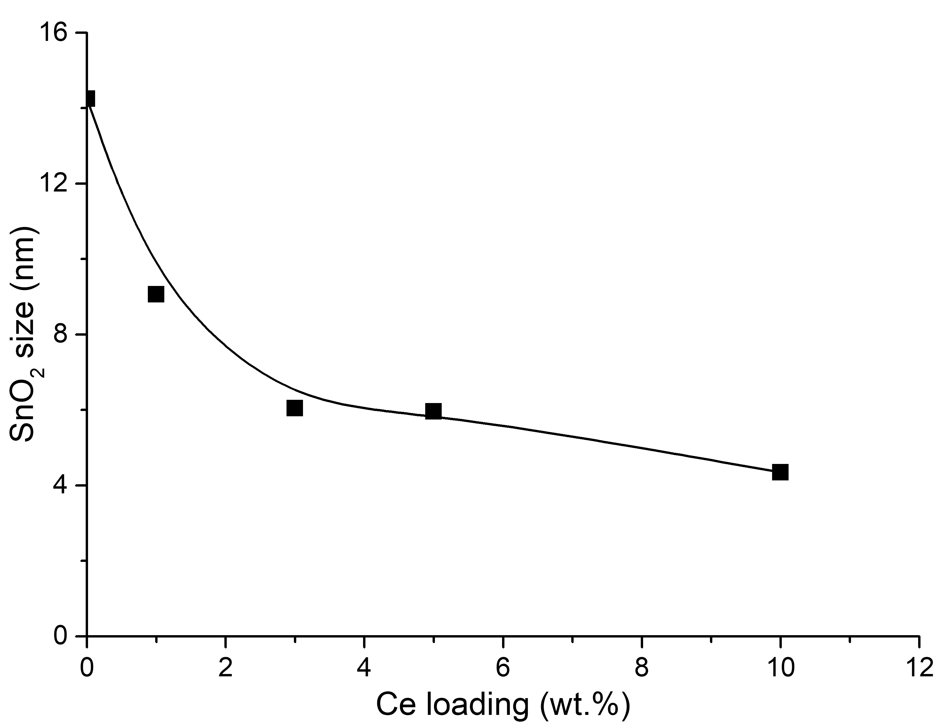 | Fig.1. Dependence of SnO2 crystal sizes in sensor materials on cerium loading.

