Nanocomposites and nanomaterials

The study of reduce CeO₂-MoO₃ system modified by mechanochemical and ultrasonic methods
Diyuk N.V.1, Sachuk O.V. 2, Zazhigalov V.A.2, Sanzhak O.V.2
1 Taras Shevchenko National University of Kyiv. Volodymyrska street, 60, Kyiv-01033, Ukraine.
2 Department of Heterogeneous Catalytic Oxidation Processes, Institute for Sorption and Problems of Endoecology of the NAS of Ukraine. General Naumov str., 13, Kyiv-03164, Ukraine.
E-mail: Slena951@ukr.net

Ce-Mo-O compositions are well known for ecological catalysis, and partial oxidation processes. The preparation of CeO₂-MoO₃ compositions was carried out by two ways: i) CeO₂-MoO₃-UST − treatment in a dispersant UZDN-2T and ii) CeO₂-MoO₃-MChT − treatment in a ball planetary mill Pulverisette-6 (Fritsch). The aim of this work was studies of UST and MChT impacts on reducing properties (in H₂-Ar mixture at 30-800°C) of Ce-Mo-O system.
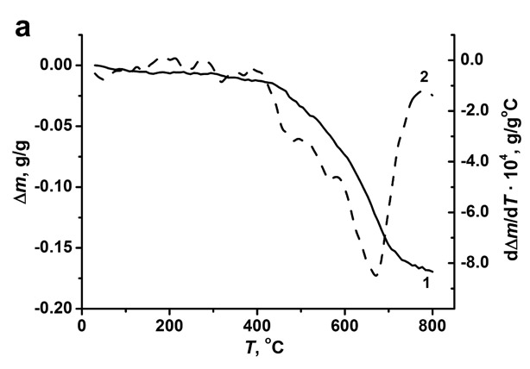 | 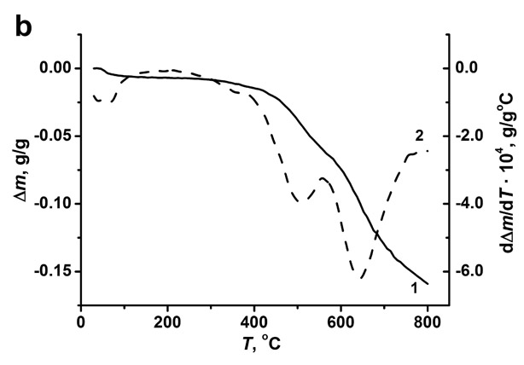 | 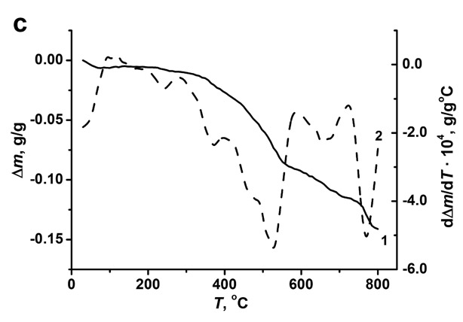
Fig. 1. TG (1) and DTG (2) dependences of hydrogen reduce of samples:
CeO₂-MoO₃ initial (a), CeO₂-MoO₃-UST (b) і CeO₂-MoO₃-MChT (c).
The TG and DTG dependence of the hydrogen reducing of the CeO₂-MoO₃ samples is presented in fig. 1. It was shown that the reducing of the initial sample CeO₂-MoO₃ (fig. 1 a) begins at 400°C, that is 100°C less than the reducing of MoO₃. There are several effects on the DTG curve, that is explained by the stepwise reducing of MoO₃ to MoO₂ and then to Mo. In these conditions, the reducing of CeO₂ was carried out partially with the formation of CeO_{1.82-1.84}. For the CeO₂-MoO₃-UST the reducing begins at 300°C with formation of MoO₂ (~550°C) and Mo (~750°C) that is clearly observed on the reducing curves (fig. 1 b). It is found that the reduce of CeO₂-MoO₃-MChT was begun at 250°C, UST and MChT lead to the significant activation of the surface layer and the defects appearance in the structure of CeO₂-MoO₃ samples, that accompanied by an increase of oxygen mobility and the ability to remove it already at 250-300°C as a result of controlled reducing.

