Effect of Concentrated Light on Mixture of Boron and Aluminum Powders Transformation

Sartinska L.L.¹, Voinich Ye. V. ¹, Timofeeva I.I. ¹, Fecenko O.M.², Kavelin V.V.²,

Frolov G.A. ¹

¹Frantsevich Institute for Problems of Materials Science of NASU, Krzhyzhanovsky Str., Kiev-142, 03680 Ukraine.

E-mail: sart@ipms.kiev.ua
²Institute of Physics, National Academy of Sciences of Ukraine, 46 Nauki Ave.,
Kyiv 03680, Ukraine
E-mail: fesenko@iop.kiev.ua

Abstract
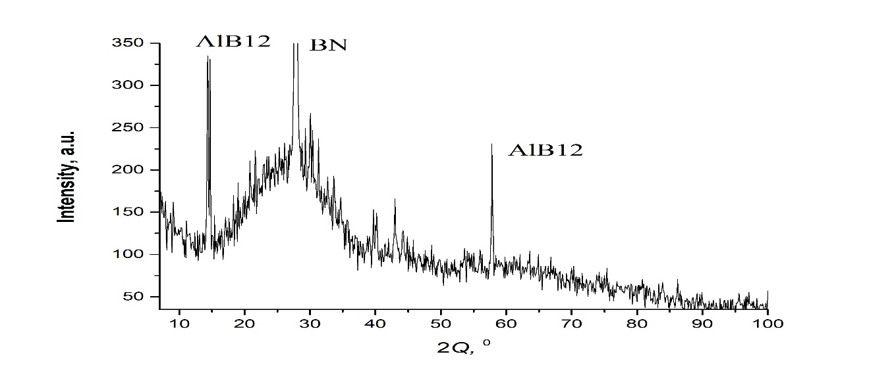
Transformation of boron powders and 25 wt. % aluminum powdered additive was considered. Heating initial powders was carried out in a xenon high-flux optical furnace in a nitrogen flow at the temperatures 1000-1400 ⁰C. It was demonstrated that addition of aluminum results in formation of amorphized BN and AlB₁₂ (Fig. 1). Presence of AlB₁₂ changes FTIR and Raman spectra of BN in the obtained composite nanostructures.

Fig. 1. XRD pattern of the obtained composite showing the peaks corresponding to a mixture of amorphized BN and AlB₁₂ particles.

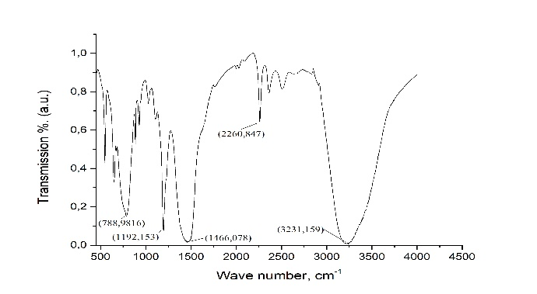  a | 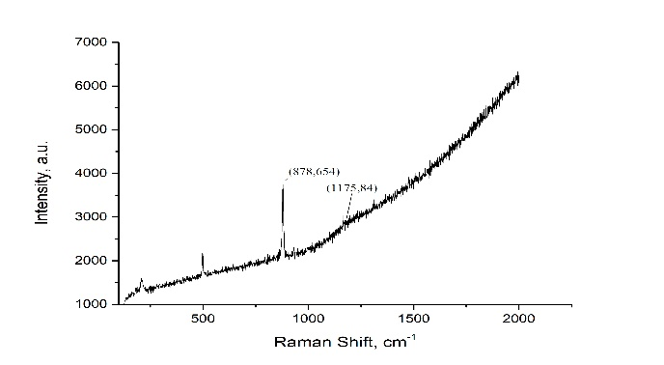  b
Fig. 2 FTIR (a) and Raman (b) spectra of composite powders corresponding to a mixture of amorphized BN and AlB₁₂ particles.

