Nanostructured surfaces

Theoretical spatial structure and spectral characteristics of various ZrO₂ nanoparticles and Zr doped TiO₂ films

O.V. Smirnova, A.G. Grebenyuk, V.V. Lobanov

Chuiko Institute of Surface Chemistry, NAS of Ukraine, 17 General Naumov Str., Kyiv 03164, Ukraine, olsmirnova2001@ukr.net

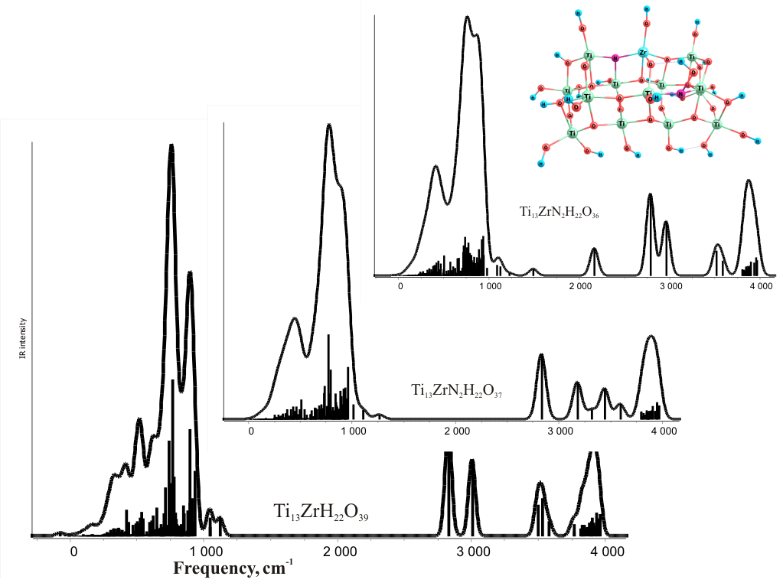
Zirconium is an important structural and functional element and has unique physical and chemical properties. High ion exchange activity and oxidation-reduction potential make it useful as a catalyst, a dopant and a promoter. In addition, high chemical stability, mechanical strength and microstability cause their use as thermal barrier and as an oxygen sensor. Previously we have analyzed the atomic and electronic properties of pure and nitrogen-doped TiO₂ clusters of different compositions (14 or 21 Ti atoms, stoichiometric, and having oxygen vacancies) [1]. In this work we have studied the equilibrium geometries and distribution of single-electron energy levels, absorption spectra (XPS (Zr3p), IR (Fig. 1) and UV) for the models of small (ZrO₂)_{n} (n=4, 6, 19) and Ti₁₃ZrH₂₂O₃₉ clusters with different defects. These structures have been studied systematically by density functional theory (B3LYP/3-21G**) calculations by means of the software package PC GAMESS (FireFly 8.1.0, A.Granovsky [2]). As a result of calculations, it has been found that the calculated vibration frequency of the Zr₄O₈ cluster in the 583.6 cm⁻¹ region corresponds to the "breathing" vibrations of Zr-O bonds, and 978 cm⁻¹ corresponds to the stretching vibrations of Zr=O groups. For the Zr₁₉O₃₈ cluster, this value corresponds to 955 cm⁻¹. Energy levels of Zr3p in Zr₄O₈, Zr₆O₁₂, and Zr₁₉O₃₈ clusters are 322.11, 319.97, and 324.19 eV respectively. It follows from the results of calculations of the UV spectra that all the clusters have absorption bands with maxima at 337 nm. The appearance of another absorption band of cluster Zr₄O₈ in the range of 410 nm is due to the presence of chromophores Zr=O. However, in the UV spectrum of cluster Zr₁₉O₃₈ this band (410 nm) is absent, but there is a band 342 nm with negligible intensity. Cluster Zr₆O₁₂ has a distorted structure, so a bathochromic shift occurs of relative absorption bands.
Fig. 1. IR spectra of the clusters of composition Ti₁₃ZrH₂₂O₃₉, Ti₁₃ZrN2H₂₂O₃₇, Ti₁₃ZrN2H₂₂O₃₆
For titanium dioxide structures with zirconium atom substituting titanium one, Ti₁₃ZrH₂₂O₃₉, parent and nitrogen-substituted with an oxygen vacancy and without it, differences in spectral characteristics are observed. Thus, the shift and change in the shape of the IR spectrum in the frequency range 500-1000 cm⁻¹, the XPS spectrum in the interval 320-400 eV, and in the UV spectrum, along with absorption around 290 nm, characteristic of pure titania and zirconia, an absorption arises near 550-700 nm, due to impurities.
These differences allow us to verify the absorption bands related to zirconium atoms in the complex experimental spectra of doped and defective TiO₂ structures. The absorption in the IR spectrum of the Ti₁₃ZrN₂H₂₂O₃₆ structure near the 2000 cm⁻¹ absorption band is also seen. This indicates the formation of hydrogen bonds between the surface Ti–OH groups that arise when the cluster is "compressed" due to compensating of an oxygen vacancy in the cluster.

- Smirnova O., Grebenyuk A., Linnik O., and Lobanov V. Quantum Chemical Study of Water Molecule Adsorption on the Nitrogen-Doped Titania Thin Films // Nanophysics, Nanomaterials, Interface Studies, and Applications: Selected Proc. 4th Int. Conf. Nanotechnology and Nanomaterials (NANO2016, Aug. 24-27, 2016, Lviv, Ukraine). - Springer, 2017. - P.603-609.
- Schmidt M., Baldridge K., Boatz J., Elbert S., Gordon M., Jensen J., Koseki S., Matsunaga N., Nguyen K., Su S., Windus T., Dupuis M., Montgomery J. General Atomic and Molecular Electronic Structure System // J. Comput. Chem. – 1993. – V. 14. – P.1347.

