Thematic area: “Nanoscale Physics”

Patterned ultra-thin layers of (Ga,Mn)As & (Ga,Mn)(Bi,As) for spintronic
memory application

K. Levchenko 1, T. Andrearczyk 1, E. Lusakowska 1, J. Sadowski 1,2, Z. Tkaczyk 1, J. Wrobel 1, I. Radelytskyi 1, T. Figielski 1 and T. Wosinski 1

1 Institute of Physics, Polish Academy of Sciences, 02-668 Warsaw, Poland
E-mail: levchenko@ifpan.edu.pl
2 MAX-IV Laboratory, Lund University, P.O. Box 118, SE-221 00 Lund, Sweden

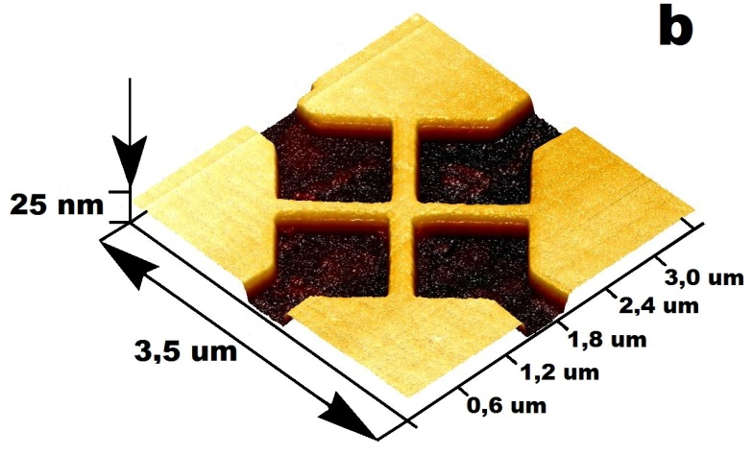
Moore’s law enduring demand on smaller and more efficient devices sets up a bar for the new ideas very high, thus not only technology, but material as well is a subject of improving. Currently, we’d like to present how a conventional semiconductor, such as GaAs, doped with Mn and Bi, is a an attractive dilute magnetic semiconductor for novel spintronic applications [1,2]. With a reach history of experimental success and elaborated theory behind, this ternary/quaternary alloy provides a reach basis for further investigation. Appropriate nano-structurization of thin (Ga,Mn)As layers introduces a shape-dependent magnetic anisotropy in addition to the original magneto-crystalline anisotropy of the layers, creating an arrangement of magnetic domains. In our work, we’d explain how to turn initial defects into useful utility on the example of ring-shaped (Figure 1a) and cross-like (Figure 1b) 10-nm-thick nanostructures of (Ga,Mn)(Bi,As) and (Ga,Mn)As with 6% Mn and 1% Bi contents. For the two types of nanostructures their resistance, measured under a weak in-plane magnetic field at low temperatures, displays hysteresis-like behaviour, controlled by rearrangement of domain walls in the nanostructures, which could be utilized in a new class of nonvolatile two-state memory cells.
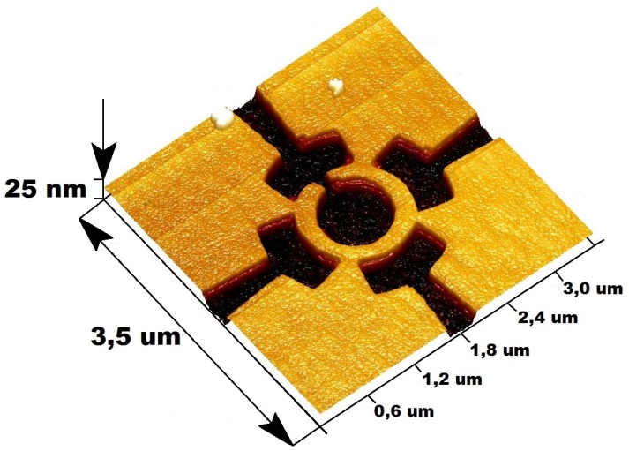
a
b
Figure 1. AFM images for the ring-shaped (a) and cross-shaped (b) nanostructures prepared using electron-beam lithography patterning and chemical etching from (Ga,Mn)(Bi,As) and (Ga,Mn)As thin epitaxial layers grown on semi-insulating GaAs substrate. The darker contrast corresponds to non-conducting areas etched to the substrate.

This work was supported by the Polish National Science Centre under grant UMO-2016/23/N/ST3/03501 Preludium.
- T. Dietl and H. Ohno, Rev. Mod. Phys. 86, 187 (2014).
- T. Wosinski, T. Andrearczyk, T. Figielski, J. Wrobel and J. Sadowski, Physica E 51, 128 (2013).

