A new class of methyl-orange assisted core-shell polypyrrole-silver nanosheets for highly sensitive ammonia chemiresistors
Vishal Chaudhary
chaudhary00vishal@gmail.com
Shivaji College, Department of Physics & Astrophysics
University of Delhi, Delhi-110007, India
Abstract
A cost effective, eco-friendly and one pot synthesis of a new class of homogenous core-shell polypyrrole-silver nanosheets (PPy-Ag) is achieved with the assistance of supramolecular aggregates of amphiphilic methyl-orange (MO) and oxidant ions of silver nitrate (AgNO₃). Due to Ostwald ripening, the morphology of the nanocomposite was found to be transformed from spherical (core-shell) to plate like polygonal particles with increase in concentration of AgNO₃. The contrast of the transmission electron microscopy (TEM) images depicts the presence of Ag at the core side (due to stronger contrast) and PPy at the shell, as Ag being metal scatters more electrons than organic polymer. The core-shell nature of the nanocomposite was confirmed by surface enhanced Fourier transform infrared spectroscopy and potassium cyanide (KCN) washing technique. The selected area electron diffraction (SAED) pattern reveals the hexagonal nature of PPy-Ag hybrid nanosheets with [111] orientation and interplanar spacing around 2.4 Å corresponding to face-centered-cubic (fcc) structure of silver. The X-ray diffraction spectra reveals the crystalline nature of the hybrid and found to be consist of four sharp diffraction peaks at 2θ values of 38.2º, 44.4º, 64.5º and 77.2º representing Bragg’s reflections due to (111), (200), (220) and (311) planes of the face centered cubic lattice phase of Ag. The two characteristic peaks of MO doped PPy were observed at 20⁰ and 25⁰ due to the periodicity parallel and perpendicular to the PPy chains. Furthermore, the chemiresistors fabricated using the PPy-Ag nanocomposite was analyzed for ammonia monitoring behavior. The fabricated chemiresistor was found to be highly sensitive (150% sensitivity) towards concentration as low as 5 parts per million of ammonia, which opens a new window for fabricating cost-effective commercial sensors to detect ammonia at room temperature.

Keywords: Core-shell nanocomposite, surface enhanced Fourier transform infrared spectroscopy, Ostwald ripening, chemiresistors.

Figures:
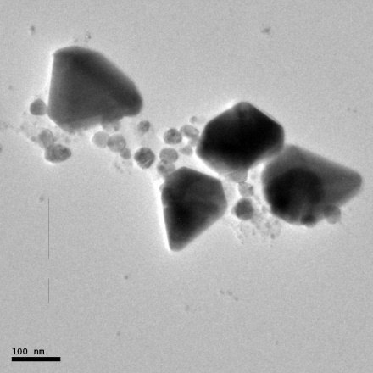
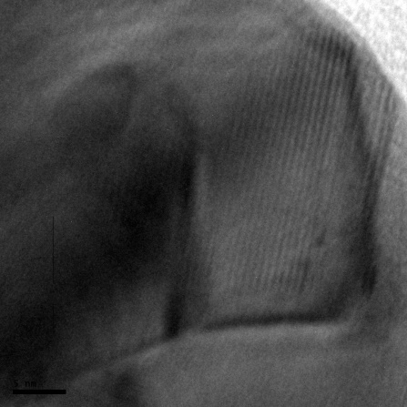
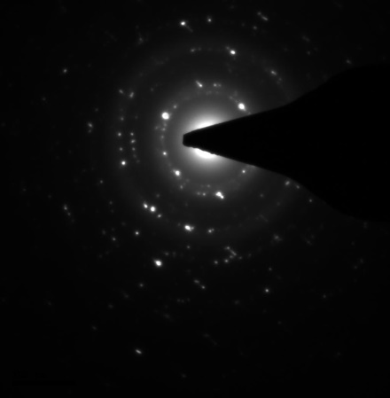
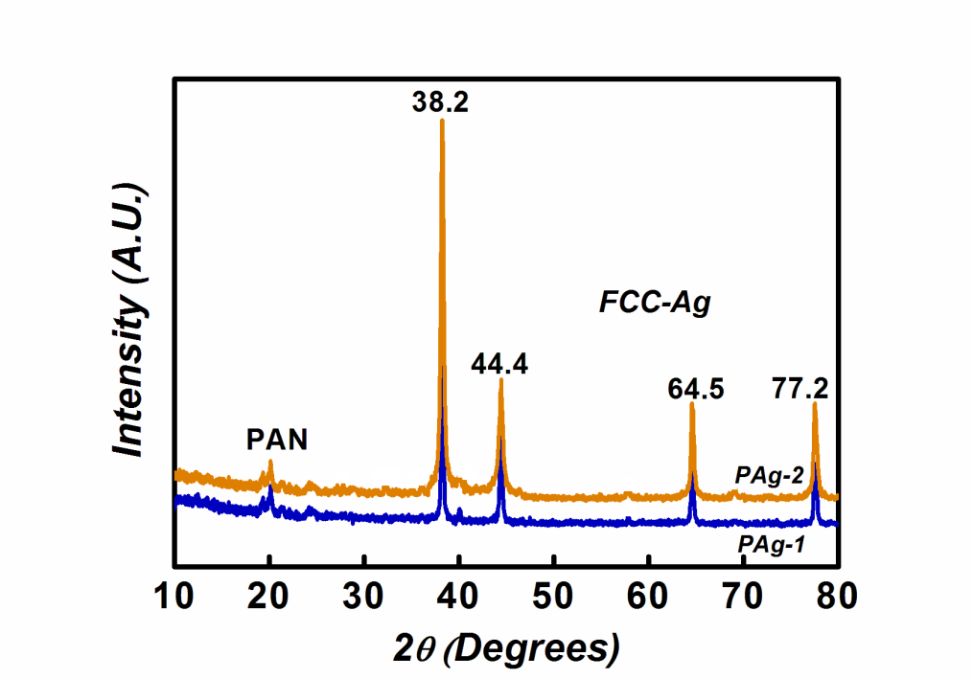

HR-XRD Micrograph Ammonia Sensing behavior of PAg HR-TEM Micrograph

References:
- V. Chaudhary and A. Kaur, Journal of Industrial and Engineering Chemistry, 26 (2015) 143–148.
- V. Chaudhary and A. Kaur, RSC Advances, 5 (2015) 73535-73544.
- V. Chaudhary and A. Kaur, RSC Advances, 6 (2016) 95349-95357.
- V. Chaudhary and A. Kaur, Polymer International, 64 (2015) 1475-1481.

