NEW PHOTOSENSITIVE POLYMERIC THIN FILM NANOCOMPOSITES FOR PHOTOVOLTAIC APPLICATIONS

Mokrinskaya E.V., Studzinsky S.L.¹, Davidenko N.A., Davidenko I.I.

¹Department of Macromolecular Chemistry, Kiev Taras Shevchenko National University, Kiev, Ukraine

The novel photosensitive polymeric thin film structures based on poly(styrene-co-nonyl methacrylate) doped by high concentration of the azo-dye based glycidyl derivative Azog have been prepared.

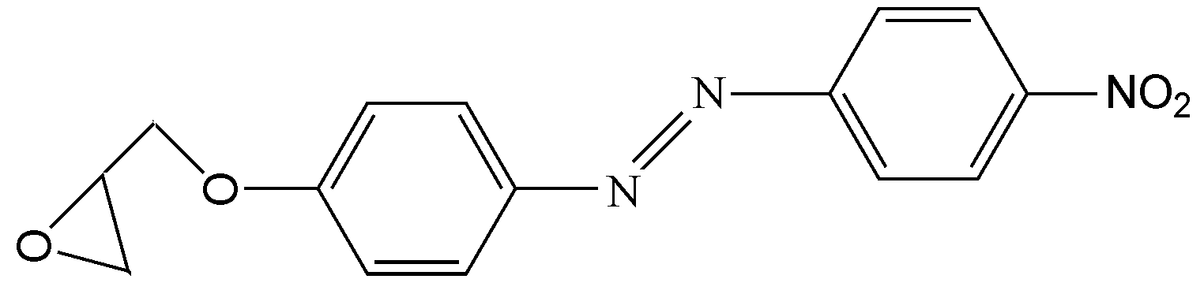

Their spectral, photoconductive and photovoltaic properties are investigated. The photoelectric properties of obtained composite films samples with a free composite surface (glass substrate – transparent electroconducting ITO (SnO₂:In₂O₃) sublayer – composite film) have been investigated by Kelvin probe method of surface electric potential measurement. It was shown, that all investigated film composites exhibit photoconductive and photovoltaic properties under illumination by light from the azo-dye absorption region. The nature and features of the photoconductive and photovoltaic properties of the investigated film compositions, as well as the possible mechanisms of the photovoltaic effect and charge carriers photogeneration are discussed. The respective phenomenological model for internal photoeffect in investigated film compositions was proposed.

