Excitation of surface electromagnetic waves on a multilayer system with a charged particle
Igor Goliney
Institute for Nuclear Research, NAS of Ukraine
47 prospekt Nauki, Kiev, Ukraine
Email: igoliney@kinr.kiev.ua

Surface electromagnetic waves (SEW) exist on the boundary of a periodic medium because electromagnetic wave cannot penetrate in the medium in when the Bragg condition is met. Surface electromagnetic waves exist when two evanescent solutions of Maxwell equation on both sides of interface could be joined. The wave decays exponentially into the outer space due to the total reflection and into the periodic medium due to the Bragg condition.
Like surface plasmons, SEW cannot be excited with an external plane wave but they can be excited with an object that creates non-uniform field.
The report presents results of the theoretical study of the possibility to excite SEW with a charged particle crossing the multilayer structure. The indicator of the excitation of SEW is the emission from the surface through a prism in the Kretschman configuration.
Intensities of the emission of s- and p-polarized waves are calculated. Dependence of the emission spectra are analyzed as functions of the parameter of the multilayer structure, the number of layers, the angle of incidence of the particle and the angle at which the emission is registered.
In the complex spectrum of the transitional radiation of a particle crossing the multilayer structure, the emission corresponding to the SEW can be discerned by the resonant frequency, intensity and polarization. The intensity of the SEW excitation grows significantly when at least one of the dielectric materials of the multilayer structure supports Cherenkov radiation.
The theoretical case of the infinite number of layers has been analyzed. The SEW manifest themselves in their purest form. Yet, this case is physically non-realistic due to energy lost of the charged particle in the medium.
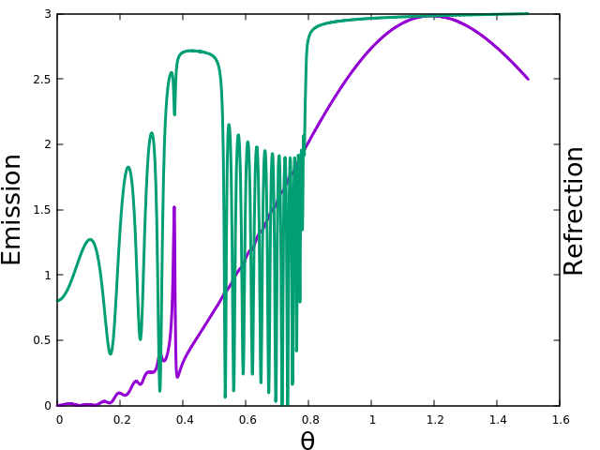
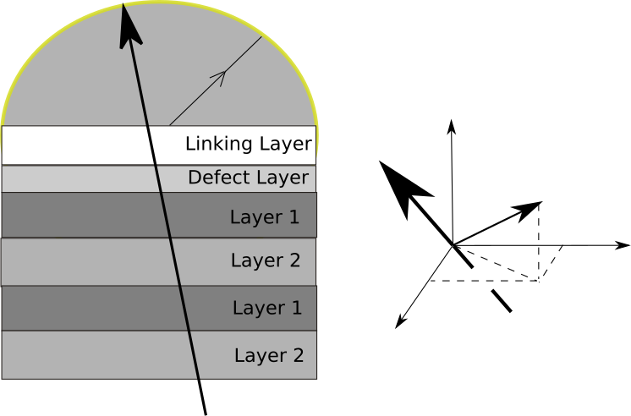

Fig. 1. Reflection spectrum (green) in the Kretscman configuration and the emission spectrum (purple) for the 16 bilayer structure. The narrow peak in the emission corresponds to the SEW.

