Physicochemical Properties and Characterization of Biobased Materials
BELLEL Nadjoua¹, BOUFENDI Toufik¹, BELLEL Nadir^{1*}
¹ Energy Physics Laboratory, Université Frères Mentouri Constantine1
* Author corresponding: bellelnadir@yahoo.fr

Abstract:
The purpose of this work is to contribute to the use of biobased materials in wallcoverings to improve thermal insulation. A study that contributes in the construction sector for energy efficiency of the batimant. The natural fibers used in this study as reinforcement are the fibers of the date palm clusters collected in Biskra (Algeria). The matrix used is cement (Portland cement pozzolan CEM II / A-P 42.5 N) supplied by the cement company of Hamma Bouziane Constantine in Algeria.
Samples prepared with six different weight fractions (0, 1, 2, 3, 4, 5 and 100%) of FPD are tested after grinding. The characterization of these samples was performed by Fourier transform infrared spectroscopy (FTIR), Raman spectroscopy, X-ray diffraction (XR), differential scanning calorimetry (DSC) and thermogravimetric analysis (TGA).
DSC analyzes show that the addition of fibers does not affect the melting and crystallization temperatures of the samples. ATG analyzes show that the loss of mass with increasing temperature is not significant. The FTIR and XRD analyzes show that 0% to 5% samples are composed of: CaCO3, SiO2, Al2O3 and Fe2O3. For the 100% sample, no diffraction peaks (amorphous material).
According to our results, the addition of biobased materials (MB) increases the porosity of cementitious materials. This increase induces a decrease in the stress applied compared to the pure cement. This trend can probably be related to voids caused by methyl bromide inclusions in cement. It has been noted that the effect of sizes and the addition of MB on the strength of cement materials is very significant. According to the results obtained, composites containing MB have in practice excellent properties that can compete with building materials.
Keywords:
Biosourced materials, thermal insulation, FPD, FTIR, DSC, XRD, TGA, characterization

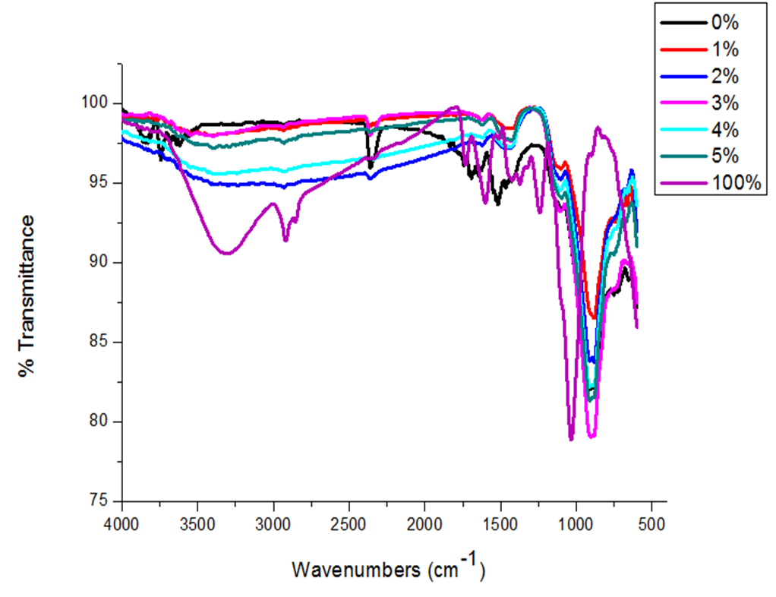
FTIR, analyzes show:
- samples from 0% to 5% are composed of: CaO, SiO2, Al2O3, Fe2O3, MgO, SO3, CO2, K2O, Na2O.
- The 100% sample is composed of: C, N, O, H.
(absence of diffraction peaks (amorphous material)).

