Thematic area of your work "Nanocomposites and nanomaterials")

Preparation and characterization of biodegradable biopolymer film for Dural Substitute
R. Kozakevych¹, V. Tertykh¹, A. Panteleichuk²
1Chuiko Institute of Surface Chemistry of National Academy of Sciences of Ukraine, 17 General Naumov Str., 03164 Kyiv, Ukraine
E-mail: kozakevych@gmail.com
2 The State Institution Romodanov Neurosurgery Institute, National Academy of Medical Sciences of Ukraine, 32 Platona Mayborody Str., 04050, Kyiv, Ukraine

Dural defect is a common problem during neurosurgery. Current artificial dura mater substitutes have shortcomings. Among these are a high infection rate, poor bio-compatibility, incomplete absorbability, and difficulty in loading medicine and controlling the effective release of the medicine [1]. The work is devoted to the study of effective polymeric film based on gelatin, chitosan. All films were prepared by a casting solvent evaporation technique. Obtained materials were characterized using FTIR, ATR, DSC. Morphological properties, water permeability, physical property, biocompatibility were also investigated.
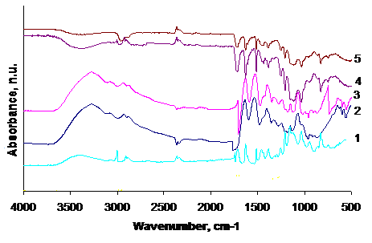 | Fig. ATR-spectra of composite films Gelatin (1), Chitosan (2), Gelatin/Chitosan (3), Chitosan/PEO 1/1 mass (4), Chitosan/PEO 5/1 mass(5)
Physical and mechanical properties of chitosan films can be controlled by choosing appropriate molecular weight of chitosan and adding PEO. The result on mechanical properties showed that the tensile properties of the reinforced chitosan films were superior to the free film. The reinforcement of PEO into the chitosan film improved thermal stability of the chitosan film. The swelling ratio and water permeability of the chitosan film can be decreased with added PEO. Cellular responses to the implants were assessed histologically at these time points and determined that all of the groups had similar inflammatory response, indicative of normal tissue repair response.
- Gazzeri R, Neroni M, Alfieri A, et al. Transparent equine collagen biomatrix as dural repair. A prospective clinical study. Acta Neurochirurgica. 2009. 151(5) p. 537

