Nanobiotechnology for health-care
Investigation of proteonectic properties of biologically active nanocomposites based on silica matrices
Gaidai A.¹, Oliniichuk H.¹, Kozakevych R.², Murlanova T.¹, Vakuliuk P.¹, Kunytsya N.¹, Furtat I.¹, Tertykh V.², Golub A.¹
¹National University of Kyiv-Mohyla Academy, 2 Skovoroda Str., Kyiv, 04070, Ukraine. E-mail: alina.gaidai@ukma.edu.ua

²Chuiko Institute of Surface Chemistry of National Academy of Sciences of Ukraine
17 General Naumov Str., 03164, Kyiv, Ukraine

The creation of biocompatible nanocomposites that exhibit antimicrobial and probiotic activity and can play the role of a transport agent for targeted drug delivery is one of the main development strategies in clinical practice. The use of silica as a carrier of the active components can provide not only the delivery of the latter, but also contribute to the effective removal of exudate and cleansing the wound. Adsorption modification by various biologically active compounds allows providing silica improved physico-chemical properties, which are necessary for the creation of new dosage forms on its basis. At the same time, the question remains unclear which effect has modification with antiseptic compounds of initial silica and silica with organic groups grafted to its surface (various types of matrices) on the further sorption properties of produced nanocomposite materials respectively to proteins, which is essential for their subsequent use for the treatment of wounds because proteonectic properties (ie, the ability to bind proteins) determine the pharmaceutical activity of drugs [1].
In this study nanocomposites based on various silica matrices were produced, in particular, on the basis of pyrogenic silica with a specific surface of 300 m²/g (A-300), aminated silica (A-NH₂), methylated silica with different contents of
-CH₃ groups (A-CH₃-30%, А-CH₃-83%, А-CH₃-100%) and a biologically active agent ornidazole (O) with an active substance content on the surface of 4% by weight. The availability of ornidazole on the surface of the produced nanocomposites was confirmed by IR spectroscopy.
The adsorption kinetics of protein (bovine serum albumin (BSA)) by nanocomposites was determined in static conditions and compared with sorption of BSA in nonimpregnated matrices. The results of this comparison are presented below in the graph (Fig.1):

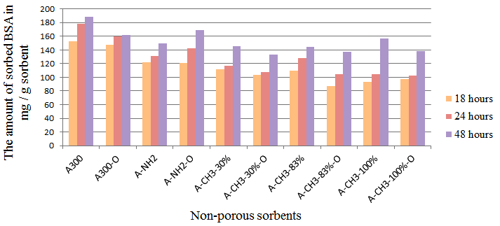
Fig.1. Adsorption kinetics of BSA
by nanocomposites and nonimpregnated matrices

Analyzing the sorption capability of nanocomposites’ samples with ornidazole relatively to BSA, it can be concluded that their sorption capacity is slightly lower than for the initial silica matrices.
In order to study the stability of the produced composites and the rate release of the biologically active substance, the kinetic of ornidazole desorption in an aqueous solution was studied (Fig.2)
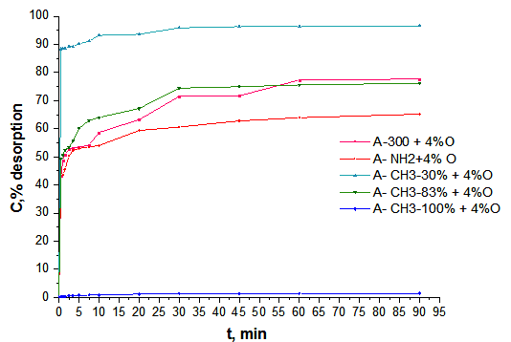
Fig.2. Dependence of ornidazole desorption (in %) from the surface of nanocomposites on the type of silica matrix used for preparation thereof

Having analyzed the obtained dependence of ornidazole desorption from the nanocomposites’ surface, we can conclude that the highest percentage of desorption has a nanocomposite on the basis of partially methylated surface (30% -CH₃). The slowdown of the release rate of the active substance is observed for nanocomposites based on pyrogenic silica, aminated silica and methylated silica with a content of -CH₃ groups of 83%. The least desorption has nanocomposite based on the 100% methylened matrix due to its hydrophobicity.

- A.R. Gaidai, P.V. Vakuliuk, I.M. Furtat, T.V. Murlanova, N.I. Kunytsya, V.A. Tertykh, R.B. Kozakevych, A.H. Grebeniuk, A.A. Golub «Preparation and properties of nanocomposites based on silica matrix modified with antimicrobial preparations» // Voprosy khimii i khimicheskoi tekhnologii, 2019, No. 3, pp. 6-16.

