Nanooptics and nanophotonics
Third order optical susceptibilities of the cooper oxide thin films
¹Liakhovetskyi V., ²Mulenko S., ¹Rudenko V., ³Brodin A.
¹ Institute of Physics NAS of Ukraine, 46 Nauky Blvd, Kiev-28, Ukraine
E-mail: lyakh@iop.kiev.ua
² G. V. Kurdyumov Institute for Metal Physics NAS of Ukraine, 36 Academician Vernadsky Blvd., Kiev 142, Ukraine
³ National Technical University of Ukraine “Igor Sikorsky Kyiv Polytechnic Institute”, 37, Peremohy av., Kyiv, 03056, Ukraine
The study of the nonlinear optical susceptibility of thin films of metal oxides remains an important area of research due to the possibility of their use for optical communications and optical limiting devices. Previously, we have shown the presence of a large nonlinear susceptibility of third order χ(3) in thin films of iron oxide [1], chromium oxide [2] and oxide of palladium [3]. thin films of copper oxide also attract interest of researchers as a medium with high optical nonlinearity [4].
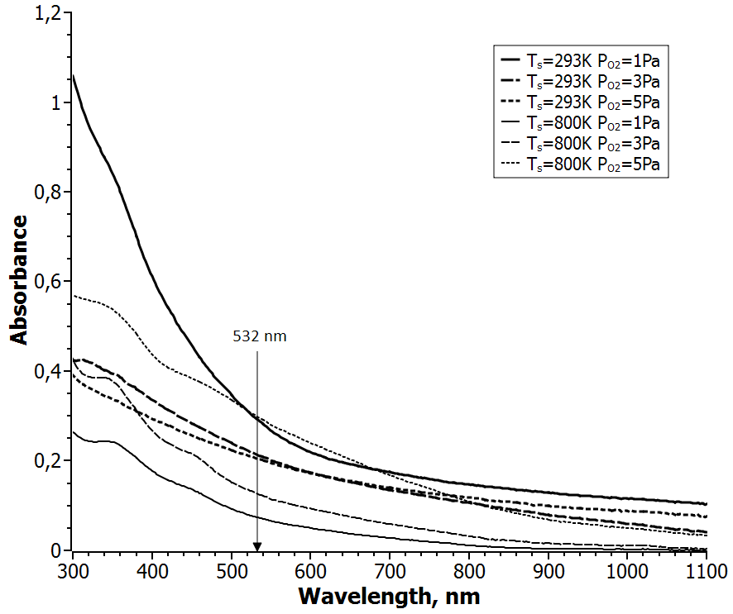
Fig.1. Linear optical absorption properties of cooper oxide thin films.
Using the technique of reactive pulsed laser deposition in a vacuum reactor made of stainless steel, we obtained samples of thin films of copper oxide on glass substrates at various substrate temperatures T_{s} and the various pressures of oxygen P_{O2} in the chamber. Fig.1 shows the absorption spectra of these samples. The band gap of the films, depending on deposition conditions were determined in the range of 2.58 – 2.87 eV.
The study of the cubic nonlinear susceptibility using the techniques of Z-scan at 532 nm when exposed to nanosecond laser pulses revealed the presence of negative refractive nonlinearity. The greatest value of the real part of the cubic nonlinear susceptibility is equal to Reχ⁽³⁾ =-5.3×10⁻⁵ esu. Also, in the samples exhibit nonlinear absorption, which changes the sign depending on the conditions of synthesizing the sample.
The large optical nonlinearity of the cooper oxide thin films indicated their potential application for future nonlinear optical devices.

1. S.A. Mulenko, V.I. Rudenko, V.R. Liakhovetskyi, A.M. Brodin, N. Stefan, Large third-order optical nonlinearities in iron oxide thin films synthesized by reactive pulsed laser deposition, Optical Materials.- 2016 – 60.- P.123-127.
2. M.S. Brodyn, S.A. Mulenko, V.I. Rudenko, V.R. Liakhovetskyi, M.V. Volovyk, N. Stefan, Cubic Optical Nonlinearity of Thin Fe₂O₃ and Cr₂O₃ Films Synthesized by Pulsed Laser Deposition, Ukr. J. Phys.- 2016 – 61.- No. 6 - P.495-501.
3. M. S. Brodyn, V. I. Volkov, V. I. Rudenko, V. R. Liakhovetskyi, A. O. Borshch. Large third-order optical nonlinearity in PdO thin films, Journal of Nonlinear Optical Physics & Materials.- 2017 – 26. - 1750037
4. Ming Fu, Hua Long, Kai Wang, Guang Yang, Peixiang Lu, Third order optical susceptibilities of the Cu₂O thin film, Thin Solid Films.- 2011 – 519. - P.6557–6560.

