Influence of Solar Energy on Self-Organization of Water Molecules
Igor V. Shevchenko Institute of Bioorganic Chemistry and Petrochemistry, Kiev, Ukraine

Solar energy exerts a strong influence on the ability of water molecules to self-organization. This influence is manifested on the chemical reactivity of water clusters. The rate of hydrolytic reactions involving water clusters can vary within very large limits over the course of minutes, hours, days, months and years. The results of regular 4-year (2015-2018) investigations of the hydrolysis of triethylphosphite in acetonitrile indicate that the rate of this reaction with all other conditions being equal displays diurnal and annual variations and may be also modulated by the 11-year cycles of solar activity. (Figure 1)

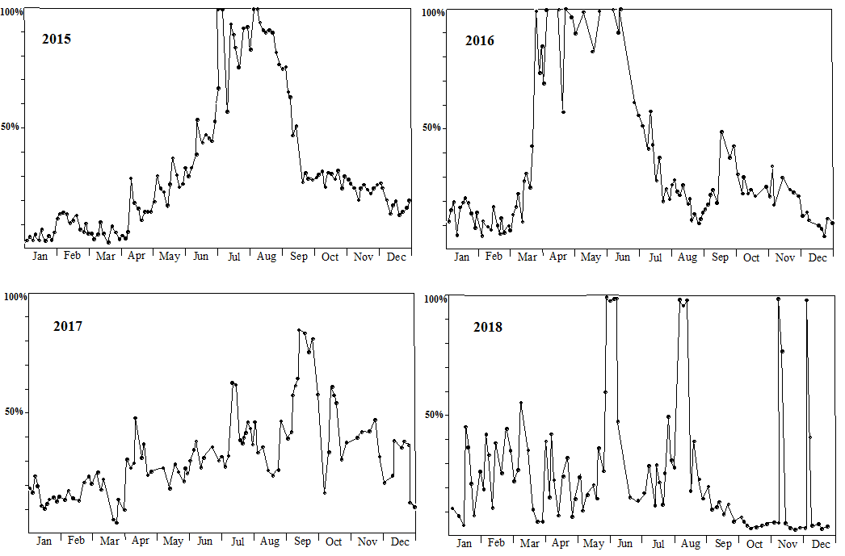
Fig. 1. (EtO)₃P + H₂O = (EtO)₂PH(O) + EtOH. Fluctuation of the rate of hydrolysis of triethylphosphite in acetonitrile in 2015, 2016, 2017, 2018 (conversion after 25 minutes of heating at 80ºC).
The hydrolytic cleavage of P-O bond in triethylphosphite can be considered as a simplified model system of the conversion of ATP to ADP which is known to underlie bioenergetics processes in living organisms. The dependence of biochemical processes on solar activity during the rotation of the Earth around its axis and around the Sun is well known as circadian and circannual rhythms.

I.V. Shevchenko, Influence of solar energy on self-organization of water molecules. Diurnal, annual and 11-year variations. Reports of National Academy of Sciences of Ukraine 6, 61-66 (2019).

