Nanochemistry and biotechnology

Theoretical study of the interaction of styrylcyanine telomerase inhibitors with various quadruplex DNA structures
Ilchenko M.M., Kryvorotenko D.V., Dubey I.Ya.
Institute of Molecular Biology and Genetics, NAS of Ukraine, 150 Zabolotnogo str., 03680 Kyiv, Ukraine
E-mail: dubey@imbg.org.ua

Some guanine-rich nucleic acid sequences can fold into the four-stranded assemblies called G-quadruplexes (G4). G4 structures are formed by the stacks of guanine quartets coordinated by K⁺ or Na⁺ ions. These higher-order structures play a crucial biological role as elements regulating the activity of telomerase enzyme and gene expression. Their specific targeting and stabilization by small molecules results in the inhibition of telomerase associated with antitumor effect [1].
We have recently identified a series of new telomerase inhibitors based on styrylcyanines containing basic fragments. To find possible mechanism of their biological activity we have performed here a quantum chemical modeling of their binding to quadruplexes formed by Tel22 oligonucleotide d[AGGG(TTAGGG)₃], a fragment of human telomeric DNA. G4 DNA structures of parallel and antiparallel topology (Protein Data Bank codes 1KF1 and 143D, respectively), were studied.
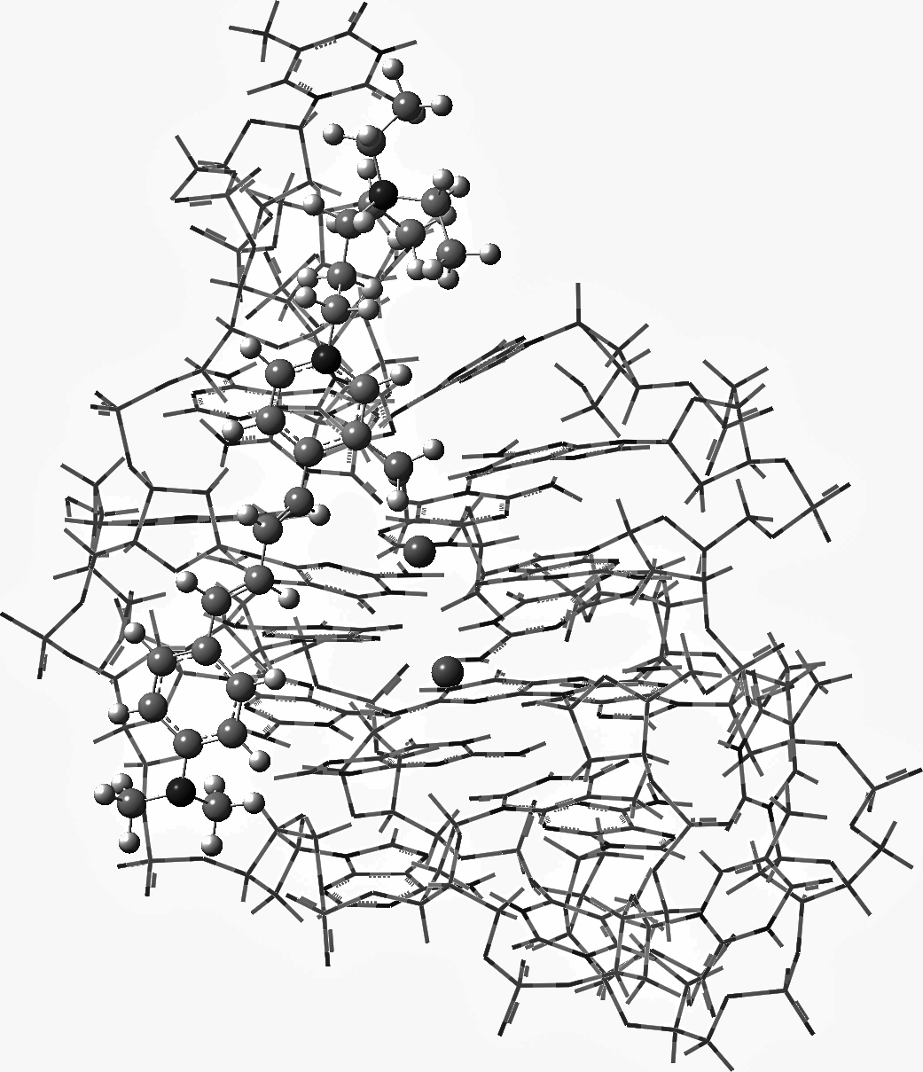
All calculations of G4-ligand complexes were carried out in water by semi-empirical PM7 method (MOPAC-2016 package) using COSMO solvent model. The structures and energetic parameters of complexes were obtained. Groove binding to antiparallel G4 was found to be the most energetically favored binding mode (Fig. 1). Less efficient ligand interaction with a parallel G4 DNA is realized mainly via the terminal π-stacking. The enthalpy of interaction (ΔΔH) of the most affine ligand DS6 with 143D and 1KF1 G4 structures is -62.77 and -55.76 kccal/mol, respectively. Modeling data will be used for the design of new G4 ligands as potent telomerase inhibitors and antitumor agents.

Fig. 1. The complex of antiparallel G4 Tel22 with compound DS6. Quadruplex is shown as a wireframe model, ligand atoms and Na⁺ cations as spheres.

- Neidle S. Quadruplex nucleic acids as targets for anticancer therapeutics // Nat Rev Chem.-2017.-1.-0041.

