Physico-Chemical nanomaterials science

Structure and properties of nanoscaled multifunctional layers based on guanidine derivatives
Vyshnevska Yu.P.1,2, Brazhnyk I.V.3
1 National Technical University of Ukraine "Igor Sikorsky Kyiv Polytechnic Institute".
37K20, Peremohy Ave., Kyiv, 03056, Ukraine.
E-mail: vishnevsk@ukr.net
2 Institute for Renewable Energy
20A, H. Khotkevych str., Kyiv, 02094, Ukraine.
3 Gimasi SA Ukraine R&D Centre
18, Via Luigi Lavizzari, Mendrisio, 6850, Switzerland.

The mechanism, preconditions and regularities of the phase layer formation in the presence of polyhexamethylene guanidine (PHMG) and polyhexamethylene biguanide (PHMB) involving the complexation process with the transition metal ions (Fe, Cu, Ni, Zn) have been investigated. Electrochemical behavior during formation of phase layers has been studied with linear sweep and cyclic voltammetry while the obtained films have been characterized using SEM, AFM, EIS, Auger spectroscopy as well as surface profiling using ion etching.
The typical thickness of PHMB-based films is usually two times lower than in the case of PHMG and lays in range of 30-40 nm in comparison to 50-90 nm of PHMB, while their morphology indicates the formation of dense layers with more uniform structure. Formed films have excellent barrier properties, are able to protect metal surface in various media and owing to biocide activity of PHMG and PHMB may serve as protective and multifunctional coatings.

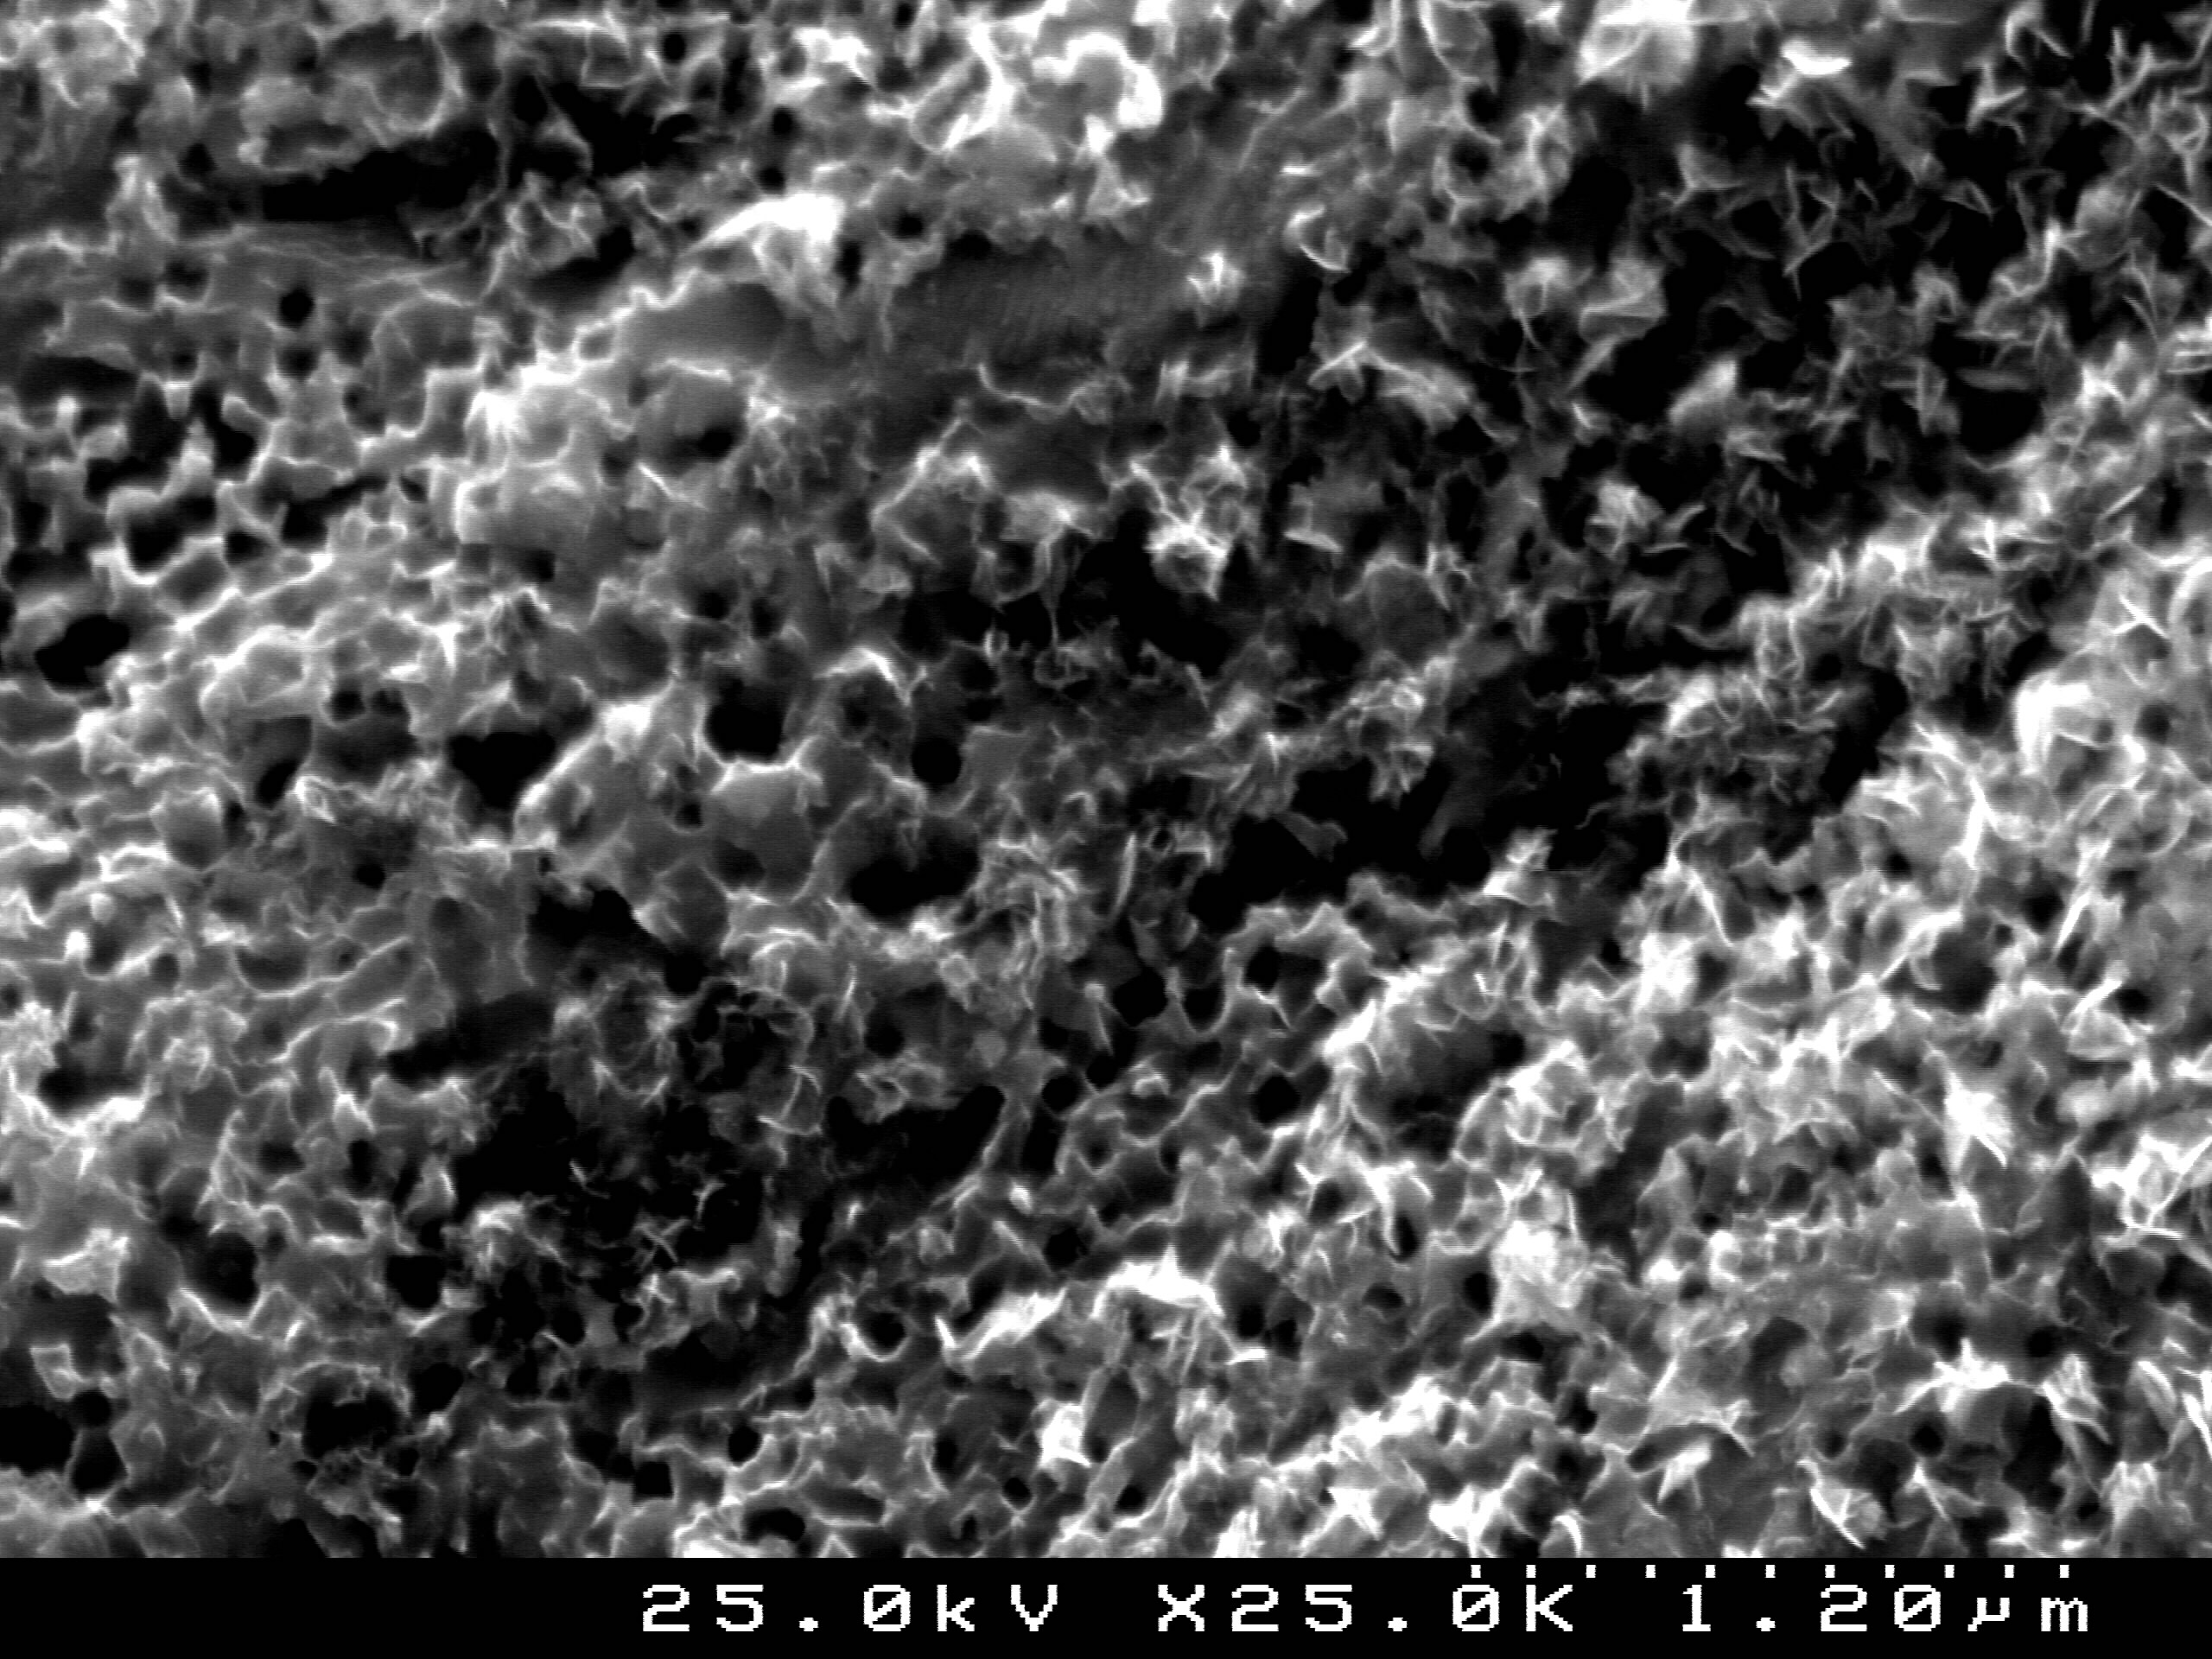
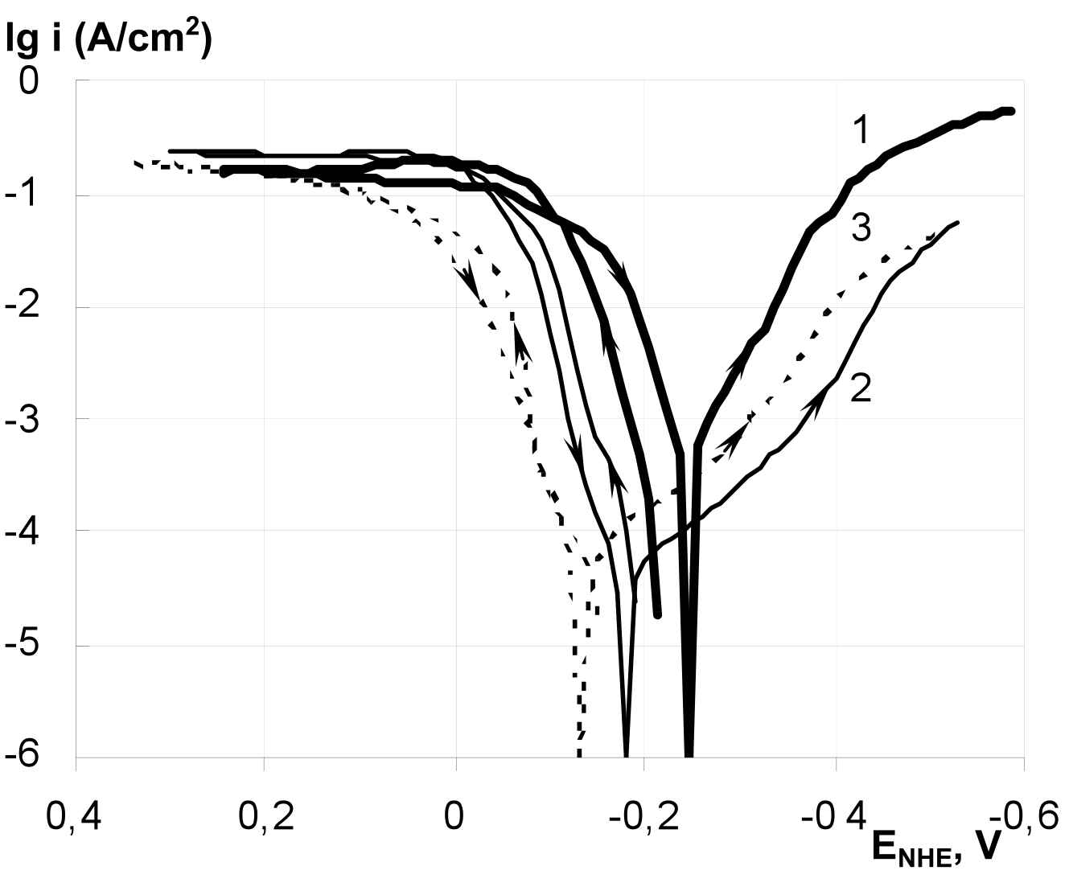
Fig. 1. Polarization curves of PHMG-Fe and PHMB-Fe systems in 0.5 M sulfuric acid solution a), and the morphology of formed PHMG-Fe complexes phase layer b).

