Nanocomposites and nanomaterials

Conductivity of nanocomposite SiOxNy and SiOxNyAlz films
Kizjak A.Yu.1, Evtukh A.A.1,2, Bratus’ O.L.1, Antonin S.V.1, Muriy Ya.2
1 V. Lashkaryov Institute of Semiconductor Physics, NAS of Ukraine 41, Nauky ave., 03028 Kyiv, Ukraine.
E-mail: antoninsv@gmail.com
2 Taras Shevchenko National University of Kyiv, Institute of High Technologies, 2 Glushkova avenue, Kiev, Ukraine.
Promising for the development of new types of turn-less inductors with controlled parameters that can be used in various integrated circuits are semiconductor-dielectric nanocomposite materials that fully fit into the principles of planar silicon technology. The purpose of this work is to study the mechanisms of conduction in planar semiconductor/SiOxNy nanostructures containing nanoparticles of Si (silicon) and oxidized metal (Al).
The films were deposited by ion-plasma sputtering, and the formation of structures and methods of their analysis are similar to those described in [1].
Based on the results of measurements, an analysis was carried out and the mechanisms of electrical conductivity of the obtained films were determined. Considerable attention is paid to a comparative analysis of the temperature dependence of the conductivity of SiOxNy and SiOxNyAlz films. For example, the temperature dependences of conductivity (Fig. 1) in the range of high voltages show that the type of annealing of SiOxNy films affects the character of conductivity, but not in SiOxNyAlz films.

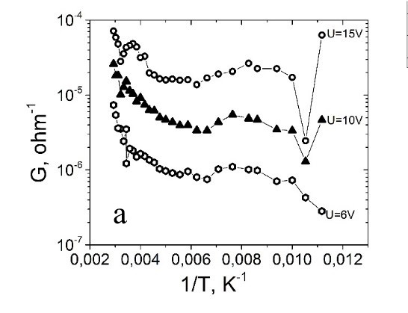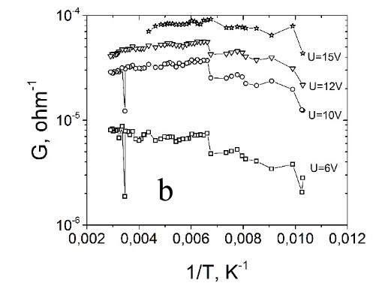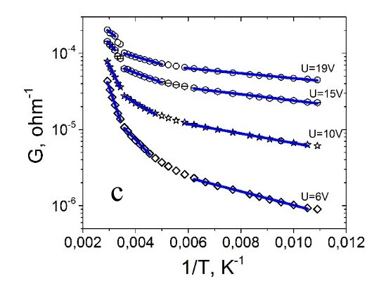
Fig.1 Reciprocal temperature dependence of conductivity for thin films: a) SiOxNy annealed in nitrogen, b) SiOxNy annealed in argon and c) SiOxNyAlz annealed in nitrogen.

- Kizjak A.Yu., Evtukh A.A., Bratus O.L., Antonin S.V., Ievtukh V.A., Pylypova O.V., Fedotov A.K. Electron transport through composite SiO2(Si)&FexOy(Fe) thin films containing Si and Fe nanoclusters // J. All. Comp.-2022.-903,-163892.

