**Nanoscale Physics**

**The effect of the pressure on electronic structure of the doped solid solutions ZnSeTe:T (T=Cr, Mn, Fe)**

**Syrotyuk S. V.1, Malyk O. P.1, Klysko Yu. V.1**

*1 Semiconductor Electronics Department, Lviv Polytechnic National University,*

*S. Bandera str., 12, Lviv-79013, Ukraine.*

*E-mail: svsnpe@gmail.com*

Here we evaluate the electronic structure taking into account the strong correlated 3d electrons of the Cr atom. The strong correlations are treated by means of the exchange-correlation functional PBE0. The obtained results are shown in Fig. 1. The calculations were done in the 64-atom supercell by means of ABINIT code [1].

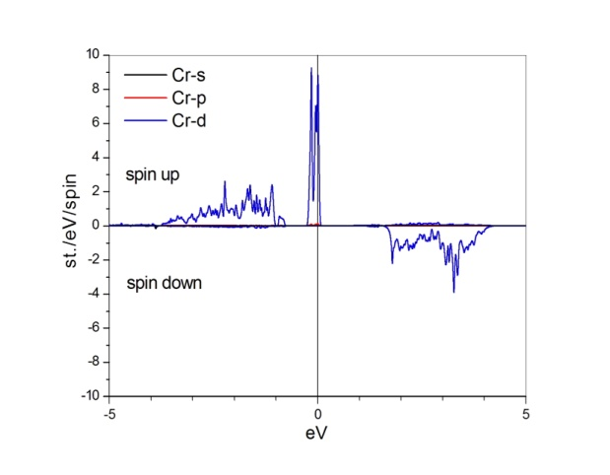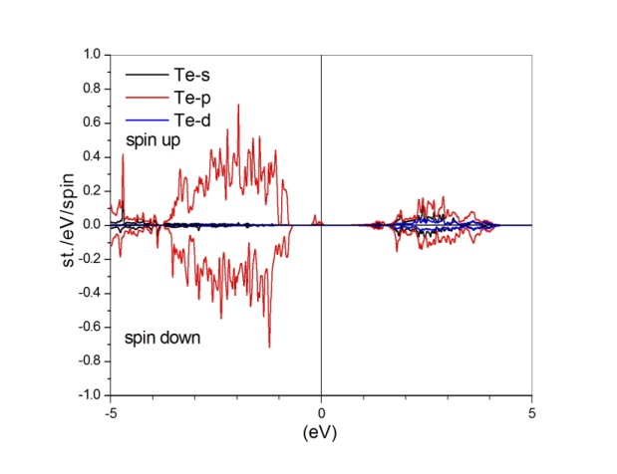

Fig. 1. Spin-resolved partial density of states of the solid solutions ZnSeTe:Cr, evaluated at ambient conditions. Fermi level is set at zero energy.

As can be seen from Fig. 1 the material ZnSeTe:Cr shows the metallic properties for the spin up and for the opposite spin it is the semiconductor. The magnetic moment of a supercell equals to 4.00 Bohr magnetons.

This contribution was created under the support of the High Performance Computing Laboratory at the Lviv Polytechnic National University.

1. *Gonze X., Jollet F., Abreu Araujo F., Adams D. et al.*, Recent developments in the ABINIT software package // Comput. Phys. Comm.-2016.-**205.-**P. 106-131.