Nanocomposites and nanomaterials

Novel Liquid Crystal System For Transdermal Drug Delivery
Kravchenko І.A. 1, Vashchenko O.V. 2, Nesterkina M.V. 1, Lisetski L.N.2
1 Odessa International Medical University, 99 Kanatna Street, Odessa 65000 Ukraine.
2 Institute for Scintillation Materials of NAS of Ukraine, 60 Nauky Ave. Kharkоv 61072, Ukraine.
E-mail: olga_v@isma.kharkov.ua

Liquid crystal systems loaded with monocyclic terpenoids (menthone, carvone, verbenone or camphor) are under development as potential anticonvulsant and anti-inflammatory drugs with transdermal delivery path [1].
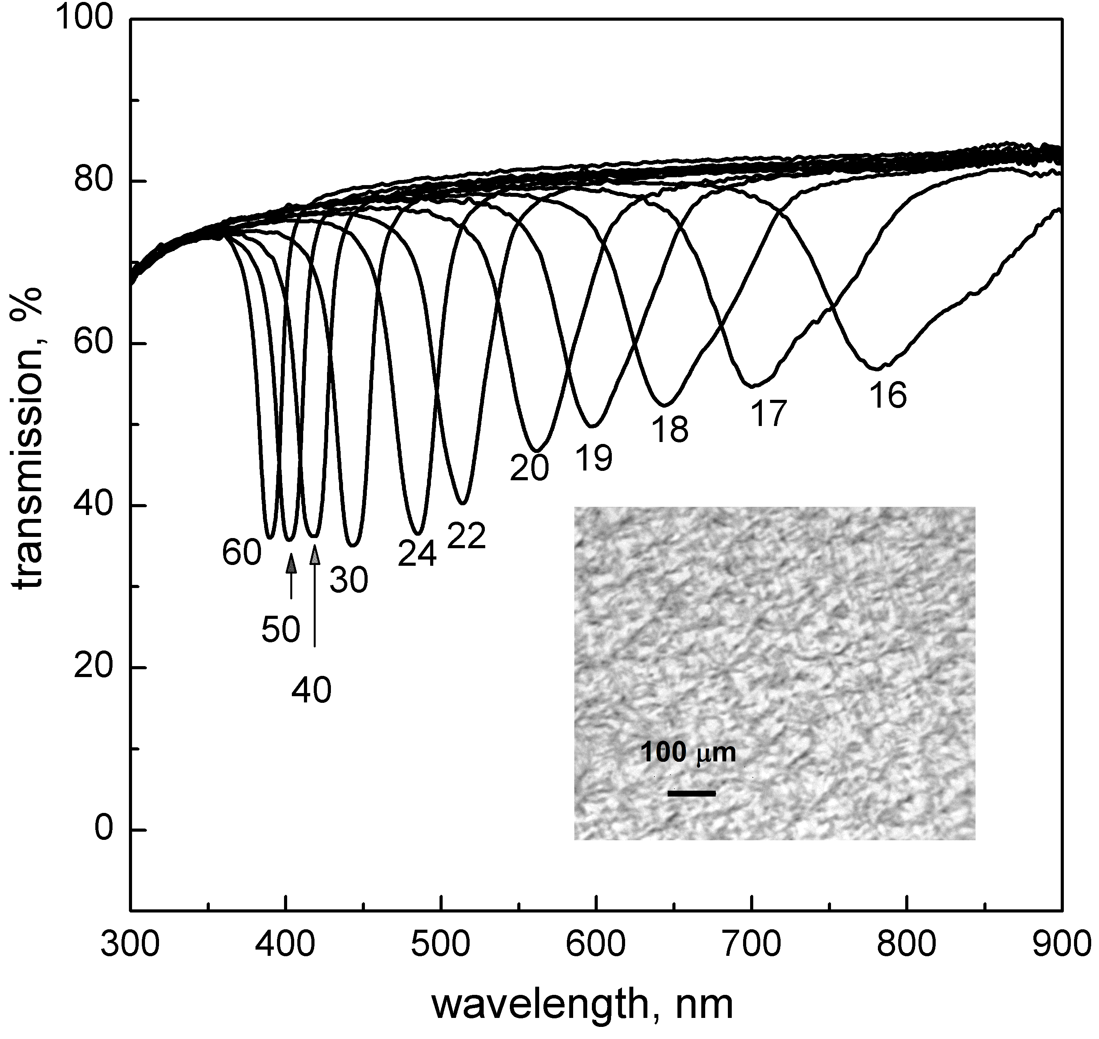
Fig. 1. A. Selective transmission spectra [2] of LC system loaded with menthone 5 % w/w. The numbers show the temperature (in ºC).
B: Microphotograph of the sample at 62 ºC
Maintenance of cholesteric liquid crystalline structure of the systems was proven in a wide temperature range (Fig. 2). Reliable drug deposition into the liquid crystal matrix was also shown. Model lipid membranes are used for biopharmaceutical studies of the drugs properties.
In a preliminary study, anticonvulsant activity was determined in vivo using the model of pentylenetetrazole-induced seizures after transdermal application of LC systems containing terpenoids. The obtained results indicate the high efficiency of the developed systems as transmembrane penetration enhancers possessing pharmacological action.

- Nesterkina M., Barbalat D., Konovalova I., Shishkina S., Atakay M., Salih B., Kravchenko I. Novel (‒)-carvone derivatives as potential anticonvulsant and analgesic agents // Nat Prod Res.-2021.-35(23).-P. 4978–4987.
- Chilaya G.S., Lisetski L.N. Helical twist in cholesteric mesophases // Sov Phys - Uspekhi.-1981.-24, N 6.-P. 496-510.

