**Nanostructured surfaces**

**Investigation mobility of current carriers from temperature for CdTe and PbTe thin films**

**Mazur M-Y.M.1, Mazur T.M.2, Mazur M.P.2**

*1* *National Technical University of Ukraine «Igor Sikorsky Kyiv Polytechnic Institute», Prosp. Peremohy, 37, Kyiv, Ukraine*

*2 Department of General and Applied Physics, Institute of Architecture, Construction and Energy, Ivano-Frankivsk National Technical University of Oil and Gas, Karpatska, 15, Ivano-Frankivsk-76019, Ukraine.*

*E-mail:* [*tetiana.mazur@nung.edu.ua*](mailto:tetiana.mazur@nung.edu.ua)

Promising materials for their creation of active elements of micro- and optoelectronics, such as sources of infrared radiation of the optical spectrum, detectors of X- and γ- radiation, thermoelectric energy converters, are films of cadmium and lead telluride [1]. In the study of transport phenomena in semiconductor films, the dependence of thickness properties is well known, due to the fact that, along with bulk mechanisms of current carrier scattering, processes on the surface play an important role. In addition, in a number of thin films, the scattering of current carriers on grain boundaries dominates, since the total surface of crystallites can exceed the film surface by several orders of magnitude.

Films were obtained by hot wall deposition on glass substrates according to [2]. The thickness of the films was determined by the spraying time. The structure of the films was studied by X-ray and electron microscopic methods. The electrical conductivity of the films was measured at direct current in the temperature range 77–300 K. All films, regardless of temperature and grain size, had hole conductivity. The main parameters that determine the grain size in thin films are the film thickness and the substrate temperature. By reducing the film thickness to 0.05 μm and reducing the substrate temperature to the temperature of liquid nitrogen, it is possible to obtain films with a grain size ≈ 2 10-7cm.

The structure of the films was studied by electron microscopy and diffraction, as well as optical metallography. The electrical parameters of the films were measured by the compensation method in constant electric and magnetic fields. The measurement was carried out on separate films of different thicknesses. The current through the samples was ≅ 0.1 mA. The magnetic field was directed perpendicular to the film surface at an induction of 0.8 Tesla. The measured sample had four Hall and two current contacts.

Based on the results obtained, it can be argued that certain activation energies are associated with potential barriers at grain boundaries, which lead to a decrease in hole mobility with decreasing temperature. It should be noted that the experimental results are in good agreement with the theoretical calculations of the effective value of mobility, which indicates the validity of the choice of a physical model for a nanostructured material. The decrease in carrier mobility due to scattering at barriers is the reason for the decrease in conductivity with decreasing temperature, Fig. 1.

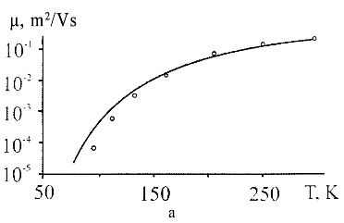 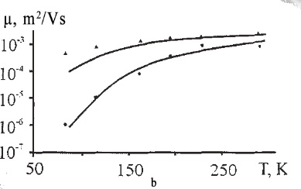

Fig. 1. Dependence of current carrier concentration on temperature for p-CdTe (a) (L=10-4 cm) and p-PbTe (b) thin films (1 – L=10-6 cm, 2 – L=10-7 cm) (points – experiment, solid line – calculation by formula)

Thus, in p-CdTe and p-PbTe films, the dominant role in transport phenomena is played by processes at grain boundaries associated with the formation of potential barriers and thermionic emission of current carriers.

1. *V.V. Prokopiv, et al* The Thermoelectric Solar Generator // Physics and chemistry of solid state, - 2017.- 372, Vol. 18, No 3. - *372*.

*2. D.M. Freik* *et al*, B. S. Dzundza, G. D. Mateik, Yu. V. Klanichka Charge Carrier Transport in Low-disperse Cadmium and Lead Tellurides Films // *Physics and chemistry of solid state, -* 2006. – 245, Vol. 7, №2. -245.