**Quantum –chemical portrait of the π-stacked complex of thiochrome and tryptophane**

***A.M.Gaponov, O. P.Dmytrenko, Kulish M.P., Pavlenko O.L., 1V.B. Neimash, 2O.D. Kachkovsky***

*Taras Shevchenko National University of Kyiv, 64/13 Volodymyrska Str. Kyiv,*

*E-mail: antongaponov@ukr.net*

*1 V.E. Lashkarev Institute of Semiconductors Physics, National Academy of Sciences, 45 Nauky Ave, Kyiv, Ukraine*

*2Institute of Bioorganic Chemistry and Petrochemistry, National Academy of Sciences, 1 Murmanska Str., Kyiv, Ukraine*

The aim of the work is to determine peculiarities of tryptophane -tiochrome interaction for case of their closest distance (so called π-π stacking, that equals 3,4 A for pure aromatic rings) that can be realized in protein-dye complexes.

The characteristics of the tryptophane -tiochrome complex compared to its independent constituents parts were studied by DFT method (basis set 3-21g, functional B3LYP) quantum-chemical methods in Gaussian -09 package. Obtained data (table 1) were compared to experimental absorption of films, prepared by vacuum evaporation (fig.1). The energies of the electron transitions were calculated with TD-SCF methods.

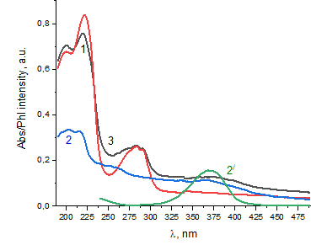 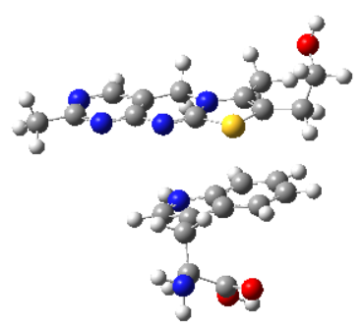

Fig.1. Absorption spectra of films, prepared by vacuum evaporation on quarts substrate of pure powders of: 1 – tryptophan, 2 –thiochrome, (2/ - absorption of water dissolved thiochrome), 3 – thiochrome, tryptophan, layer by layer.

Table 1. Maxima of the absorption,in nm

|  |  |  |  |
| --- | --- | --- | --- |
|  | Trp | Thio | Complex |
| Experimental | 283 | 370 | 384 |
| TD SCF | 260 | 325 | 345 |

The red shift, observed experimentally for the complex clearly shows TD SCF, therefore, this method can be used for further analysis of the system.