**Antimicrobial properties of nanocomposite biomaterial for the treatment of purulent wounds and infected ulcers.**

Sukhodub L.F.,Kumeda M.O., Derevianko V.G., Sukhodub L.B.

Sumy State University

One of the important problems of modern surgery is the treatment of trophic ulcers of venous origin, which affect up to 3% of the population of industrialized countries. No less important is the issue of the ever-increasing resistance of microbial cells that contribute to the development of purulent-inflammatory processes to antibacterial drugs. All this encourages the search for new methods and materials for the treatment of purulent-inflammatory diseases without the use of antibiotics or with restrictions on their use, which determines the relevance of this problem. The proposed antiseptic biocomposite scaffolds can potentially be used for the treatment of patients suffering from purulent wounds and infected ulcers of the lower extremities of venous or arterial origin, including microcirculation disorders in diabetes. The apatite-polymer scaffold is a macroporous three-dimensional network formed by the polyelectrolyte interaction between macromolecules of polymers of natural origin - sodium alginate (Alg) and chitosan (CS), in the pores of which immobilized particles of calcium deficiency hydroxyapatite. The surface chitosan layer of the scaffold is additionally doped with divalent metal ions Ca2+, Zn2+, Mg2+, Cu2+, and Fe2+, which form chelate complexes with CS and have enhanced antimicrobial action [1]. The figure shows the antimicrobial action of scaffolds containing metal ions in the form of growth inhibition zones of Gram-positive S. Aureus ATCC 25923 and Gram-negative E. coli ATCC 25922 microorganisms. To assess the antiseptic ability of experimental samples against the studied test strains of microorganisms, the calculation of the integrated indicator (A) of their antimicrobial activity was performed [2]. The applied vector theory allowed to present A as a vector in *n*-dimensional space with coordinates in the form of a zone of growth inhibition for each test microorganism. The results showed that the value of A for samples containing ions Ca2+, Zn2+, Mg2 +, Cu2+, Fe2+ is 1.85, 2.08, 1.1, 1.9, 1.65, respectively. Thus, according to the guidelines with an efficiency range of more than 1.5, all samples, except Mg2+ - containing, are those that show average antimicrobial activity, and Zn2+ - close to Chlorhexidine (2.07).

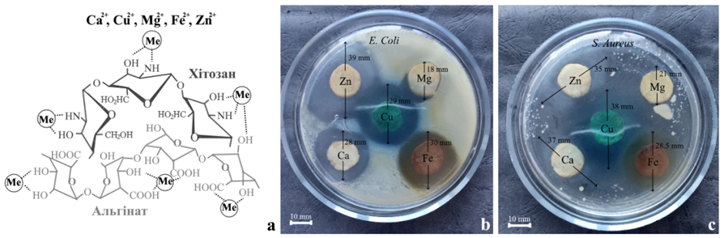

Figure - a) scheme of interaction of polymer macromolecules with metals; b, c) the results of the study of antimicrobial activity of experimental samples.

1. L.B. Sukhodub, Metal Ions Doped Chitosan Nanoparticles. JOURNAL OF NANO- AND ELECTRONIC PHYSICS Vol. 6 No 4, 04034(6pp) (2014)
2. MES of Ukraine, NAMSU "Methods of calculating integrated indicators of antimicrobial activity of antibacterial drugs. Methodical recommendations. (79.15 / 02.16), 29p.