CFD simulation of transient boiling regime for overheated water and nanofluids
Strativnov E.¹, Nie Gunochao².
¹Gas Institute of National Academy of Science of Ukraine, 39 Degtyarivska str., Kyiv-03113, Ukraine.
²School of Physics and Telecommunication Engineering, Yulin Normal University, Yulin 537000, China.
estrativnov@gmail.com

In this paper, we consider the transient mode (its CFD simulation) when hot body are cooling by liquid and nanofluids, an experiment on which was carried out by colleagues from Cambridge and described in article [1]. The following goals were pursued in the work:
1 - Identification of decisive factors affecting the nature of boiling and the transition regime (temperature-dependent properties of water, steam [2] and solid [3]).
2 - Modeling nanofluids by adjusting the water properties according to the empirical formulas described in [4, 5].
3 - Simulation as accurately as possible the phase transition process when cooling a smooth and rough heated body using the water and nanofluids.
4 - Description of technical issues related to the modeling process in ANSYS (Fluent) such as: features of building a grid model for solving non-stationary problems with a phase interface, selection and adjustment of models of boiling, turbulence, the mechanism of phase transformations, surface tension [6] e.t.c.
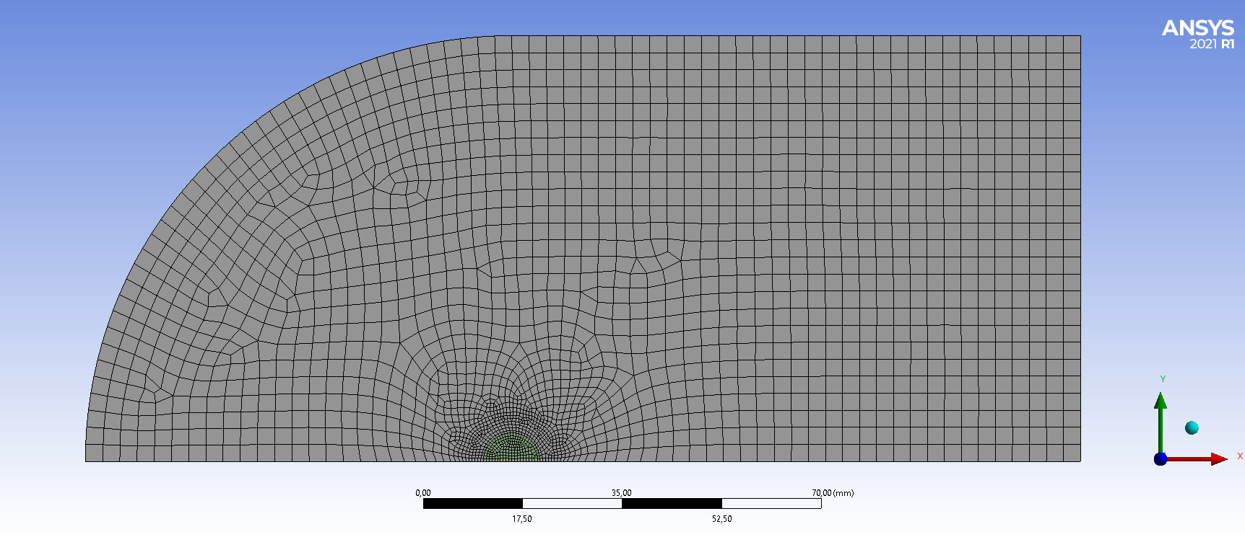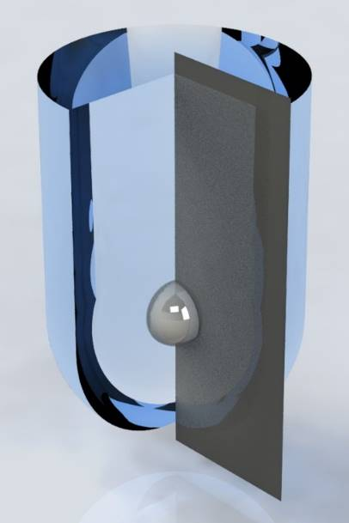
- b)
Fig. 1 – Mash and calculation domain.

The problem solved in a plane axisymmetric setting (fig. 1 a). This simplification is because the factors causing the corresponding physical phenomena at each moment of time along the vertical axis are identical. Physical phenomena, however, are relatively chaotic and in practice at each moment of time do not correspond to the conditions that cause them. At this stage of the study, we accept this assumption since it (presumably) does not significantly affect the result. The mesh is compacted at the interface between the solid and liquid substances (fig. 1, b) because of the phenomena of interest to us occur in this place. The size of the cell should be commensurate with the minimum size of the vapor bubbles.

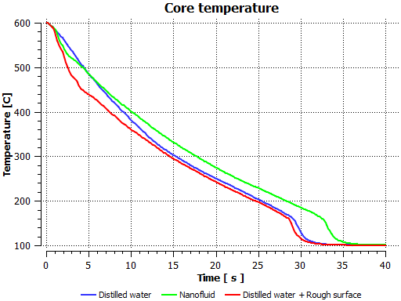

Fig. 2 – Cooling graphs for DW, TiO₂ based nanofluid and DW with nanostructured surfaces (roughness 1e-8).

These graphs (fig. 2) correlate well with the data obtained experimentally. They have a very similar shape and slope, which indicates the correct operation of the calculation model.

References

[1] H. Kim, G. DeWitt, T. McKrell, J. Buongiorno, and L. Hu, “On the quenching of steel and zircaloy spheres in water-based nanofluids with alumina, silica and diamond nanoparticles,” Int. J. Multiph. Flow, vol. 35, no. 5, pp. 427–438, May 2009, doi: 10.1016/j.ijmultiphaseflow.2009.02.004.
[2] S. Rivkin, A. Alexandrov, Thermodynamic properties of water and steam. Directory, Energoatom typography, 1984, 80 p
[3] V. Zinoviev, Thermophysical properties of metals at high temperatures. Directory, Metalurgy, Moscow, 1989, 385 p
[4] W. Duangthongsuk, S. Wongwises, Measurement of temperature-dependent thermal conductivity and viscosity of TiO2-water nanofluids, Exp. Thermal Fluid Sci. 33 (2009) 706–714.
[5] R.A. Arul Raja1, J. Sunil, Estimation of Thermal Conductivity of Nanofluids Using Theoretical Correlations, International Journal of Applied Engineering Research ISSN 0973-4562 Volume 13, Number 10 (2018) pp. 7932-7936
[6] N. Vargaftik, B, Volkov, L. Voljak, International Tables of the Surface Tension of Water, J. Phys. Chem. Ref. Data 12, 817 (1983). (Rus)

