Nanocomposites and nanomaterials

Green synthesized silver nanoparticles: characterization of structural, catalytic degradation activities and antibacterial properties
Vorobyova V.I.1, Vasyliev, G. S.1, Skiba M.I.2, Kyrii S.O.1, Sirenko S.O.1
1 National Technical University of Ukraine “Igor Sikorsky Kyiv Polytechnic Institute”. Prosp. Peremohy-03056, 37, Kyiv, Ukraine.
E-mail: sveta.sirenko@gmail.com
Grape pomace extract mediated silver nanoparticles (GPE-AgNPs) were synthesized by bio-reduction of silver ions using grape pomace extract and characterized using UV-Vis, DLS, and FTIR. The obtained particles were crystalline, round-shaped, monodisperse and stable. The achieved results indicate that silver nanoparticles varied in size with an average size of 45 nm. Synthesized GPE-AgNPs showed significant catalytic, antimicrobial and antioxidant (DPPH radical scavenging method) activities.

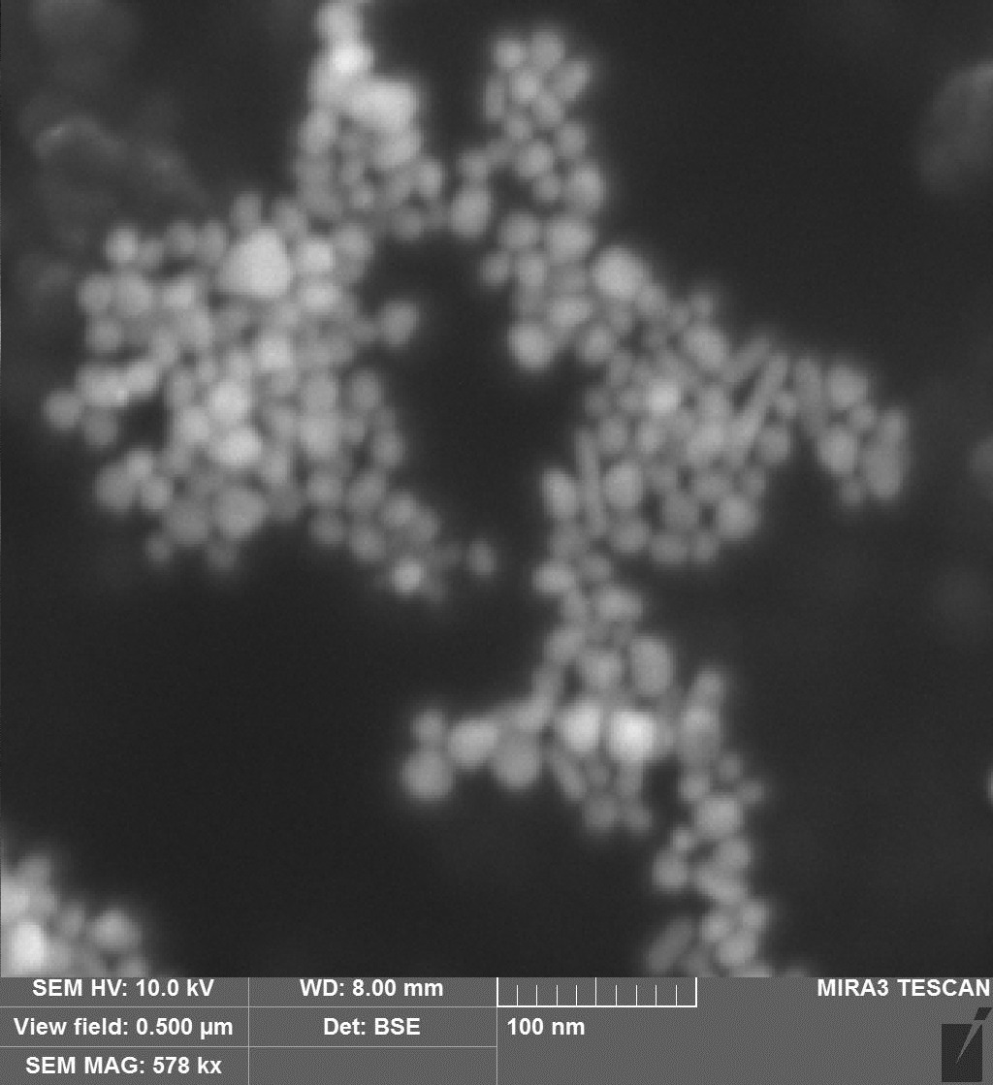 | 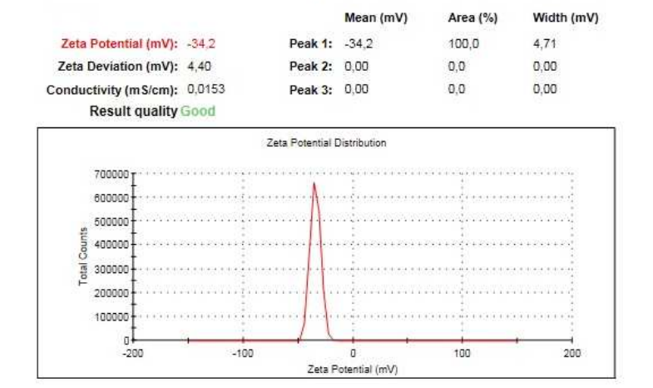  Zeta potentialf of AgNPs conjugated with GPE
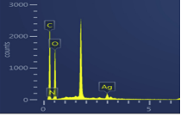
SEM morphology and EDAX spectrum

