

(High Resolution)

Title: Wearable Healthcare Devices (Smart and Tinted Contact Lenses)

*Haider Butt*

Department of Mechanical Engineering, Khalifa University, Abu Dhabi, UAE

Phone Number: +971 2 312 4457

**Abstract:**

One of the key challenges in producing nanostructures based commercial healthcare applications is the scaling up of the fabrication process. We present the fabrication of dye based nanostructures by using the fast and commercially viable method of holographic laser ablation. In this method we use a single beam of a nanosecond laser, which after reflecting from a mirror self-interferes. This results in an interference pattern which can be used to ablate well-ordered gratings in thin films. The period of the grating is determined by the incident wavelength (λ) and tilt angle (θ) of the sample with respect to normal incidence. In this manner we recorded various holographic nanopatterns onto transparent substrates, such as glasses and commercial contact lenses (Fig. 1). Using this quick, scale and economical method we produced several wearable contact lens sensors. 1,2 These contact lens based holographic sensors can be used for monitoring the eye curvature and pressure of glaucoma patients. The holograms can also be functionalized to sense glucose concentrations in the tears of diabetic patients. The findings have been reported in highly reputable journals 1,2 and have also received a lot of media attention. The approach was also extended into 3D patterning by ablating 3D assemblies of Ag nanoparticles within polymer media.3 Through laser ablation, ordered 3D geometries/patterns were written within the polymer layers. These reconfigurable geometries act as holographically recorded optical devices.

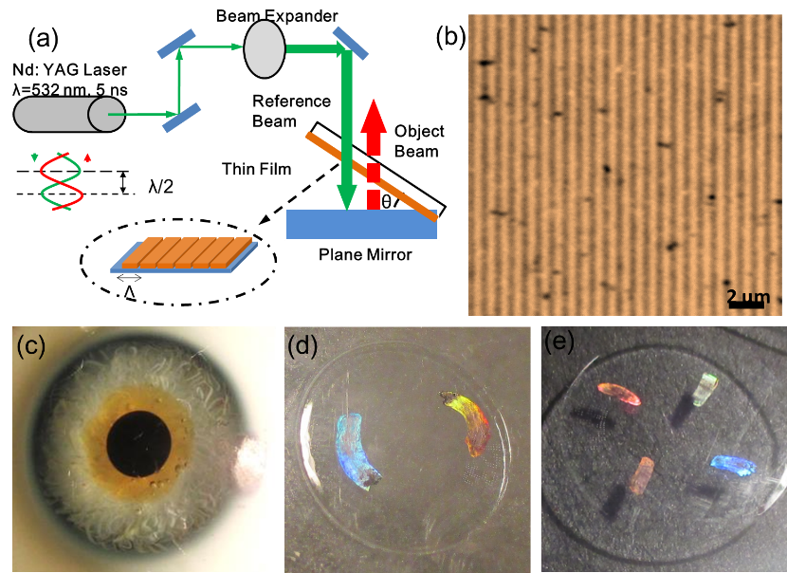

Figure 1: (a) Holographic laser ablation process, (b) the nonpatterns produced, (c-e) holograms printed on commercial contact lenses.

**Biography:**

Dr. Haider Butt did his M.Phil. in Electrical Engineering from the University of Cambridge in 2008, followed by a PhD in Nanophotonics in 2012. In 2013, he was appointed as a Lecturer of Nanotechnology at the Department of Mechanical Engineering, University of Birmingham, UK. He was promoted to Senior Lecturer in 2016 and was appointed as the Senior Admissions Tutor for Mechanical Engineering in 2017. He joined Khalifa University as an Associate Professor in Mechanical Engineering in 2019. He has published over 140 peer-reviewed articles in prestigious journals including Nature Communications, Advanced Materials, Biotechnology Advances, Light Science and Applications, and ACS Nano. He has earned international recognition for his research and leadership in optical sensors where he has contributions to nanoscale devices by conceiving novel holographic lithography methods to produce optical transducers. Dr. Butt is a Chartered Engineer by the Institution of Mechanical Engineers, London, UK. He is a Fellow of Higher Education Academy and holds life fellowships of Cambridge Philosophical Society, Hughes Hall College, (University of Cambridge), and Wolfson College (University of Cambridge). He is an acting co-editor of the Sensors journal.

**Presenting author details**Full name: Haider Butt  
Contact number: +971 2 312 4457  
Session name/ number:  
Category: (Oral presentation)