Nanocomposites and nanomaterials
Predicting limits of isomorphous substitutions and stability of solid solutions with the YF₃ structure in the Lu_{1–x}Ln_{x}F₃ (Ln=Sm–Yb) systems

Get’man E.I.¹, Oleksii Yu.A.¹, Ardanova L.I.^{2,}*, Radio S.V.^{1,}*

¹ Vasyl' Stus Donetsk National University, Vinnytsia, 21027 Ukraine
² Minnesota State University, Mankato, Minnesota, 56001 USA
* e-mail: radio@donnu.edu.ua, lyudmyla.stackpool@mnsu.edu
Solid solutions of rare earth elements (REEs) trifluorides are being intensively studied since they can find practical application as materials for phosphors, lasers, scintillators, displays, light sources, catalysts, ionic conductors, fibre-optic amplifiers. It is possible to use trifluorides for microelectronics, analytical chemistry, the technology of separation of elements, regeneration, purification and disposal of nuclear materials. In recent years, work on their application in the form of nanomaterials in medicine as optical 3D devices and probes for visualizing biological objects, for intracellular labels or measurements, and for immunoassays has become relevant.
Using the crystal-chemical energy method of V.S. Urusov in the approximation of regular solid solutions, the mixing energies, critical temperatures and temperatures of decomposition (T_{d}) of solid solutions in Lu_{1–x}Ln_{x}F₃ systems (Ln = Sm–Yb) are calculated (see Fig.).
With an increase in the REE number, the mixing energies and the critical decomposition temperatures of solid solutions regularly decrease from ~21 to ~0.5 kJ/mol and from 1240 to ~30 K, respectively, which is due to a decrease in the ionic radii of REEs in the series from Sm to Yb.  The built diagram for the Lu_{1–x}Ln_{x}F₃ systems, where Ln = Sm–Yb, allows one to estimate the thermodynamic stability of solid solutions in a wide range of compositions and temperatures and to predict the substitution limits for limited series of solid solutions at a given T_{d}, or their T_{d} at a given limit of substitution. | 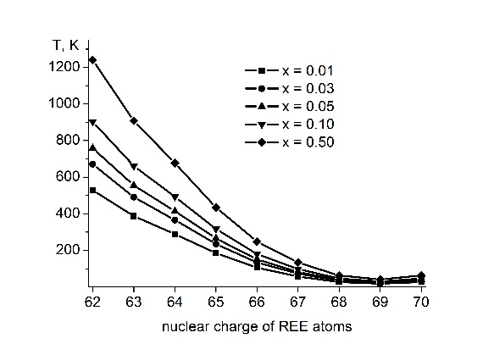  Fig. Dependences of the calculated T_{d} for Lu_{1–x}Ln_{x}F₃ solid solutions from the REE number (diagram of the thermodynamic stability of solid solutions).

