Physico-Chemical Properties of Fluorinated Oligo(azomethine)s with Azo Groups in the Main Chain
I. Tkachenko ¹, Yu. Kurioz ², A. Kovalchuk ¹, Ya. Kobzar ¹, O. Shekera ¹, R. Kravchuk ², V. Nazarenko ², V. Shevchenko¹

¹Institute of Macromolecular Chemistry NAS, Kharkiv. Sh. 48, Kyiv, Ukraine
²Institute of Physics NAS, Prospekt Nauky 46, Kyiv, Ukraine
e-mail: kurioz@hotmail.com

Stimuli-responsive materials based on photochromic switches (azobenzenes, diarylethenes, spiropyrans, azomethines) have attracted increasing attention due to their possible use in data storage devices, sensors, photoresponsive molecular switches, studies of surface phenomena, etc. Recently, a specific attention is drawn to the polymer-based materials having both azo and azomethine groups. Generally, insufficient solubility appeared to be a major drawback for such polymers, especially of fully aromatic. One of the possible ways for solving the problem is an obtaining of azo-azomethine compounds of oligomeric nature with additional flexible ether linkages. Moreover, the introduction of fluorinated units into the structure of such compounds allows upgrading their optical and electro-optical properties (particularly to reduce refractive index and optical losses, to increase hyperpolarization) [1].
Herein, we report the synthesis and optical behavior of photoactive fluorinated azo-based oligo(azomethine)s (Azo-Oam):
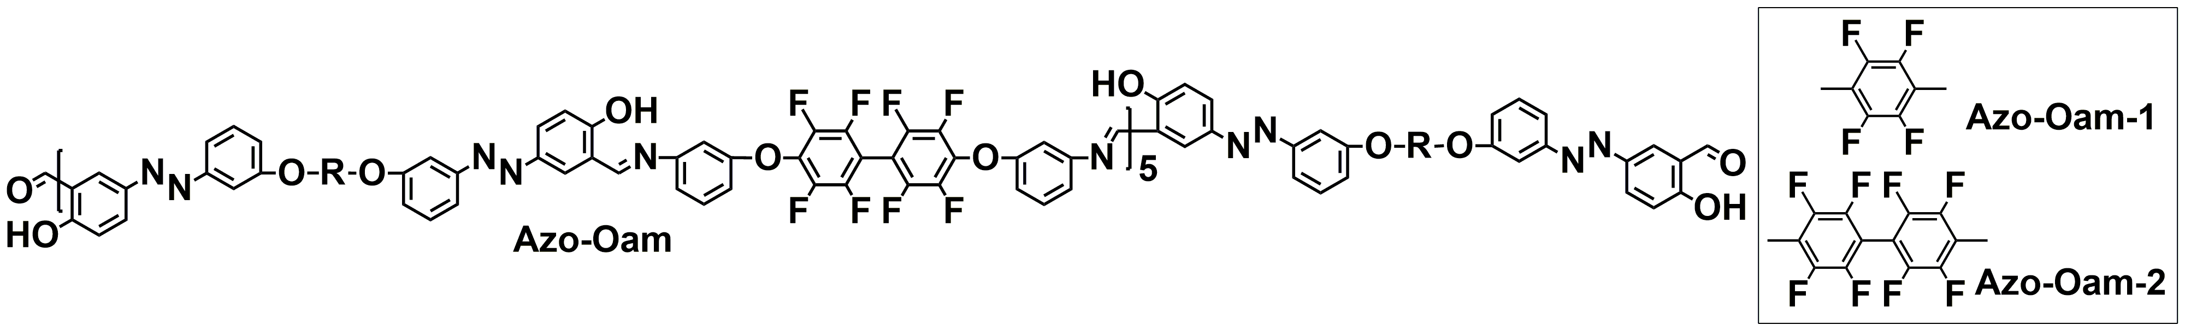
The desired oligomers were prepared by polycondensation of octaﬂuorobiphenylene-containing diamine with excess of tetraﬂuorobenzene- or octaﬂuorobiphenylene-based bis-hydroxybenzaldehydes. The repeating unit of the oligomers was targeted as n=5 by controlling the molar ratio of initial monomers. Importantly, the oligomers can be solution cast into ﬂexible solid ﬁlms with tensile strength of about 20 MPa. The studied Azo-Oam showed a remarkable response to both optical and chemical stimuli. Thus, the trans-cis photoisomerization of azobenzene units occurs in Azo-Oam solid films as well as absorption maxima of the obtained oligomers can be regulated by changing the pH of a medium and a solvent concentration. It was studied that the irradiation of the synthesized oligomers leads to the emergence of birefringence in their films. The highly stable diffraction gratings based on Azo-Oam`s films were fabricated which can be stored for the long time.

1. Kovalchuk A. et. al.//ACS Applied Polymer Materials.-2020.-2.- P.455-463.

