## Nanotechnology for health protection

**Bioconjugates of nanogold with *Chlorella v.* polysaccharides   
selectively inactivate leukemia cells**

**Oliinyk A.I.1, Skivka L.M.2, Litvin P.M.3, Fesenko O.M.4 Tregubova N.A.5, Estrela-Llopis V.R.1**

*1 F.D.Ovcharenko Institute of Biocolloid Chemistry  NAS of Ukraine*

*2Taras Shevchenko Kyiv National University, Kyiv, Ukraine*

*3  V.Lashkaryov Institute of Semiconductor Physics NAS of Ukraine*

*4 Institute of Physics NAS of Ukraine*

*5RE. Kavetsky Institute of Experimental Pathology, Oncology and Radiobiology NAS of Ukraine*

Significant side effects of existing chemotherapeutic treatments necessitate the search and the development of a fundamentally new methodological approaches to solve the problem of the effective treatment of oncology patients. Engineering of nanoparticles is one of the most promising such approaches in biomedicine1.2

The report presents the results of the study of the effect of synthesized nanogold bioconjugates with adsorbed polysaccharides of microalgae (BCAuPS) on human leukemia cancer cells lines *Jurkat* and myeloid lineage cells U937 and, in comparison - on peripheral blood mononuclear leukocytes (PBML) isolated from healthy adult.

The optimal conditions for the synthesis of NP AuPS3 have been determined by studying the PS adsorption isotherm on NP and the effect of such adsorption on their ζ-potential. The size distribution of NP AuPS (around 30 nm) was determined by TEM and AFM. By FTIR spectroscopy it was shown that the interaction of NP Au and PS occurs mainly at carboxyl groups. Based on the proposed in the laboratory complex of studies of the heterocoagulation of BC with cancer cells, the kinetics of this process and the corresponding kinetics of the cytotoxic effect were established**:** *first,* the very fact of the cytotoxic effect of BC AuPS on leukemia cells; secondly, the minimum concentrations of these nanoforms to achieve a toxic effect (~ 40 μg / cm3 on gold per 5 ٠105 cells / cm3) for 30 min of contact, and thirdly.

Cell viability assay after treatment with nanoparticles was determined by the MTT test. **Cell apoptosis assay** was assessed by staining cells with Annexin V– and counterstaining with propidium iodide (PI). **Intracellular reactive oxygen species** (ROS) levels were measured with the use of 2'7'-dichlorodihydro- fluorescein diacetate (carboxy-H2DCFDA, Invitrogen), which is converted into a non–fluorescent derivative (carboxy-H2DCF). The short time kinetics of cells viability determined by the tripan blue test.

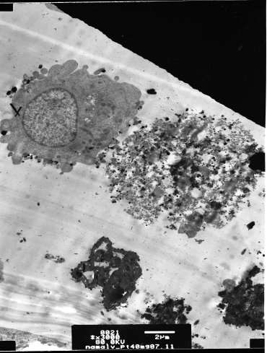 It was shown that Jurkat and U937 cells were substantially more sensitive to the cytotoxic effect BCAuPS than PBML and monocytes from healthy volunteers. The total number of dead Jurkat cells after the treatment with BCAuPS was 67% vs 32% in the samples of PBML from healthy person, and 63% of dead U937 cells were registered vs 44% in the samples of healthy monocytes. Non-functionalized Au nanoparticles were equally toxic for normal cells and induced death of about 30% monocytes and PBML. All cells treated by BCAuPS as well as non-functionalized nanogold and polysaccharides only demonstrated a pronounced increase in ROS production compared to untreated cells. But it was shown that the toxic effect of BC AuPS is greatest on blood cancer cells Jurkat compared with normal lymphocytes.

The obtained results demonstrate promising for the application of NP AuPS in the treatment of leukemia.

Fig 1. Leucemia cells Namalva line after 30 min. contact time with BC AuPC

1. H. [Sharma](http://www.ncbi.nlm.nih.gov/pubmed/?term=Sharma%20H%5BAuthor%5D&cauthor=true&cauthor_uid=26007605), P.K. [Mishra](http://www.ncbi.nlm.nih.gov/pubmed/?term=Mishra%20PK%5BAuthor%5D&cauthor=true&cauthor_uid=26007605), S. [Talegaonkar](http://www.ncbi.nlm.nih.gov/pubmed/?term=Talegaonkar%20S%5BAuthor%5D&cauthor=true&cauthor_uid=26007605), B. [Vaidya](http://www.ncbi.nlm.nih.gov/pubmed/?term=Vaidya%20B%5BAuthor%5D&cauthor=true&cauthor_uid=26007605), Metal nanoparticles: a theranostic nanotool against cancer, [Drug Discov Today](http://www.ncbi.nlm.nih.gov/pubmed/26007605), 20(9) (2015), 1143-1151.

2. V. [Krishnan](http://www.ncbi.nlm.nih.gov/pubmed/?term=Krishnan%20V%5BAuthor%5D&cauthor=true&cauthor_uid=24013811), A. K. [Rajasekaran](http://www.ncbi.nlm.nih.gov/pubmed/?term=Rajasekaran%20AK%5BAuthor%5D&cauthor=true&cauthor_uid=24013811), Clinical nanomedicine: a solution to the chemotherapy conundrum in pediatric leukemia therapy, [Clin Pharmacol Ther.](http://www.ncbi.nlm.nih.gov/pubmed/24013811), 95(2) (2014), 168-178.