THE POINT-CONTACT CYCLIC SWITCHOVER EFFECT INVESTIGATION
Pospelov Alexander, Member of Junior Academy of Sciences of Ukraine, Kharkov, Ukraine
posp.alex.elov@gmail.com
Gennadii V.Kamarchuk, Ph.D., Dr. Sc. Head of Department for Spectroscopy of Molecular Systems and Nanostructured Materials, B.I.Verkin Institute for Low Temperature Physics and Engineering National Academy of Sciences of Ukraine

1. Introduction
The ever-increasing level of anthropogenic pressure on the environment has led to an urgent need for its perfect and prompt monitoring. The problem of air monitoring is one of the main ones, as it is known that the spread of gaseous compounds is most intense
The latest research into nanostructures has shown that the use of point contacts in gas sensors can notably decrease their sizes and make them able to perform comprehensive analysis of complex gas mixtures. The most promisisng point contacts are the dendritic Yanson ones [1]
So, the objectives of this investigation were to form dendritic tin Yanson point contacts, to obtain the cyclic switchover effect in the stannum-based electrochemical system and to study its parameters.
In contrary to the earlier papers, in this work the point contacts were made of tin. Considering also the widespread use of that material in analysis of gaseous media, gas sensors based on tin Yanson point contacts will have much better characteristics, comparing to the existing one

2. Materials and methods
In my experiments I fabricated dendritic tin Yanson point contacts using the modified “needle−anvil” technique where a needle shaped tin wire (cathode) and a tin lamellar anode of 20x20 mm were used (fig. 1)
For the measurements I used the system of devices, which allowed controlling parameters of the studied process, simultaneously measuring and recording the current–voltage characteristics of point contacts
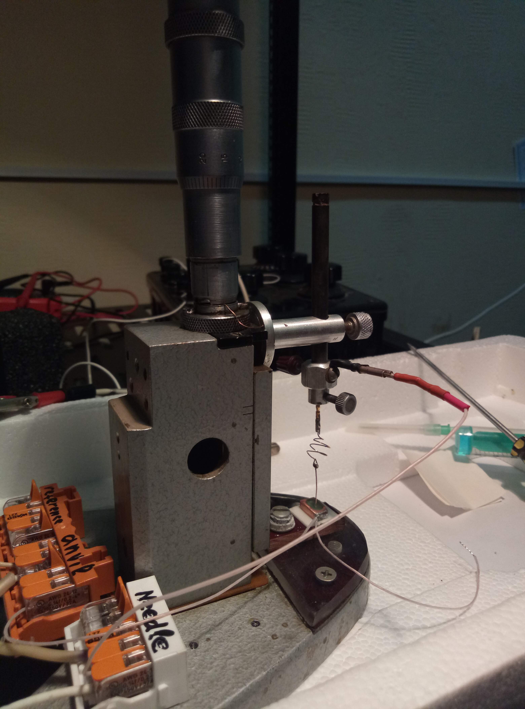
Fig. 1. The device for obtaining dendritic Yanson point
contacts

3. Results and discussion
Among the data of the experiments two resistance R versus time t dependences taking place in the system of a dendrite point contact immersed in the electrolyte were highlighted. Those dependences are represented on the figure 2
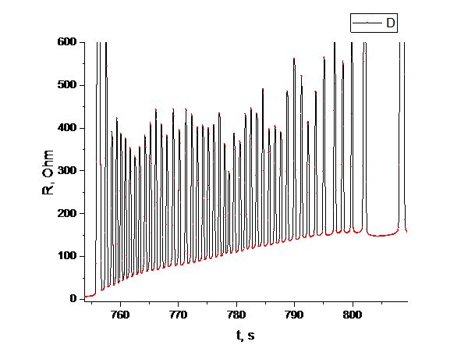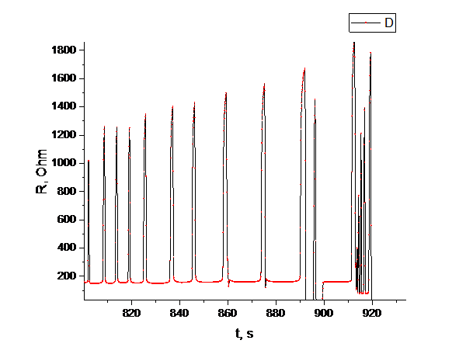
a)
b)
Fig. 2. The phases of self-oscillating switchover process:
a) of constant frequency, b) of increasing the dendritic structure lifetime
Due to the high stability of the switchover (fig. 2, a) was assumed that the single dendrite is responsible for the phase of self-oscillating switchover process of constant frequency. The dependence of the tin point contact conduction channel diameter on their resistance during that process is expressed by the relation d≈35⁄√R [nm]
The case of the self-oscillating switchover process in the phase of increasing the lifetime of the dendritic structure (fig. 2, b) consists of the polydendritic switchover. The monotonic increasing of lifetime of polydendritic structures is caused by the separate dendrites’ small sizes and high level of free surface energy. It leads to the interacting between dissolution centers of tin and the oxygen from electrolyte and the point contact passivation

4. Conclusions
The cyclic switchover effect in the tin-based electrochemical system was observed for the first time. The ability of the obtaining of such an effect opens wide prospects for creation of high sensitivity gas sensors [2]
The proposed mathematical and theoretical models of dendritic Yanson point contacts behavior during the self-oscillating switchover process helps to understand the nature of such structures what is necessary in case of its studying as sensitive elements for gas sensors
One of the most important points of my work is that the self-oscillating switchover process of constant frequency was reached for the first time. This phenomenon is characterizing point contacts with certain properties, as the frequency of switchover is constant. So subject to the further theoretical development, it can give rise to a new physicochemical characteristic of metal nanostructures

5. References
1. Pospelov A. P, Pilipenko A. I, Kamarchuk G. V, Fisun V. V, Yanson I. K and Faulques E.C. J. Phys. Chem. C, 2015, 119, pp. 632-39
2. Kamarchuk GV, Pospelov AP, Savytskyi AV, Herus AO, Doronin YuS, Vakula VL, Faulques E (2019) Conductance quantization as a new selective sensing mechanism in dendritic point contacts. SN Appl Sci 1:244

