LOCAL MODES and LOCAL RESONANCES in PHOTONIC STRUCTURES CONTAINING DOUBLED DEFECT: APPLICATIONS
Glushko, E. Ya

Semiconductor Photonic Structures Lab., Institute of Semiconductor Physics of NAS of Ukraine, Nauki Prsp., 45, Kyiv -03028, scientist.com_eugene.glushko@mail.com

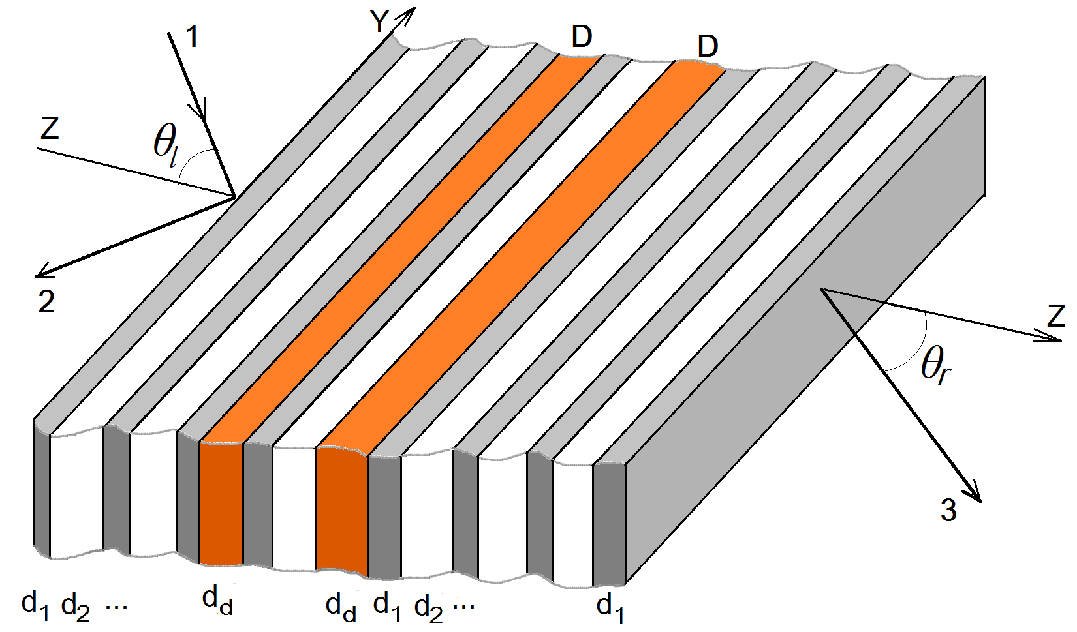
Fig. 1. A planar layered photonic crystal resonator containing two symmetrically situating defect layers. 4, input prism, 1, 2, incident and reflected beams in the external geometry of incidence, 3, transmitted beam, D, defect layer, θ_{l}, incident angle, θ_{r}, angle of output beam.
The THz range was an extremely wide spectrum of applications in this area beginning with nebular astronomy and night-vision applications, to defense, sensing, communication applications, bandpass filters, communication line couplers and resistive sheets. Depending on frequency region and geometry of resonator some unusual forms of reflection and transmission occur due to the extremely sharp local resonances of transmission inside the area of perfect reflective reflection windows [1, 2]. It was found that for quasi-normal incidence of EMW the presence of metal generates narrow spectral wells in the middle of reflection windows existing for the same free photonic crystal. An investigation of properties including the resonances shape showed that they are of Fano type. Quite another manifestation of metal-resonator inter-influence takes place at whispering incident angles when reflection spikes of a p-polarized wave coincide with modes of photonic crystal resonator and they are absent throughout the stopband areas between modes. This behaviour is typical for a surface plasmon (SP) resonance. The effect is strongly depended on polarization, number of periods and angle of incidence. The s-polarized field exhibits more complicate features: at whispering incident angles the resonances in vicinity of low energy modes of each band arise between them (Fano type resonances) whereas the resonances with higher energy close to the top of band became to be matched the mode frequencies (SP resonances).
The found novel effect of induced by metal sharp angular and frequency dependence of spikes can serve, among others, as a ground effect in compact and reliable direction control devices and THz radiation collimating devices. One more application arises due to a well expressed angular dependence of resonances that gives an opportunity to organize one of the existing all-optical signal processing schemes TR or RT where, for instance, in expression TR the first “T” corresponds to perfect transmission of signal of intensity I₀ and second “R” means perfect reflection of the signal 2I₀. The RT schemes proposed in [3] needed s(s+1)/2 logic gates built an s-digit all-optical adder that gives 131,328 cells connected by optical channels for a 512-digit capacity adder. Here, we include into consideration one more signal intensity 2I₀ and show that a combination of TRT and TRR schemes of processing in logic devices allows to decrease the number of cells in adder to 2s-1 (1023 for a 512-digit capacity adder).
We consider a polarized electromagnetic wave (EMW) passing through a planar photonic crystal resonator which contains two symmetrical defect layers occupying a central position inside the structure. Two defect layers are divided by the structure’s period (Si/air). In Fig. 2 (top panel), the bandgap structure in frequency interval (0 – 1.4) THz is presented in dependence on the wave incident angle θ₁ in the total internal reflection (TIR) range of silicon layers (17°, 90°). The chosen interval contains 3 bands each of them includes 12 - 13 modes uniting into pairs inside the band and 2 - 4 additional photonic states having a tendency to detach from the bottom or top of a corresponding band with following transformation into the local states. The number of local states varies from 1 to 4 depending on angle of incidence so that the total number of band+local eigenstates equals to 14. If the angle between wavevector k₁ and axis OZ inside the Si layers growths from the minimal one 17° (TIR angle) up to 27° then the first three photonic bands occupying intervals (0, 0.289) THz, (0.324, 0.781) THz and (0.914, 1.128) THz essentially decrease their width to where is narrowed to (0.226, 0.261) THz for the lowest band whereas the width of the
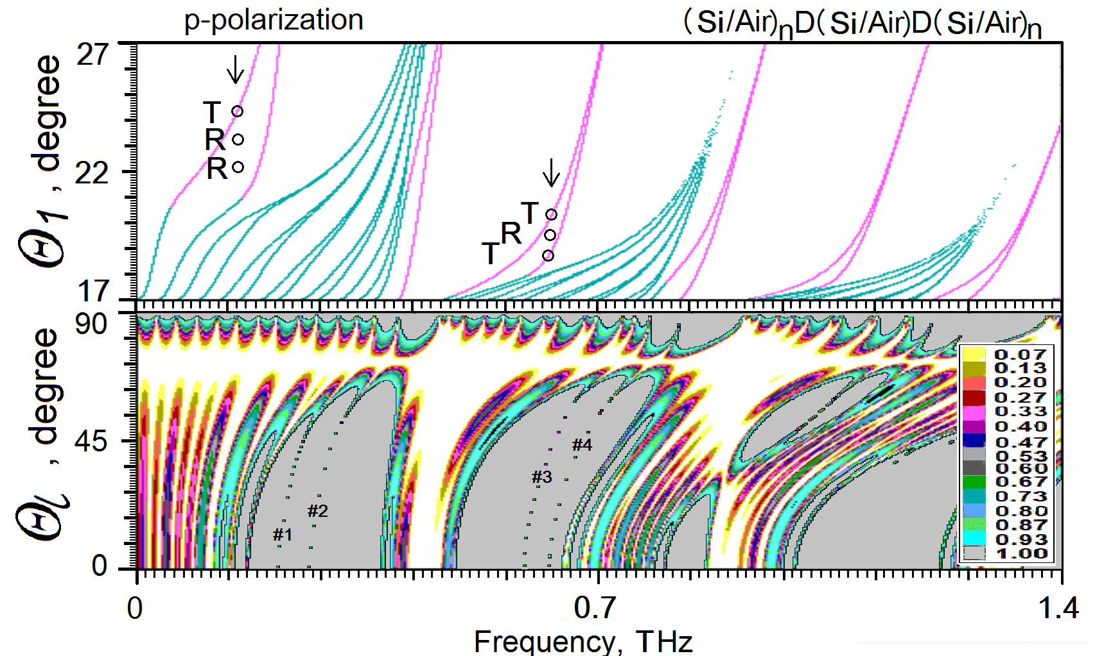 Fig. 2. (Si/Air)₅/D/(Si/Air)/D(Si/Air)₅/Si photonic structure. P-polarized modes/resonances and signal processing. Top part: Bandgap structure and local modes of the 10 period Si/air photonic crystal containing a binary one period divided defect D-D of thickness 100 µm; d_{Si} =100 µm, period 300 µm, air voids size 200 µm. External incident angle θ_{l} (see Fig.1), intrinsic angle θ₁ inside the Si material. Three bands each of them containing 10 - 13 resonator band eigenmodes and from 1 to 4 detached local states. Arrows, operating frequencies of TRR (left) and TRT (right) signal processing schemes. Bottom part: Angle-frequency diagram of reflection at external incidence (Fig.1). Notations #1, #2, #3, #4 enumerate branches of the defect caused transmission resonance. Inset: scale of colors.
next one becomes <1 GHz. The doublet structure of band modes arises due to influence of the central double defect zone which “cuts” the resonators body into two islands of similar design that interact with each other through the central defect zone. The interaction between photonic islands leads to the well known effect of mode repulsion and that is the reason of paired structure. The paired modes draw together with weakening of interaction though the perfect degeneracy of states is impossible in principle for a 1D system. It worth noting, that the width of bands is not changing in the process of such transformation. The intrinsic local states generated by the defect zone arise if their optical contrast relatively the PhCr is high enough. For instance, states D vanishes if d_{d} becomes less than 1.4 µm. In the case under consideration, the intrinsic local states D occupy positions in the first half of each gap. The resonator’s surface local states cannot exist in any periodic binary structure if one of its components coincides with surrounding medium. The angle-frequency positions are shown by circles in vicinity of local branches for two types of logic gates TRR and TRT, where the last R/T shows the perfect reflection or transmission of signal 3I₀. The latter is needed to organize a more compact all-optical adder based on the χ⁽³⁾ nonlinear effect of shifting bands (or local states) [3]. In Fig. 2 (bottom panel), the angle-frequency color map of reflection at external incidence is presented. The upper part of diagram θ_{l}≈90° in general repeats the TIR region structure of resonator’s eigenstates: the each TIR mode has a continuation out the TIR region as resonance peaks of transmission. The Brewster effect can be observed at θ_{l}≈73.65° - it is the reason of perfect reflection of p-polarized EMW at all frequencies. At θ_{l}<73.65°, the map exhibits several perfect reflection areas – windows of reflection. The first two windows contain four extremely sharp double defect caused transmission resonance lines marked as #1, #2, #3 and #4 which have at normal incidence the frequencies(GHz)/HWHM(MHz) ≈225/0.74, ≈260/0.21, ≈588/2.51, ≈624/45.2, correspondingly. Due to the angle dependence of resonant transmission lines they are sensible to intensity of EMW in the structures containing a χ⁽³⁾ nonlinear layer and an opportunity to use these resonances in a TRR logic gate exists.

References
1. E.Ya. Glushko, "Mixed Fano-SP resonant absorption of THz electromagnetic waves in a photonic resonator contacting with a metal film, " Physics Letters A 20020 384(23):126564 (2020).
2. E.Ya. Glushko. "Induced resonant electromagnetic piercing in metalized photonic crystal structures," Optik 2021 241 166502 (2021).
3. E.Ya. Glushko. " All-optical signal processing in photonic structures with nonlinearity," Opt.Commun. vol.247, №4-6, 275-280 (2005).

