**Nanostructured surfaces**

**Effect of film thickness on optical constants of CdTe thin films**

**Mazur T.M.1, Slyotov M.M.2, Prokopiv V.V.3, Mazur M.P.1**

*1* *Department of General and Applied Physics,* *Institute of Architecture, Construction and Energy, Ivano-Frankivsk National Technical University of Oil and Gas, Karpatska, 15, Ivano-Frankivsk-76019, Ukraine.*

*E-mail:* [*tetiana.mazur@nung.edu.ua*](mailto:tetiana.mazur@nung.edu.ua)

*2* *Department of Optics and Publishing and Printing, Department of Semiconductor Physics and Nanostructures, Applied-physics and computer sciences Institute, Yuriy Fedkovych Chernivtsi National University, Kotsubinskiy, 2, Chernivtsi-58012, Ukraine.*

*3 Department of Physics and Chemistry of Solid* *State, Faculty of Physics and Technology, Vasyl Stefanyk Precarpathian National University, Shevchenko, 57, Ivano-Frankivsk-76018, Ukraine.*

The structural perfection of CdTe films substantially depends on the temperature and type of the substrate. Accordingly, the choice of the substrate material and the correlation of technological parameters (deposition time, substrate and evaporator temperatures) can smoothly change the complex of physicochemical and optical properties

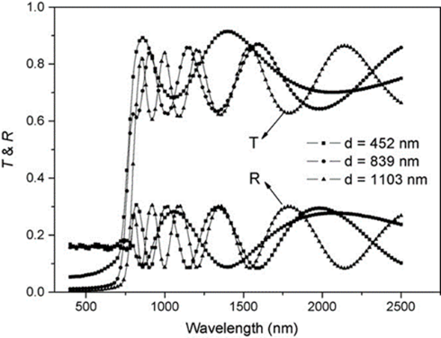

Fig. 1. Transmission and reflection spectrum for thin CdTe films of various thicknesses.

The spectral dependence of the optical transmission ($T_{ω}^{'}$) and reflection ($R_{ω}^{'}$) of the sample under study can be obtained using a two-beam spectrophotometer. The change in the absolute value of *T (λ)* and *R (λ)* depending on the wavelength is shown in Fig. 1.

The absorption coefficient α can be obtained from the experimentally measured values of *R* and *T* in the region of strong absorption according to the expression [1]:



where *d* is the thickness of the sample.

For higher values (α ≥104 cm-1) of the absorption coefficient α (where absorption is associated with interband transitions), the band gap can be determined

It is proved that the optical band gap increases with increasing film thickness, since the crystallinity of the film also increases due to an increase in the crystallite size. The calculated *Eg*opt values for polycrystalline thin CdTe films are in good agreement with the known value of 1.514 eV at room temperature for the CdTe single crystal [2].

1. *Kastner, Marc.* Bonding bands, lone-pair bands, and impurity states in chalcogenide semiconductors // Physical Review Letters, *-*1972.- **355**, 28.6.

2. *Yu, Zhonghai, et al.* Interpretation of near-band-edge photoreflectance spectra from CdTe // Physical Review. -1995.- B 51.19, 13789.