Nanoscale Physics

The effect of the Si vacancy on electronic structure of the co-doped crystal Si<B, Cr>

Syrotyuk S. V.¹, Khoverko Yu. M.¹, Shcherban N. O.¹, Druzhinin A.A.¹

1 Semiconductor Electronics Department, Lviv Polytechnic National University,
S. Bandera str., 12, Lviv-79013, Ukraine.
E-mail: svsnpe@gmail.com

In the work [1] the magnetoresistance of Si whiskers doped with Ni and B elements has been studied. The electronic structure of Si crystal doped with the 3d transition elements has been evaluated [2], but without the point defects.
Here we evaluate the electronic structure taking into account the strong correlated 3d electrons of the Cr atom. The strong correlations are treated by means of the exchange-correlation functional PBE0. The obtained results are shown in Fig. 1. The calculations were done in the 64-atom supercell by means of ABINIT code.

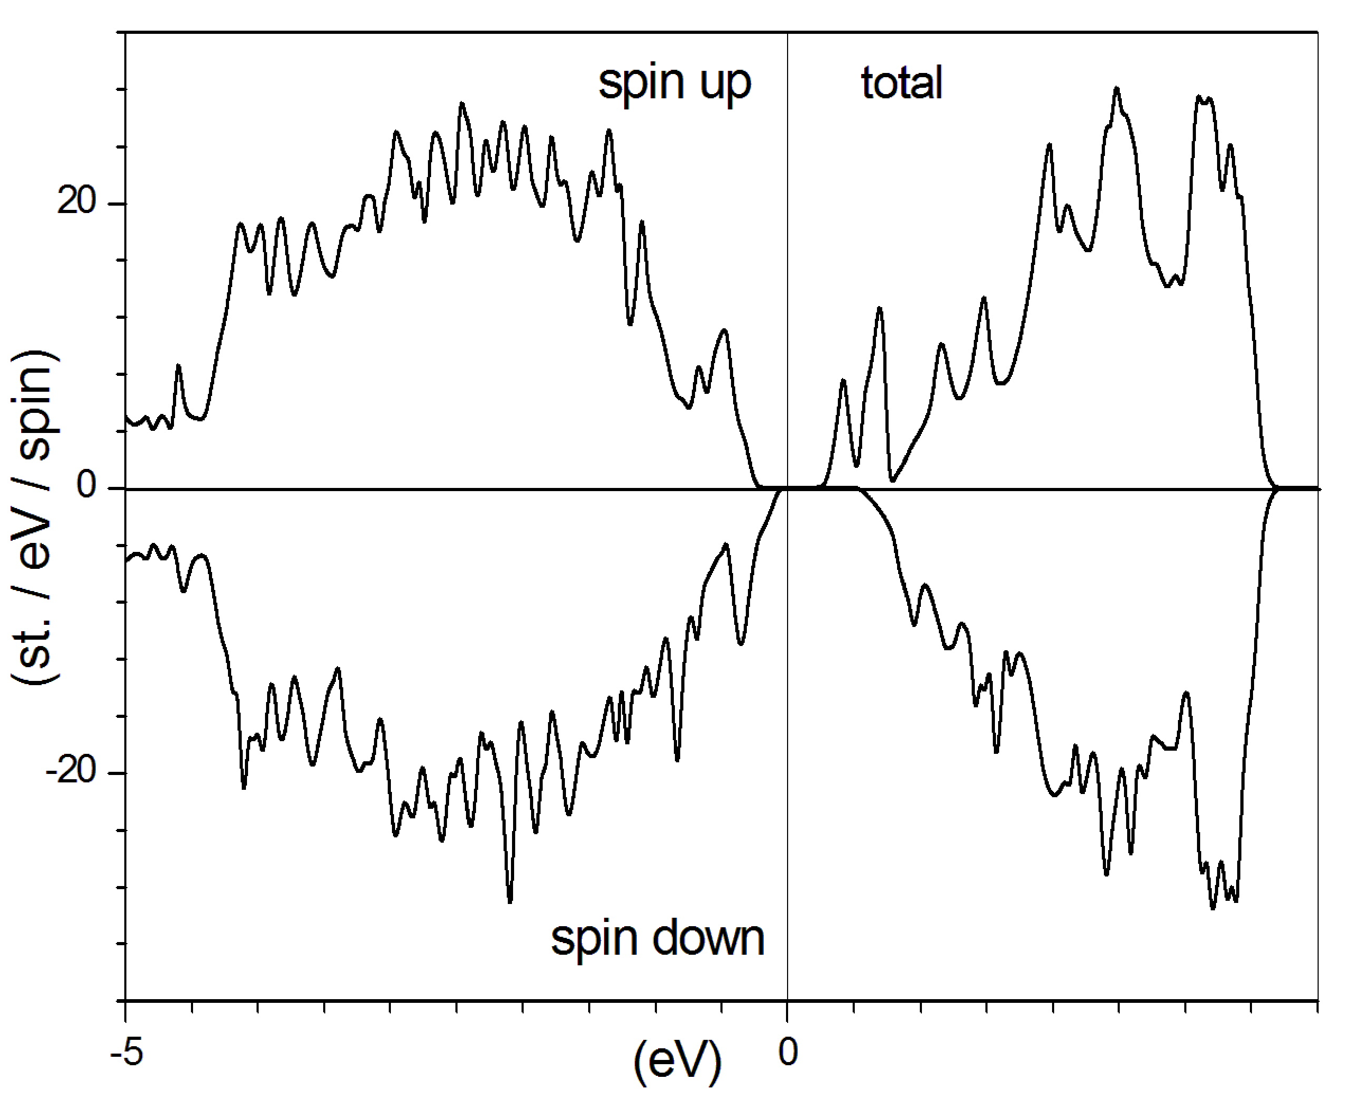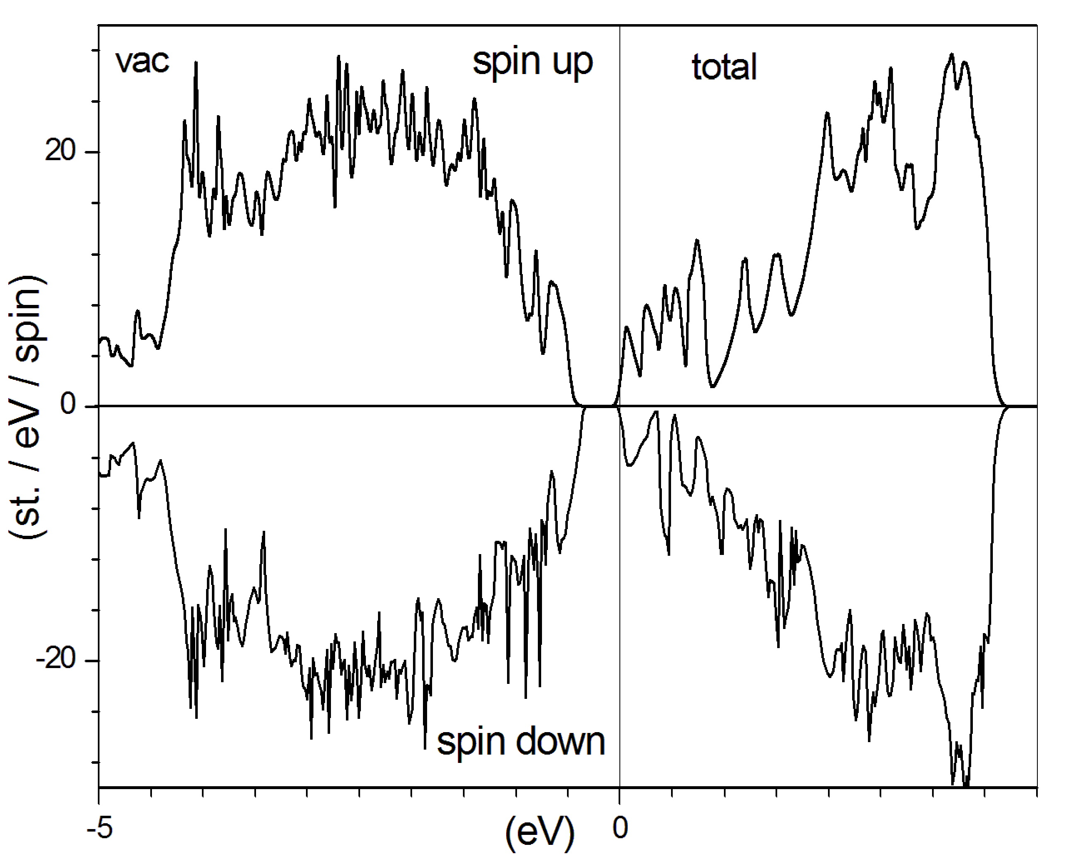

Fig. 1. Spin-resolved electronic structure of the crystals Si<B,Cr> without (left) and with the Si vacancy (right). Fermi level is set at zero energy.

As can be seen from Fig. 1 the material Si<B, Cr> is the semiconductor for both spin states. This material with a vacancy at Si atom site reveals that the Fermi level crosses the dispersion curves in the conduction band. The magnetic moment of a supercell equals to 2.54 Bohr magnetons for both materials.

- Druzhinin A., Ostrovskii I., Khoverko Yu. et al. Magnetic properties of doped Si <B, Ni> whiskers for spintronics // J.Nano Res. - 2016.-39.-P. 43-54.
- Zhang Z.Z. et al. First-principles study of transition metal impurities in Si // Phys. Rev. B. -2008.-77, 155201.-P. 1-8.

