Nanoscale physics
Features of optical characteristics of nanoobjects
Lukiyanets B.A., Matulka D.V.
Department of Applied Physics and Nanomaterial Science, Lviv Polytechnic National University,
S. Bandera str., 12, Lviv, Ukraine, 79000
E-mail: dariya.v.matulka@lpnu.ua

The results of optical research of objects are a useful source for understanding the effects and phenomena in them. Consider such studies to establish the manifestations of the shape of nanoobjects, their size on their physical characteristics. We analyze the fundamental characteristic of optical research - the absorption index $α\left(ω\right)$ in a semiconductor nanoobject. According to the theory of semiconductors $α\left(ω\right)$ takes the form:
$α\left(ω\right)=\frac{4π^{2}e^{2}}{{\text{ncm}}_{0}ω Ω}\sum_{\text{if}}{{\left|\vec{e}{\vec{p}}_{\text{fi}}\right|}^{2}}\left[f\left(E_{i}\right)−f\left(E_{f}\right)\right]δ\left(E_{f}−E_{i}−ℏω\right)$. (1)
Here n is the refractive index of the medium, $m_{0}$ is the mass of an electron, $Ω$ is a volume of the crystal, $ω$ is the angular frequency of the electromagnetic wave. Summation in (1) is over all states in the optical transitions - from the initial state,$E_{i}$, in the valence band to the final state, $E_{f}$, in the conduction band. The coefficient $\left[f\left(E_{i}\right)−f\left(E_{f}\right)\right]$ describes the filling of the corresponding states ($f\left(E\right)$ is the Fermi-Dirac distribution; in the case T = 0 K the valence band is completely filled and the conduction band is completely empty). The delta function $δ\left(E_{f}−E_{i}−ℏω\right)$ indicates that the states must be separated by an energy equal to the photon energy, according to conserve energy.
The squared momentum matrix element ${\left|\vec{e}{\vec{p}}_{\text{fi}}\right|}^{2}$ describes the transition between states, caused by the $\vec{e}$- polarized light. In 3-dimensional space with (x, y, z) (or, otherwise, (1, 2, 3)) the momentum matrix element under the $e_{α}$-polarized light radiation is

$$p_{\text{fis}}=\iiint{{\text{dx}}_{α}}{\text{dx}}_{β}{\text{dx}}_{γ}ψ_{f}^{}\frac{ℏ}{i}\frac{∂}{∂x_{s}}ψ_{i}$$
where $ψ$ is the wave function of s state; $s∈$$α,β,χ∈$ (1, 2, 3), but $α≠β≠χ$.
We choose a parabolic potential for both the conduction band and the valence band $V\left(x_{α}x_{β}x_{χ}\right)=\sum_{α=1,2,3}{\frac{m_{0}ω}{2}x^{2}\frac{m_{α}}{m_{0}}}$ ($m_{α}$ is an effective mass of an electron $m_{α_{c}}$ ($m_{α_{v}}$) in conduction band ( of a hole in valence band).
Energy states in it are
$$E_{ν_{1}νν_{3}}=ℏω\sqrt{\frac{m_{0}}{m_{1}}}\left(ν_{1}+\frac{1}{2}\right)+ℏω\sqrt{\frac{m_{0}}{m_{2}}}\left(ν_{2}+\frac{1}{2}\right)+ℏω\sqrt{\frac{m_{0}}{m_{3}}}\left(ν_{3}+\frac{1}{2}\right)$$
(here $ν_{α}$ are quantum numbers, $ν_{α}$= 0, 1, 2, 3… ..) with the following wave functions:
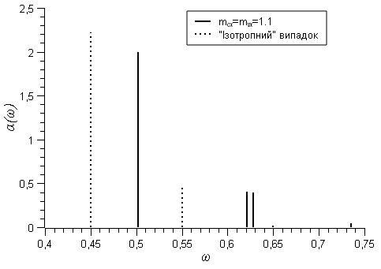
1.
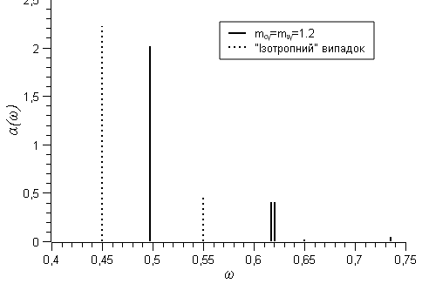
2.
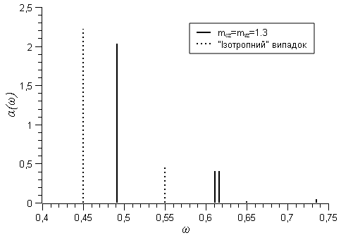
3.
$ψ_{ν_{1}ν_{2}ν_{3}}\left(ξ_{1,}ξ_{2,}ξ_{3}\right)=\prod_{α=1,2,3}{\frac{1}{\sqrt{2^{ν_{α}}ν_{α}!\sqrt{π}}}}\text{exp}(−\frac{ξ_{α}^{2}}{2})H_{ν_{α}}\left(ξ_{α}\right)$ ($H_{ν_{α}}\left(ξ_{α}\right)$ is the Hermite polynomial; $ξ_{α}=x{\left(\frac{ℏ}{m_{0}ω}\frac{m_{0}}{m_{α}}\right)}^{−12}$ ).
We apply the above results for the case of a nanoobject - „anisotropic” quantum dot - in the form of a rectangular parallelepiped with nanosized sides $2a×2b×2c$. The depth of the parabolic well $V_{0}$, its size and effective mass are related by the ratio $a_{α}=\sqrt{\frac{2V_{0}}{ω_{c}^{2}}\frac{1}{m_{α}}}$, i.e. the size of the well is larger for particles with smaller effective masses.
Analysis of the momentum matrix element in Eq (1) indicates that it is nonzero at $ν_{β}+ν_{β}^{'}$and $ν_{γ}+ν_{γ}^{'}$even, and $ν_{α}+ν_{α}^{'}$ odd. Since the most intense transitions are between the lowest states of electrons in the valence band and holes in the conduction band, we consider the transitions $ψ_{{vν}_{1}ν_{2}ν_{3}}→ψ_{cν_{1}^{'}ν_{2}^{'}ν_{3}^{'}}$from the ground state of the hole ($ν_{1}, ν_{2}, ν_{3}$) to the lowest electronic states ($ν_{1}^{'}, ν_{2}^{'}, ν_{3}^{'}$), namely, with polarization $\vec{e}=\left(e_{x},0 , 0\right)$- 1) $\left(0,0,0\right)→\left(1,0,0\right)$, 2) $\left(0,1,0\right)→\left(1,1,0\right)$, 3) $\left(0,0,1\right)→\left(1,0,1\right)$ , 4) $\left(0,1,1\right)→\left(1,1,1\right)$.
Similar considerations are valid for the $\vec{e}=\left(0,e_{y}, 0\right)$ and $\vec{e}=\left(0 , 0,e_{z}\right)$ polarization of light. Numerical calculations $α\left(ω\right)$ were performed under the assumption of equality of the effective masses of electrons and holes ($m_{\text{sc}}=m_{\text{sv}}=m_{s} \left(s=α,β,γ\right)$) for different polarizations at the following parameters, e.g. for $α=1 −m_{1}=1\text{.}1$, for $β=2 −m_{2}=1\text{.}2$, $γ=3 −m_{3}=1\text{.}3$; $E_{g}=0\text{.}2 \text{eV}$, $ℏω_{c}=0\text{.}1 \text{eV}$.They and for comparison the analogical ones of the isotropic nanoobject (i.e. when $m_{1}=m_{2}=m_{3}=m_{0}$) are presented in Fig.
From his analysis it follows:
1) the line nature $α\left(ω\right)$ in all cases is a consequence of the discrete spectrum of the carriers;
2) in all anisotropic nanoobjects $α\left(ω\right)$ are observed at frequencies higher than in the isotropic one. This difference is the dependence on the polarization of the electromagnetic wave: its maximum difference is at $e_{α}$- polarization and the minimum difference at $e_{γ}$-polarization;
3) the values $α\left(ω\right)$ at the transitions between the ground and the lowest states are smaller in comparison with similar ones in the isotropic nanoobject. For example, for the ground state it is by 7..10%.
4) at transitions$\left(0,1,0\right)→\left(1,1,0\right)$, $\left(0,0,1\right)→\left(1,0,1\right)$ in the isotropic nanoobject $α\left(ω\right)$ takes the same value - 0.455 at a frequency of 0.550 eV. The transition to the anisotropic case shifts such a doublet toward higher frequencies, it splits to a magnitude that depends on the polarization of light.

