Nanoscale physics
Magnetocaloric effect in multilayered Gd films with different substrate orientation

Koplak O.V.1,2, Dremova E.V.1, Mangin S.3, Morgunov R.B.1
1Taras Shevchenko National University of Kyiv, Volodymyrska Street, 64/13, Kyiv, Ukraine, 01601
2Institute of Problems of Chemical Physics, Semenov av. 1, Chernogolovka, Russia 142432
E-mail: o.koplak@gmail.com
3Université de Lorraine, CNRS, IJL, F-54000 Nancy, France

The magnetocaloric effect (MCE) in rare-earth elements is normally higher than fin transition metals due to high value of ionic magnetic moment. The MCE in rare-earth films is controlled by interface strain between film and substrate, mechanical stress and dimensionality limitations. The MCE in the W/Gd/W/MgO structures with different crystallography orientations of MgO substrates is investigated near the Curie temperature T ~ 293 K (Fig. 1).
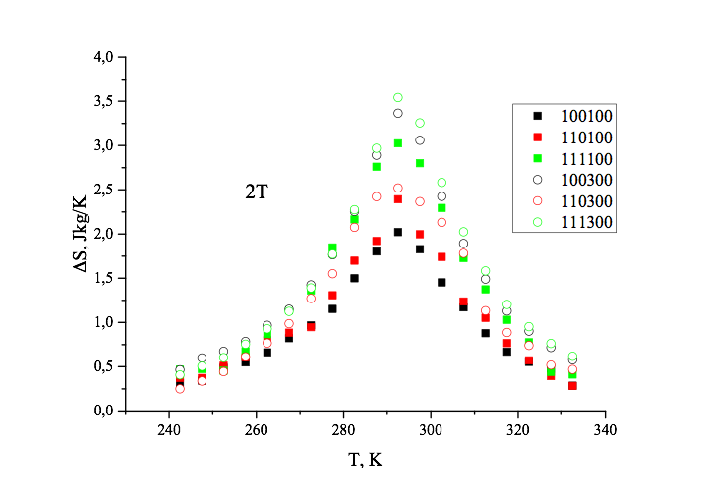
Fig. 1. Temperature dependences of entropy change ΔS for Gd films deposited on MgO substrate of different crystallography orientations.

We analyzed dependences of MCE and relative cooling power (RCP) on Gd thickness (100-300 nm), MgО orientation (<100>, <110> и <111>) and Gd amorphization. Maximal change of entropy -ΔS = 8 J/kgK in field Н = 5 Т at Т= 293 K was revealed in 300 nm Gd film deposited on Mg (111) substrate. This value is smaller, than one known for the bulk Gd (-ΔS = 10.2 J/kgK). Decrease of Gd thickness causes decrease of the ΔS in Gd films deposited on Mg (100) and MgO (111) substrates. Amorphous Gd was identified in MgO <110> sample, where Gd thickness does not affect entropy. The relative RCP cooling power in samples with MgO <111> orientations at 5 T reaches 480 J/kg, exceeding the RCP value known for the bulk Gd (410 J/kg). This effect opens up new possibilities for optimizing the magnetocaloric effect in thin gadolinium films controlled by crystallography orientations of MgO substrates.

