Folding-analogs of ATPase RavA of Lokiarchaeota
Tabulina A.M.¹, Venger A.M.¹, Venger O.O.², Pasternak S.L³.
¹ Department of microbiology, virology and immunology, Odessa National Medical University, Valychovski Lane, 2, Odesa-65000, Ukraine.
E-mail: email.of. corresponding_author@server.com
² Plant Breeding and Genetics Institute – National Center of Seed and Cultivar Investigation, Ovidiopol’ska doroga Str., 3, Odesa-65036, Ukraine.
³ Odessa National University of I. I. Mechnikov, Dvoryan’ska Str., 2,Odesa-65082, Ukraine.

ATPase RavA is important membrane enzyme in prokaryotes. Genetic relationship of microorganisms can be associated with polymorphism of this enzyme. The aim of current scientific work was the modulation of the three-dimensional structure and search of folding-analogs of ATPase RavA of Lokiarchaeota. Models were built based on the target-template alignment using ProMod3. Coordinates which are conserved between the target and the template are copied from the template to the model. Insertions and deletions are remodeled using a fragment library. The geometry of the resulting model is regularized by a force field. In case loop modelling with ProMod3 fails, an alternative model is built with PROMOD-II [1]. As result, three-dimensional structure of CaCA was calculated by folding-analogs (fig. 1). Three of them are statistically correct: Magnesium chelatase, DNA replication licensing factor MCM7 and Minichromosome maintenance protein MCM.

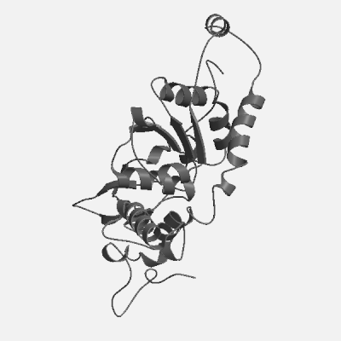
Fig. 1. Structure of ATPase RavA of Lokiarchaeota

1 Guex N., Peitsch M. C. SWISS-MODEL and the Swiss-PdbViewer: an environment for comparative protein modeling // Electrophoresis.-1997.-18, N 15.-P. 2714-2723.

