TRANSIENT FANO-SP TERAHERTZ RESONANCES IN METALIZED PHOTONIC CRYSTAL RESONATORS: PHYSICS AND APPLICATION
Glushko, E. Ya

Semiconductor Photonic Structures Lab., Institute of Semiconductor Physics of NAS of Ukraine Nauki Prsp., 45, Kyiv -03028, scientist.com_eugene.glushko@mail.com

A polarized electromagnetic wave (EMW) interacting with a metal film through a planar photonic crystal resonator in terahertz frequency region exhibits some unusual forms of reflection and transmission. The physical nature of arising effects can be explained by extremely high both real and imaginary parts of refraction index of metals in the THz region of frequencies. One more motivation to choose the THz range was an extremely wide spectrum of applications in this area beginning with nebular astronomy and night-vision applications, to defense, sensing, communication applications, bandpass filters, communication line couplers and resistive sheets. We have investigated theoretically a correlation between spectra of a free photonic structure and that deposited on a gold film. It was found that for quasi-normal incidence of EMW the presence of metal generates narrow spectral wells in the middle of reflection windows existing for the same free photonic crystal. An investigation of properties including the resonances shape showed that they are of Fano type. Quite another manifestation of metal-resonator inter-influence takes place at whispering incident angles when reflection spikes of a p-polarized wave coincide with modes of photonic crystal resonator and they are absent throughout the stopband areas between modes. This behaviour is typical for a surface plasmon (SP) resonance. The effect is strongly depended on polarization, number of periods and angle of incidence. The s-polarized field exhibits more complicate features: at whispering incident angles the resonances in vicinity of low energy modes of each band arise between them (Fano type resonances) whereas the resonances with higher energy close to the top of band became to be matched the mode frequencies (SP resonances).
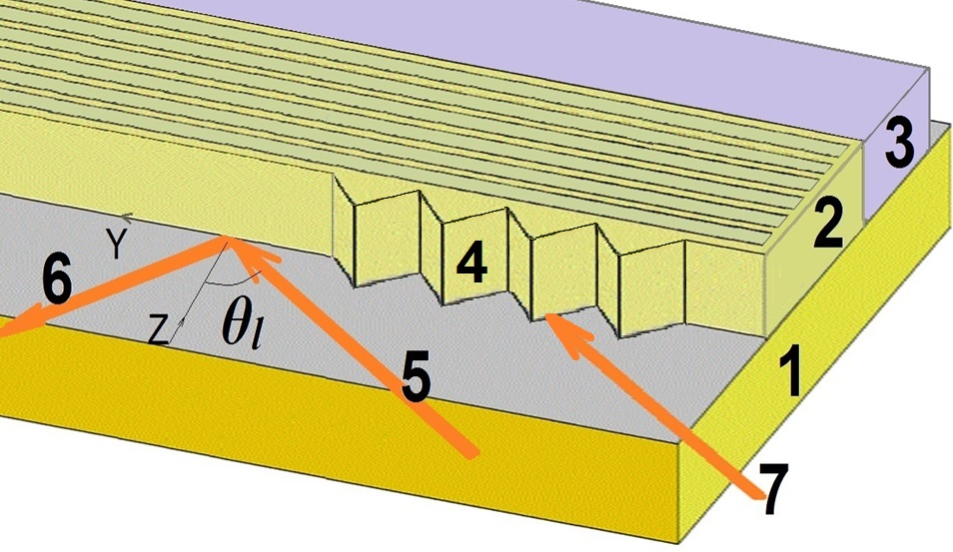
Fig. 1. A planar layered photonic crystal resonator contacting with a metal. 1, substrate, 2, photonic crystal, 3, metal wall, 4, input prism, 5, 6, incident and reflected beams in external geometry of incidence, 7, θ_{l}, incident angle.
If an optical resonator, a structure exhibiting well expressed sequence of reflection and transmission windows, is brought into contact with a good mirror (Fig. 1), like practically all metals are, an expectation could arise that a superposition of reflection spectra will occur and the reflectance of this modified system will become more perfect. But a little more attentive look onto the problem should take into consideration several mechanisms of losses that can depend on the geometry of the photonic crystal and its interaction with metal. First of all, the interaction of resonator modes with free electrons of metal can excite surface and bulk plasmons and plasmonic polaritons. The SP resonance occurs when a plane-polarized wave falls onto the metal film with a big enough tangential component of momentum. In our case, the EMW after being filtered by the photonic crystal resonator meets the metal and therefore reflection spectra might reflect both the bandgap structure of the photonic crystal and plasmonic spectrum of metal. Another related mechanism could have features of Fano resonance when a wave passing through the photonic resonator interacts with the electron subsystem of metal.
We shall use a numerical approximation to refraction index components for gold measured in [1]:
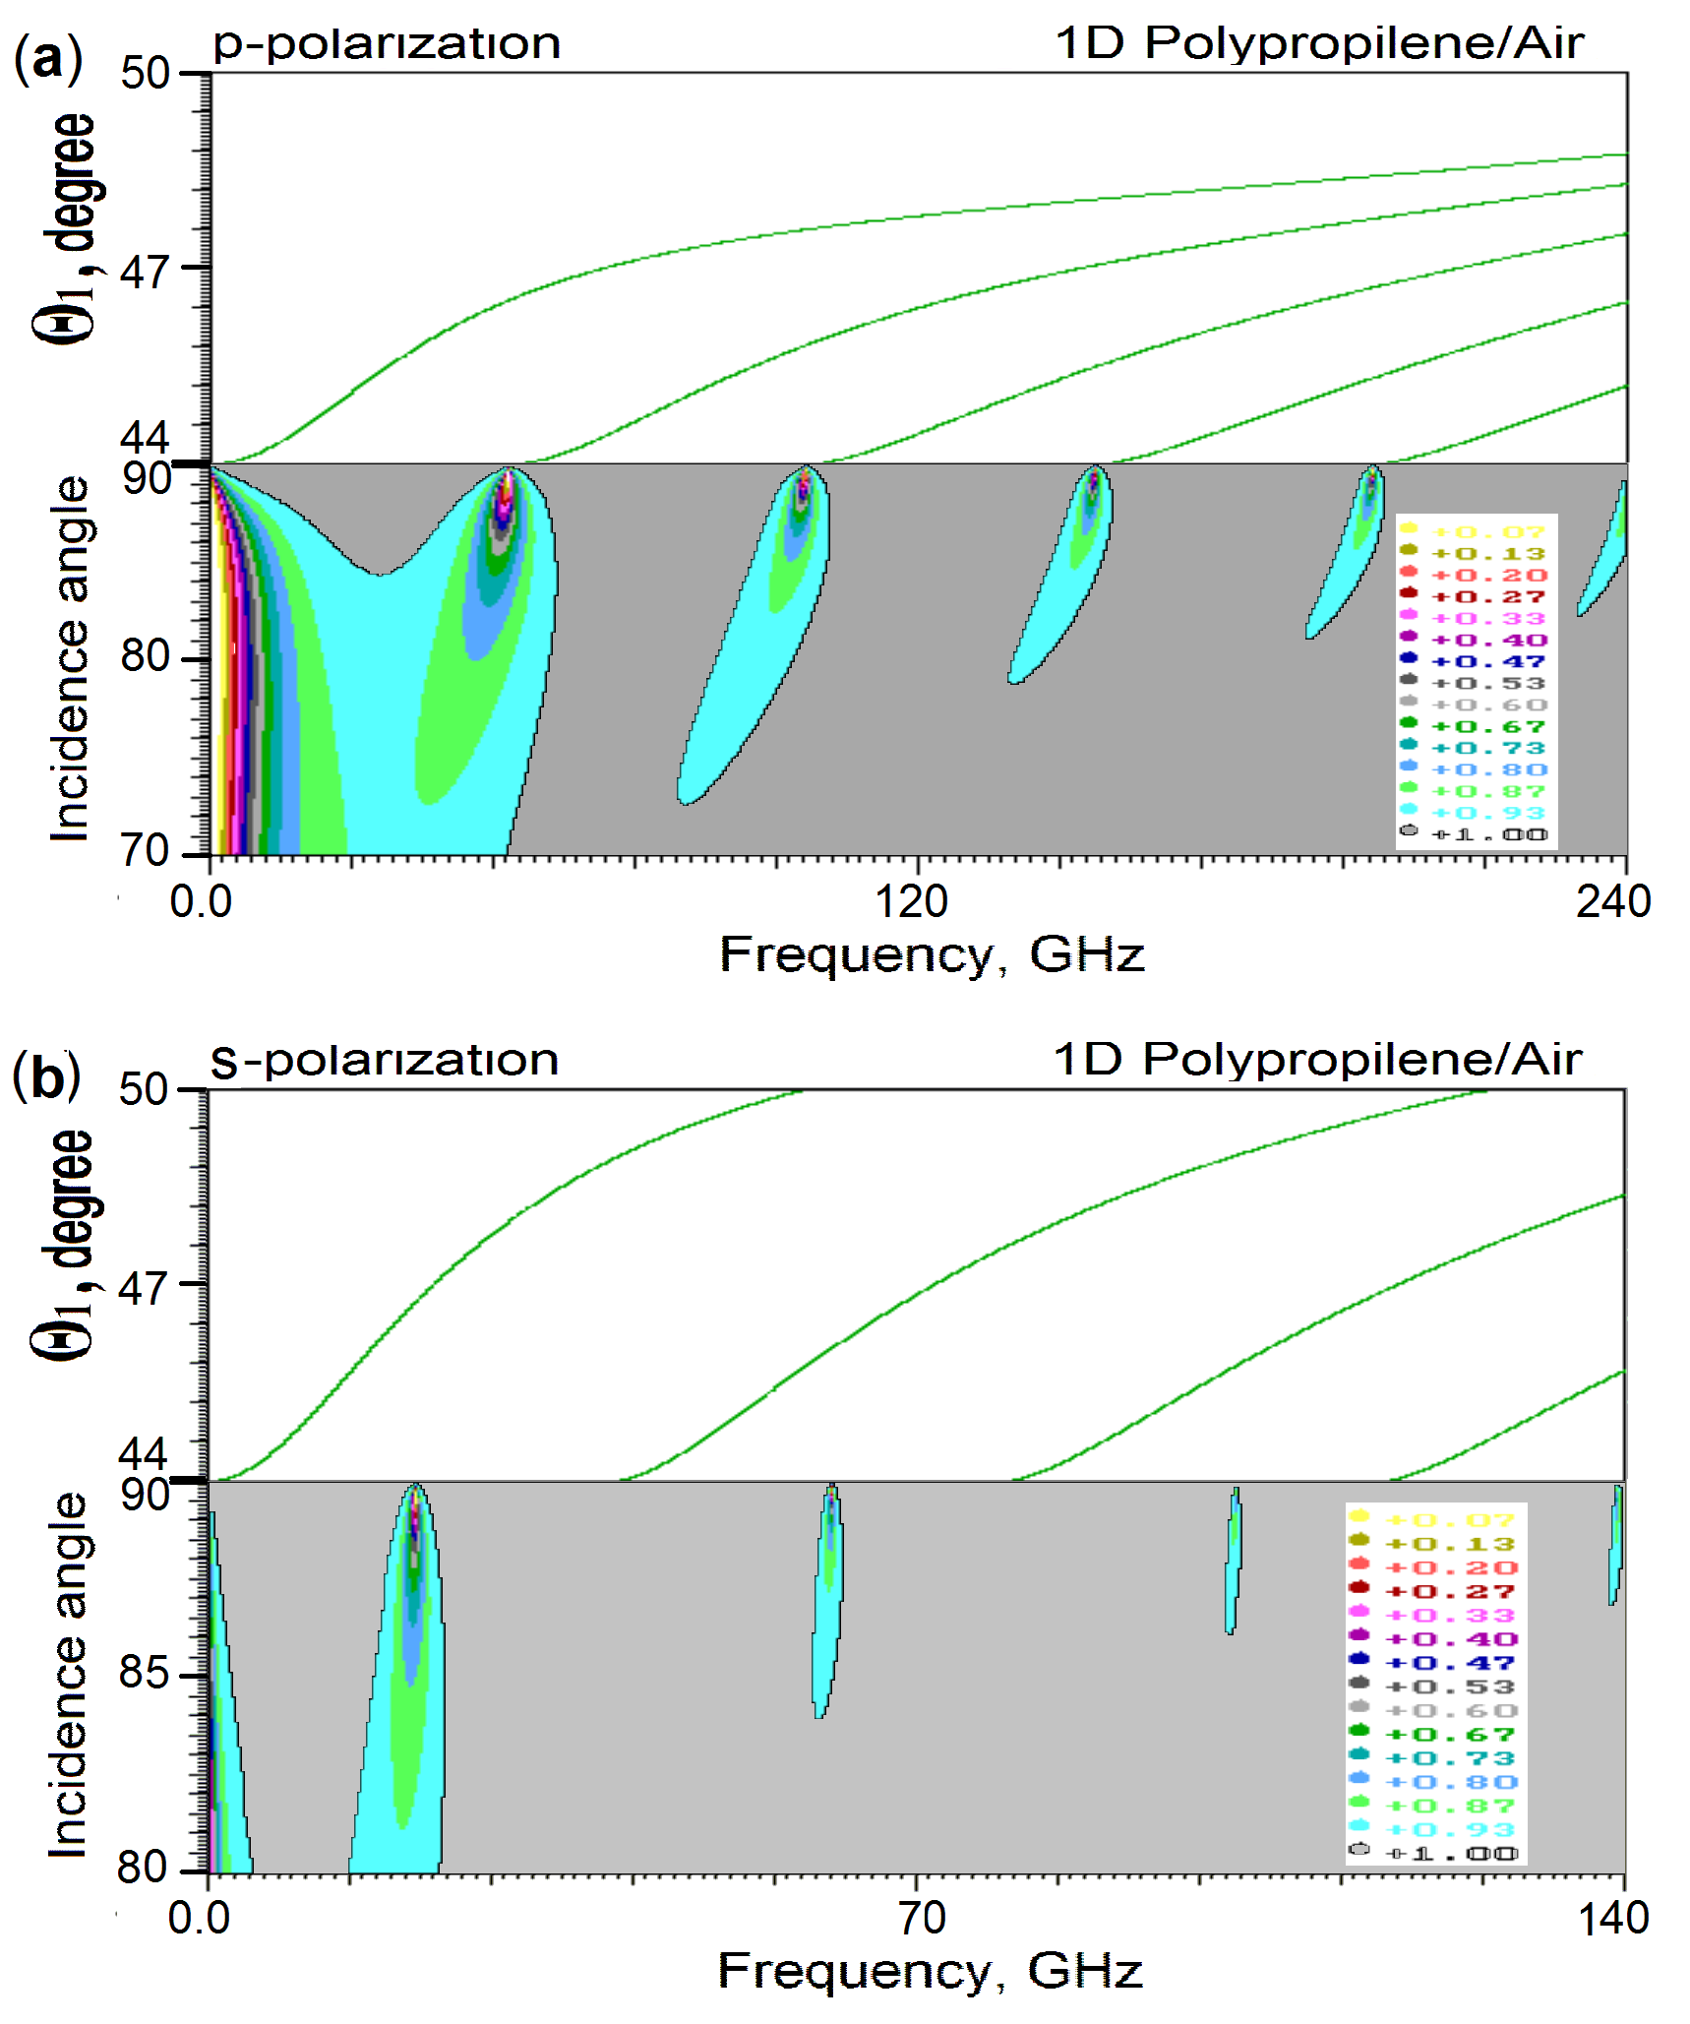Fig. 2. Difference in positions of reflection spikes for different polarizations. Upper parts: Modes of the 8 period PP/air photonic crystal contacting with gold film of thickness d_{m} =40 nm, period 800 µm, PP layer thickness 200 µm. External incident angle θ_{l} (see Fig.1), intrinsic angle θ₁ inside the PP material. (a) P-polarization. 6 SP spikes and 5 resonator eigenmodes in upper part. (b): S-polarization. 5 Fano type spikes and 5 resonator eigenmodes in upper part.
(1)
and n’≈200. The frequency depended dielectric function has a view ε(υ)=(n’+i·n’’)². We have considered reflection spectra of a p- and s-polarized EMW passing through the PhCr resonator contacted with a metal film described by (1). It was found that the inter-influence of the PhCr and metal leads to the sharp needle-like peaks of EMW quenching. A photonic crystal deposed onto a metal film reconstructs the own reflectance spectrum and forms a system of sharp frequency and angle resonance spikes of reflection. Our study shows that the spike shape and HWHM depend on the number of periods of a photonic resonator and metal film thickness. Here, the maximal depth (R=0) of the second spike ν₂ (328.10 GHz) is reached at N=11 with HWHM=0.06 GHz, the maximal quenching is moved to higher N for the next number spikes. For instance, spike ν₃ (683.10 GHz) becomes maximally deep at N=13 with HWHM=0.08 GHz. The width at the half maximum of spike decreases with the growth of metal film thickness and reaches for this spike HWHM=0.02 GHz at d_{m}=180 nm. In Fig. 2a, 2b, shown are the difference in positions of reflection spikes for different polarizations at whispering incidence. A vertical section at a chosen frequency in lower parts of figures 2a and 2b gives angle dependence of reflection. In a metalized resonator, the angular width of spike lines is essentially narrowing. For the spike ν₂ at 350 GHz and d_{m}=40 nm the HWHM is about 0.4° and decreases with growth of thickness d_{m} that opens a possibility to collimate divergent electromagnetic beam transmitting through the system .
We have compared several models for gold and copper. The results show that the spike position is practically independent on the adopted model of metal. In the all metal models, Fano spikes weakly asymmetric. Our investigation shows that asymmetry of Fano spike shape and its half-width growths with its number and becomes more significant for spikes with shorter wavelengths. Different metal models provide only weak influence on the considered phenomenon. The comparison of the results for Cu and Au shows that a metal with higher conductivity “eats” a deeper hole in the curve of reflection at the same position of spike’s tip.
The novel effect of induced by metal sharp angular and frequency dependence of spikes found here can serve, among others, as a ground effect in compact and reliable direction control devices and THz radiation collimating devices.
References
- H. Yasuda, I. Hosako. Measurement of Terahertz Refractive Index of Metal with Terahertz Time-Domain Spectroscopy. Jpn. J. Appl. Phys. 47, pp. 1632 - 1634 2008.

