Nanochemistry and biotechnology of International research and practice conference "Nanotechnology and nanomaterials"

Three-dimensional structure of ATPase RavA of Odinarchaeota

Shevchuk G.Yu.¹, Venger A.M.¹, Venger O.O.², Pasternak S.L³.

¹ Department of microbiology, virology and immunology, Odessa National Medical University, Valychovski Lane, 2, Odesa-65000, Ukraine.
E-mail: shanni2901@gmail.com
² Plant Breeding and Genetics Institute – National Center of Seed and Cultivar Investigation, Ovidiopol’ska doroga Str., 3, Odesa-65036, Ukraine.

³ Odessa National University of I. I. Mechnikov, Dvoryan’ska Str., 2,Odesa-65082, Ukraine.

ATPase RavA is energetically important enzyme, which is present in different forms of life. The evolution of ATPase RavA can be correlated with evolution phylogeny of prokaryotes and eukaryotes. The structure of enzymes in some Asgardarceae is still unknown. The aim of current scientific work was to build and describe three-dimensional structure of ATPase RavA of Odinarchaeota by SWISS-model.
The hexameric ATPase RavA and the decameric lysine decarboxylase LdcI form a 3.3 MDa cage, proposed to assist assembly of specific respiratory complexes in Odinarchaeota. Here, we show that inside the LdcI-RavA cage, RavA hexamers adopt an asymmetric spiral conformation in which the nucleotide-free seam is constrained to two opposite orientations [1]. Cryo-EM reconstructions of free RavA reveal two co-existing structural states: an asymmetric spiral, and a flat C2-symmetric closed ring characterised by two nucleotide-free seams. The closed ring RavA state bears close structural similarity to the pseudo two-fold symmetric crystal structure of the AAA+ unfoldase ClpX, suggesting a common ATPase mechanism (fig. 1).
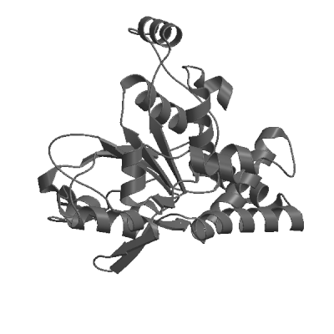

Fig. 1. Three-dimensional structure of ATPase RavA of Odinarchaeota

1 Guex N., Peitsch M. C. SWISS-MODEL and the Swiss-PdbViewer: an environment for comparative protein modeling // Electrophoresis.-1997.-18, N 15.-P. 2714-2723.

