Ligands of ATPase RavA of Thorarchaeota
Radkevich K.V.¹, Venger A.M.¹, Venger O.O.², Pasternak S.L³.
¹ Department of microbiology, virology and immunology, Odessa National Medical University, Valychovski Lane, 2, Odesa-65000, Ukraine.
E-mail: email.of. corresponding_author@server.com
² Plant Breeding and Genetics Institute – National Center of Seed and Cultivar Investigation, Ovidiopol’ska doroga Str., 3, Odesa-65036, Ukraine.
³ Odessa National University of I. I. Mechnikov, Dvoryan’ska Str., 2,Odesa-65082, Ukraine.

Genome of Thorarchaeota encodes homologues of proteins of eukaryotic membranes. Moreover, the thorarchaeal proteins are identified being with similar features to eukaryotic coat proteins involved in vesicle biogenesis. The evolution relationship of prokaryotes and eukaryotes is based on diversity of genome and functionally important proteins, such as ATPases. The structure and functional properties of ATPase RavA of Thorarchaeota are still not described. The aim of current work was to detect ligands of those enzymes. Ligands present in the template structure are transferred by homology to the model when the following criteria are met: (a) the ligands are annotated as biologically relevant in the template library, (b) the ligands are in contact with the model, (c) the ligand is not clashing with the protein, (d) the residues in contact with the ligand are conserved between the target and the template. If any of these four criteria are not satisfied, a certain ligand will not be included in the model.
The model template of ATPase RavA of Thorarchaeota has been built by SWISS program (fig. 1) [1].
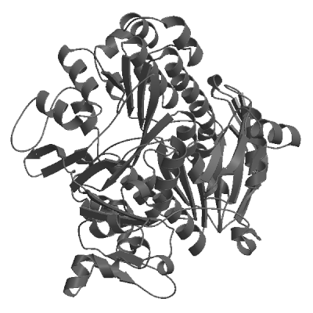
Fig. 1. The model of ATPase RavA of Thorarchaeota
As result of research two types of ligands – adenosine-5’-diphosphate and iron/sulfur cluster were detected.
1 Guex N., Peitsch M. C. SWISS-MODEL and the Swiss-PdbViewer: an environment for comparative protein modeling // Electrophoresis.-1997.-18, N 15.-P. 2714-2723.

