Nanoscale Physics

The electronic structure of doped crystals Si<Mn> and Si<B, Mn>

Syrotyuk S. V.¹, Khoverko Yu. M.¹, Shcherban N. O.¹, Druzhinin A.A.¹

1 Semiconductor Electronics Department, Lviv Polytechnic National University,
S. Bandera str., 12, Lviv-79013, Ukraine.
E-mail: svsnpe@gmail.com

Investigation of semiconductors with transition metal impurities has attracted a lot of attention in the few last years. For example, in the paper [1] the magnetoresistance of Si whiskers doped with Ni and B elements has been studied. The electronic structure of Si crystal with transition metal impurities has been evaluated within the GGA approach on PAW basis states [2].
Here we evaluate the electronic structure taking into account the strong correlated 3d electrons of transition element. All calculations were made by means of ABINIT code in the PAW formalism. The strong correlations are considered by means of the exchange-correlation functional PBE0. The results obtained here are shown in Fig. 1.
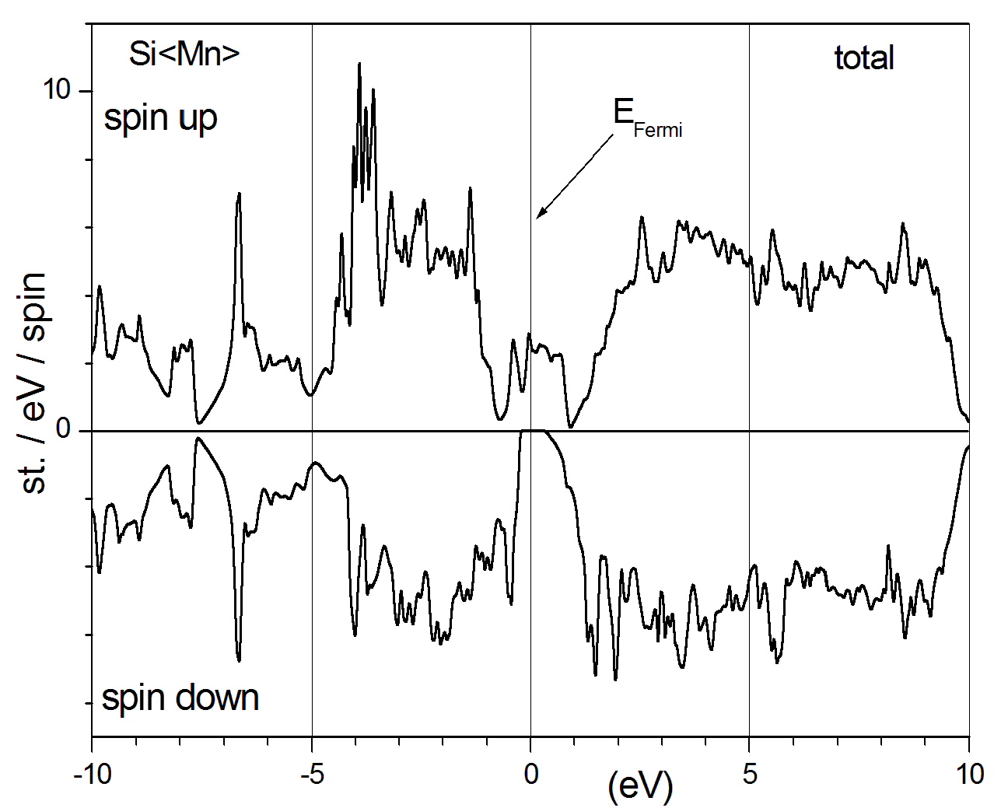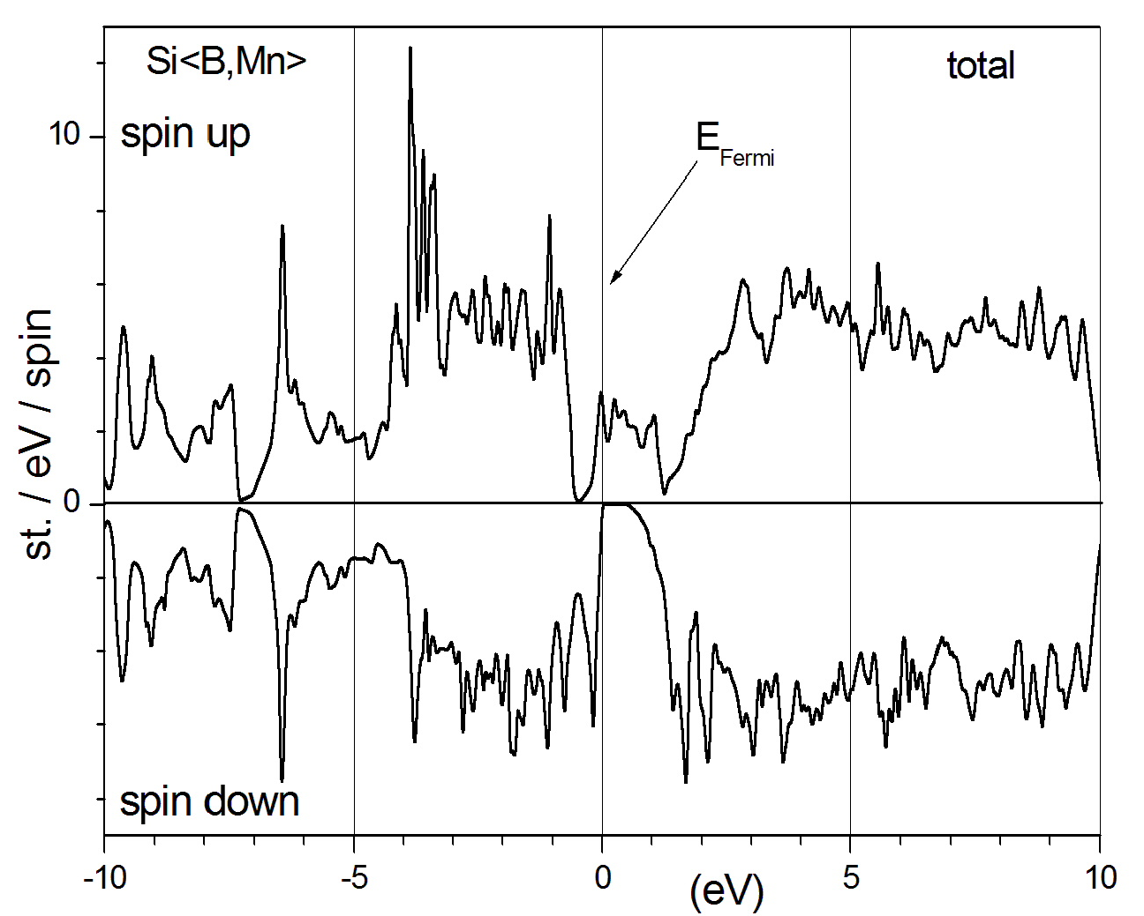
Fig. 1. Spin-resolved electronic structure of the crystals Si<Mn> and Si<B, Mn>.

As can be seen from Fig. 1 both crystals Si<Mn> and Si<B, Mn> show the metallic properties for the spin-up electronic states and are the indirect band gap semiconductors for spin-down ones. The magnetic moments of a unit cell equal 3.47 and 3.26 Bohr magnetons for Si<Mn> and Si<B, Mn>, respectively.

- Druzhinin A., Ostrovskii I., Khoverko Yu., Yatsukhnenko S. Magnetic properties of doped Si <B, Ni> whiskers for spintronics // J.Nano Res.-2016.-39.-P. 43-54.
- Zhang Z.Z., Portoens B., Kai Chang, Peeters F.M., First-principles study of transition metal impurities in Si // Phys. Rev. B. -2008.-77, 155201.-P. 1-8.

