Nanooptics and photonics
Quantum chemical calculations of electron absorption spectra of tryptophan in complexes with oxygen and water
O. Smirnova, A. Grebenyuk, Iu. Mukha, N. Vityuk
Chuiko Institute of Surface Chemistry, NAS of Ukraine, 17 General Naumov Str., Kyiv 03680, Ukraine. E-mail: olsmirnova2001@ukr.net

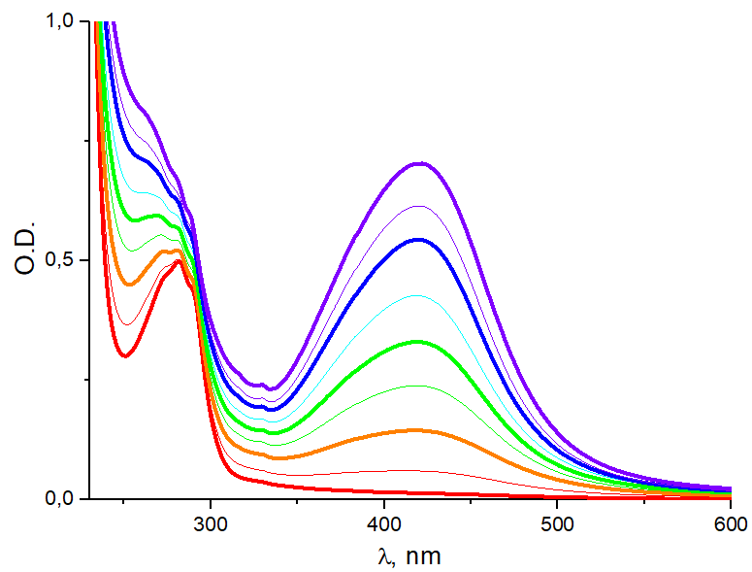
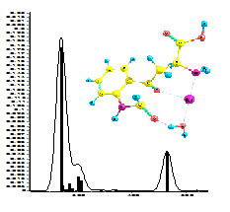Biosafety and environmental friendliness of the production of metal nanoparticles, is growing rapidly. Obtaining of stable colloids of mono- and bimetallic silver and gold nanoparticles in the presence of amino acid tryptophan (Trp) (Fig.1) is of great importance for the treatment of cancer without the need of their further functionalization [1]. To reveal the mechanism of metal reduction and particle stabilization in metal/Trp systems, starting with individual molecules, quantum-chemical calculations can help. Here we describe the optimal structures and electronic spectra of single tryptophan molecules [2] and of their derivative N’-formylkynurenine in singlet and triplet states in relative complexes with water molecules (Fig. 2). In the calculations DFT method (B3LYP/3-21G* , including TD variant) and PCM solvation model were used. The complex [Trp-O₂-Ag-H₂O]⁺ appeared to be stable. In the singlet state, a structure with O-O bond is formed covalently to carbon atom adjacent to the amino group. The transition to the triplet state is accompanied by absorption of 0.5 eV and the rupture of the N-Ag coordination bond. In this case, two C = O groups are formed in the five-membered core of the tryptophan molecule, so that a structure is formed close to the structure of the N’-formylkynurenine molecule. This is reflected in the corresponding UV spectra of the complexes, which makes it possible to identify the states of the complexes in the system. Thus, the experimental UV spectra of tryptophan in an aqueous medium are best described by the model of the stacking tryptophan and N’-formylkynurenine in singlet state .The presence of silver cation as well as oxygen and water molecules in the complex have a polarizing effect on the electronic structure of tryptophan molecules. This is manifested in a change in the absorption spectrum.
Fig.1. Experimental absorption spectra of tryptophan/silver system in time.
Fig. 2. The complex
[Trp-O₂-Ag-H₂O⁺].
- Katifelis H., Lyberopoulou A., Mukha Iu., at all. // Artificial Cells, Nanomedicine, and Biotechnology – 2018. – V. 46(sup3). – P.S389-S398.
- Smirnova O., Grebenyuk A., Mukha Iu., at all. // International research and practice conf.: Nanotechnology and nanomaterials (NANO-2019) (27-30 August 2019, Lviv, Ukraine): Abstract Book. – P.517

