**CdTe/ZnSe core-shell QDs: synthesis via a new approach and investgating optical properties**

Mehdi Molaei, Farzad Farahman, Masoud Karimipour

Department of Physics, Faculty of Science, Vali-e-Asr University, Rafsanjan, Iran

Email:mmolaei8@gmail.com

Abstract

In this research, CdTe QDs prepared using a microwave activated approach. Then via a simple UV-assisted approach CdTe QDs were shelled by ZnSe. CdTe QDs indicated a band edge emission which it indicate a red shift after ZnSe shell growth confirming formation of a tye I core-shell structure. Synthesized QDs were characterized by means of XRD, FESEM, EDAX, UV–vis and PL analysis.

**Keywords:** CdTe/ZnSe, core-shell, Optical Properties

**Introduction**

Today II–VI nanocrystals (NCs) known as interesting materials because of the unique properties and applications [1–3]. CdTe QDs have attracted great attention because of the using them in different applications such as LEDs, solar cells and especially biological and photocatalyst applications [1,2]. Because of the high surface to volume ratio surface defects play significant roles in different properties of the QDs especially in optical properties [4]. Organic capping agent molecules can control and decrease the surface defects and dangling bonds of the QDs, but shelling QDs by wider band gap inorganic materials is a proper approach for improving their optical properties and chemical stability [4]. Different groups reported many approaches for core-shell QDs growth [5]. Most of the approaches are complex and high temperature. In this study we will report a simple one-pot room temperature approach for growth of the CdTe/ZnSe QDs. To the best of our knowledge this method has not been reported by the others yet.

**Synthesis of CdTe/ZnSe core-shell QDs:**

CdTe QDs were grown by a previously reported microwave activated approach [1]. For synthesis of CdTe/ZnSe QDs, 0.1314 g of Zn(Ac)2 was dissolved in 50 ml D.I water and 0.102 g of Na2SeO3 was dissolved in 30 ml D.I water. 0.1 ml of TGA was added to Zn(Ac)2 solution and pH of the solution was adjusted to 9 value by adding proper amount of NaOH then 10 cc of as prepared CdTe QDs was added to that. The finally prepared solution was located under a high pressure mercury and was illuminated for different intervals.

**Results and discussions**

Fig.1. presents XRD pattern of the CdTe and CdTe/ZnSe QDs. The position of the three peaks correspond to the (111), (220) and (311) planes of the cubic structure of the CdTe (JCPDS No.5-0566). For CdTe/ZnSe, diffraction peaks shifted to the higher angles because of the decreasing lattice parameter after ZnSe shell growth. There is an extra peak correspond to the (200) plane of the ZnSe.

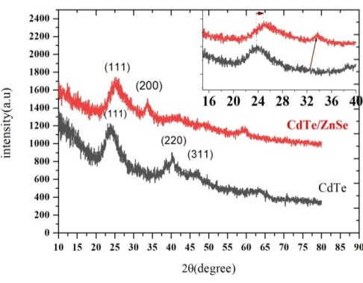

Fig. 1. XRD pattern of the CdTe and CdTe/ZnSe QDs

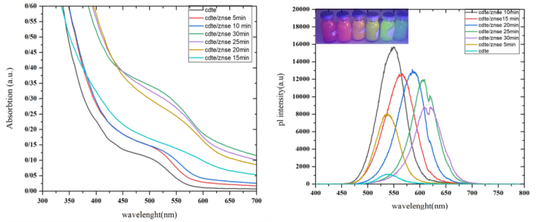

Fig.2. Absorption and PL spectra of the prepared QDs

Absorption and PL spectra of the CdTe/ZnSe QDs were depicted in the Fig.2. CdTe QDs indicated a band edge emission. Clearly after ZnSe shell growth PL intensity of the QDs was increased and indicated an optimum value for 10 min UV-illumination. On the other hand PL peak shifted to the longer wavelength indicating formation of a type I core-shell structure. Inset of the Fig.3. is a micrograph of the QDs emission under 254 nm excitation. Actually in this method by tuning shell thickness via UV-illumination in the shell growth step, QDs with different wavelength emission were prepared.

**Conclusion**

CdTe QDs were prepared via a microwave approach, synthesized QDs indicated a band edge emission. ZnSe shell was grown on the CdTe QDs by a simple UV-assisted approach which it was resulted in formation of a type I core-shell structure.

**References**

[1] M. Molaei, H. Hasheminejad, M. Karimipour, Electron. Mater. Lett. 11 (2015) 7–12.

[2] M. Molaei, A.R. Bahador, M. Karimipour, J. Lumin. 166 (2015) 101–105.

[3] M. Kuppayee, G.K. VanathiNachiyar, V. Ramasamy, Appl. Surf. Sci. 257 (2011)

6779–6786

[4] F. Dehghan, M. Molaei, F. Amirian, M. Karimipour, A. R. Bahador, Materials Chemistry and Physics 206 (2018) 76-84

[5] R. S. Mane and C. D. Lokhande, Mater. Chem. Phys. 65 (2000) 1.